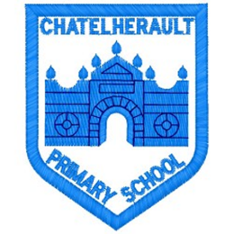
Chatelherault Primary School
Pupil Groups

Group: How Good Is OUR School

Date: 29.3.23
Points from previous meeting
Reviewed discussion about skills. Previously we had talked about skills for Life, Learning and Work
Main discussion points from today:

- Introduce and welcome committee members
- Talked about how we can promote discussions about skills within the classes
- Started posters of core skills – Remembering, Understanding, Applying, Analysing, Evaluating and Creating to be displayed in classes to raise awareness and promote discussion
- Continued to discuss aspects of learning and teaching using How good is OUR school self evaluation document.
- Pupils were confident that they knew the progress they were making in school, they talked about teacher feedback and learner conversations; learning intentions and success criteria, self, peer and teacher assessment; awards; recognition of success and next seps within the class
- This is shared with parents through consultations; reports; homelinks; twitter; showcases; award certificates; google classroom
- Pupils were satisfied with the digital technology used to support learning. They thought that it was used in a variety of ways and that they were able to access it often. They felt that there are enough resources within the school with Ctouches, iPads, chrome books, and the ICT suite giving them a lot of access to technology

Focus Article:

Including the Article number and the description
ARTICLE - 29
Children have the right to an education which develops their personality, respect for others’ rights and the environment
Action Points:

- Finish and produce posters to promote discussions on Skills within classes
- Think about our school facilities and resources and our school within the community, for the next meeting

Minute Taker: J.McDonald

