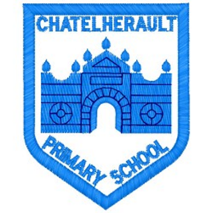
Chatelherault Primary School
Pupil Groups

Group: Eco Committee

Date: 29.11.22

Points from previous meeting:
We raised £35 from the sale of the Halloween costumes .
Everyone enjoyed this and we will think about what to spend the money on

Main discussion points from today:
We discussed walking and the benefits of walking/walking to school
- Exercise
- Fresh air
- Using less fuels so helping the environment
- Time to look at nature and see what is happening around us
- Healthy choice
- Time to meet friends
- Ease parking at school gate making it safer for all

How can we encourage our friends to walk to school?
- Posters
- Eco pupils to chat to classes
- Introduce travel tracker- eco group to demonstrate to class
- Mrs Stewart demonstrated travel tracker and explained to achieve a badge after a month this doesn’t need be walking to school 5 days a week, this can be walking to/from school . Park and ride , scooter and can be 2 or 3 times a week to achieve award

Focus Article:
Article 24 (health and health services) Every child has the right to the best possible health. Governments must provide good quality health care, clean water, nutritious food, and a clean environment and education on health and well-being so that children can stay healthy. Richer countries must help poorer countries achieve this
Action Points:
- Eco group to talk to classes about travel tracker
- Room 12 to pilot this in the month of December
- School to be introduced to this in January
- Mrs Stewart to arrange mascot to visit.

Minute Taker:

