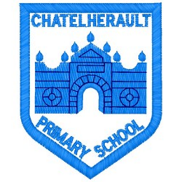
Chatelherault Primary School
Pupil Groups

Group: HGIOS

Date: 29.11.22

Points from previous meeting:
- Group to speak at Chat at Chatelherault this afternoon at 2pm to tell the parents about our focus for this term. Practised what each member was going to say.
- Half of our group went round each class to ask if they wanted a time slot for our ICT suite. Teachers were asked their preferred slot and group will create timetable to get up and running.
Main discussion points from today:

- Timetable finalised and slots allocated. OL from Room 11 will take this timetable around classes this week to conform with classes. ICT suite up and running for next week.
- Posters made to freshen up the room. These were finished and put up.
Focus Article: Article 12 (respect for the views of the child)

Every child has the right to express their views, feelings and wishes in all matters affecting them, and to have their views considered and taken seriously. This right applies at all times, for example during immigration proceedings, housing decisions or the child’s day-to-day home life.
Action Points:

- Audit of our ICT equipment.
- Timetable confirmed with classes with a view to be used from next week.

Minute Taker: Mrs Dunbar

