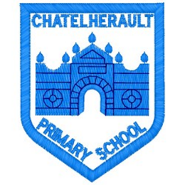
Chatelherault Primary School
Pupil Groups

Group: Pupil Council

Date: 30th August 2023

Points from previous meeting:

Main discussion points from today:

- Welcome and introduction!
- Photograph
- Discuss previous action points from last session
- Our plans/aims for the year – what do we want to improve? What is our job as part of the Pupil Council?
Focus Article:

Including the Article number and the description

Article 15 - Children can join or set up groups or organisations, and they can meet with others.
Action Points:

- Connor (Rm 16– having a sign for people that we know who is feeling lonely.
- Connor (Rm 3) – toadstools to create a calming corner outside Room 17.
- Sam – buddy bench away from the bin in a nice quiet area.
- Speak to our classes – as well as the buddy bench in the playground, what can we do to help those who are looking for a friend? Areas/zones/signs.

Minute Taker: Miss Cunningham

