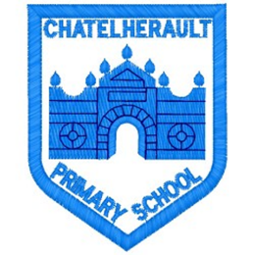
Chatelherault Primary School
Pupil Groups

Group:

Date:

Points from previous meeting:
We were amazed how many costumes were handed in to school

Main discussion points from today:

- Fraser and Isla fed back to the group about the COS 1 event. They told the group about the different activities they did and how they learned about climate action in lots of fun and interesting ways
- Fraser, Isla and Rosie will demonstrate some of the activities and learning with the eco group in the next meetings
- We looked at the costumes that were handed in
- Separated costumes into infants, juniors, seniors
- Pupils decided the fairest way to decide on classrooms to visit the Halloween Charity shop as there are not enough for everyone.
- Organised cost 50p, where – Room 16 and when – Friday morning
- Eco committee will sell costumes and collect classes on Friday
- A representative visited classes to share the news about being chosen to visit the shop first
Focus Article:

Including the Article number and the description

I have the right to an education which develops my personality, respect for others’ rights and the environment

Action Points:

- Sale on Friday 28th
- Next time we will play the corners game from COS event

Minute Taker: Mrs Stewart

