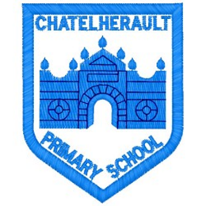
Chatelherault Primary School
Pupil Groups

Group: How Good Is Our School

Date: 26.1.23
Points from previous meeting
Discussed the opening of the ICT suite to whole school. Timetable to be made and issued. Posters made about looking after the ICT suite.
Main discussion points from today:

- Introduce and welcome committee members
- Introduced ‘Our Learning and Teaching’ resource from How Good Is Our School
- Discussed examples of highly effective practice
- The group discussed some of the themes and shared how they felt about:
- How attractive and well maintained our school is
- Do we have the resources and equipment we need to learn
- How doe sour school make sure we have opportunities to choose how and what we learn
- Are we able to learn in ways that suit our needs
- How helpful is the feedback we get from our teachers

Focus Article:

ARTICLE - 29
Children have the right to an education which develops their personality, respect for others’ rights and the environment
Action Points:

- Have discussions in class with teachers about how staff take account of our views when planning learning and teaching
- Look at progression pathways that help plan our learning journey through school

Minute Taker: G. Cunningham

