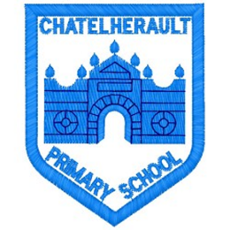
Chatelherault Primary School
Pupil Groups

Group: HGIOS

Date: 26.10.22

Points from previous meeting:
- Taking forward ICT suite resources.
- Evaluating our current ICT suite and what we need to take forward.
Main discussion points from today:

- Group to speak at Chat at Chatelherault this afternoon at 2pm to tell the parents about our focus for this term. Practised what each member was going to say.
- Half of our group went round each class to ask if they wanted a time slot for our ICT suite. Teachers were asked their preferred slot and group will create timetable to get up and running.
Focus Article: Article 12 (respect for the views of the child)

Every child has the right to express their views, feelings and wishes in all matters affecting them, and to have their views considered and taken seriously. This right applies at all times, for example during immigration proceedings, housing decisions or the child’s day-to-day home life.
Action Points:

- Create timetable now we know which classes would like a time.
- Group to meet at 2pm for Chat with parents (Mrs Dunbar to collect group if possible)
- Audit of our ICT equipment.

Minute Taker: Mrs Dunbar

