Chatelherault Eco Shop
The Eco Committee have been learning about Climate Action and we can all do a little to help. We have been talking about recycling and have decided to run an Eco shop selling Halloween costumes and Christmas Jumpers.
We are looking for donations of ….
Old Halloween costumes that could be recycled
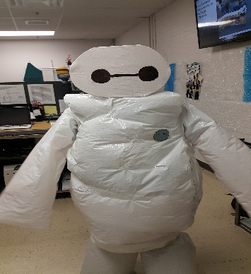 We are also looking for donations of Christmas jumpers that may be too small to be donated to our Eco shop
This Photo by Unknown Author is licensed under CC BY-SA

