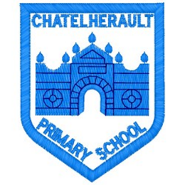
Chatelherault Primary School
Pupil Groups

Group: Total Communication

Date: 31/8/22

Points from previous meeting:

Main discussion points from today:

- Discussion about what total communication means and what communication methods are currently used in Chatelherault
- Focus and plan for group set out
- Group decided what visuals they would like included in their symbol lanyard
- Create a logo for the total communication group
Focus Article:

Article 15
I have the right to meet with friends and join groups and clubs.
Action Points:

- Miss Munro to create symbol lanyards for next meeting
- Group to audit the symbols around the school

Minute Taker: Miss Munro

