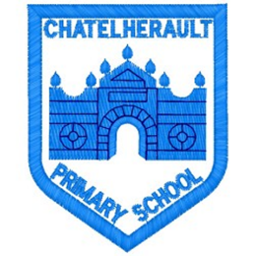
Chatelherault Primary School
Pupil Groups

Group: Digital Learning Group

Date: 31/08/22

Points from previous meeting:
This was the first meeting of this session, no previous points.

Main discussion points from today:
- We discussed the types of digital technologies that we have available within school – Chromebooks, IPads, ICT suite, Clevertouch. Majority of children said Ipads were their preferred technology.
- DN identified that sometimes inappropriate content could be accessed on the school technology.
- As a group we discussed different ways to manage this. We will aim to do a poster campaign to promote internet safety within our school technology.
- We discussed that the focus of our group should be on the learning aspect of digital learning. Over this session we will aim to create digital learning games to support learners in our classes.
- We will also look at different websites that provide learning games and compile a list of reviewed resources that could be used.
- Some children said they had issues accessing technology due to passwords etc. Mr Gilligan will email teachers to check if there are issues with passwords.
Focus Article:

- Article 1 - Everyone under the age of 18 has all the rights in the Convention.
- Article 3 - The best interests of the child must be a top priority in all decisions and actions that affect children.
Action Points:

- Mr Gilligan to email teachers before next meeting.
- Children to take a note of websites/games that they use in school or at home to support their learning. This will be talked about at our next meeting.

Minute Taker:G Gilligan

