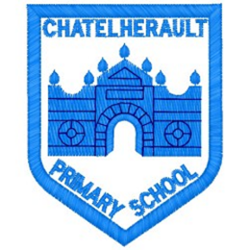
Chatelherault Primary School
Pupil Groups

Group: Sustainability Group
Date: 3.1.26

Points from previous meeting:
- Looking again at our focus for the coming year – discussing again the idea of setting up Food Waste Warriors.

Main discussion points from today:
- Today we joined with the Eco Pupil Group.
- Miss Kearney shared with us all that we have successfully gained our next Eco Flag.
- We conducted our next audit to identify the key areas that we are going to work on this session.
- The 3 key areas are: Heritage, Energy, Food and Global Citizenship
- These were the areas the pupils felt best matched our development needs as a school.

Focus Article:
- Article 29 – Education should develop children’s respect for the environment
- Article 12: - Every child has the right to express their views.
- Global Goals: 11, 12, 13
Action Points:
- Split the pupils into groups to explore each of the areas identified.
- Mrs S and Miss K to identify how we can address key areas as a school.



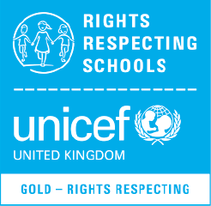

Minute Taker: Mrs Scott

