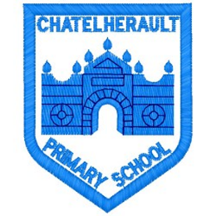
Chatelherault Primary School
Pupil Groups

Group: ECO

Date: 23.2.22

Points from previous meeting:
- Plan for Pocket Garden started by P7 children with additional input from members of the ECO Group.
- Some resources such as plant pots have been brought in by the children.

Main discussion points from today:

- Litter: school grounds really untidy due to recent storms blowing litter; EM and SM to deliver litter pickers to classes each interval and lunch, incentive for class collecting the most TBC; if necessary, a timetable will be made to ensure all areas are covered.
- Pocket Garden: Theme ‘A Year of Stories’, Hungry Caterpillar has been selected by the children; seeds and bulbs available to start planting in the tubs, etc; include a water feature (AM) and include underwater plants; decorative stones and using P7 wind features from their Science (anemometers and rain gauges); work will be extended to include children in Supported Study Group.
Focus Article:

Including the Article number and the description

Article 29: Education must encourage the child’s respect for human rights, as well as respect for their parents, their own and other cultures, and the environment.
Action Points:

- Daily Litter Picking & Monitoring
- Pocket Garden ‘Design and Do’

Minute Taker: Mrs Corns

