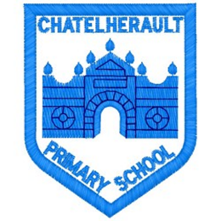
Chatelherault Primary School
Pupil Groups

Group: RRSA

Date: 30.03.22

Points from previous meeting:
OutRight campaign
Preparation for Gold visit
Involve Parents
Scavenger hunt

Main discussion points from today:

- Sharing Children’s Rights at home and in the community
- Discuss how we can share Rights learning at home
- Feedback from other pupil groups and reflect on the Rights discussed within them.
- Prepare for walk-round and chat to visitor about RRSA
Focus Article:

Article 5 Your family has the responsibility to help you learn to exercise your Rights and to help ensure that your Rights are protected.
Action Points:

- To involve parents in the RRSA – have a meeting with parents to share our journey so far. Do this through Google meet, after Spring break
- Plan a grid of activities that will be shared with the whole school on google classroom to share Rights learning at home
- Review journey to Gold in preparation for assessor visiting the school.

Minute Taker: J McDonald

