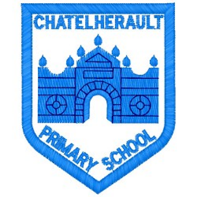
Chatelherault Primary School
Pupil Groups

Group: HGIOS

Date: 23.02.2022

Points from previous meeting:
- Engagement in Literacy lessons
- Engagement in Numeracy lessons
Main discussion points from today:

- We revised what we had previously discussed around what makes a good Literacy lesson and what makes a good Numeracy lesson. We spoke about similarities and differences between each area.
- What makes a good learner? We discussed the attributes that both children and teachers need to have in order to be successful learners. Consider this more next time and look at engagement characters for each class.
- What makes a good lesson overall – non specific to Literacy or Numeracy but learning across the curriculum in general. Mind maps created in groups.
- Pupil participation – how much do we participate in choosing our learning and learning in a way that’s best for us? Pupils comments:
- pupil groups
- choice of where to work (outdoors, open areas, different class areas)
- learning walks
- challenges – choice of challenges to suit each person
- option of working individually or in a pairs
Focus Article:

Including the Article number and the description
- Article 12 – the right to express views and feelings
- Article 28 – the right to an education
- Article 29 – education must develop every child’s personality and abilities
Action Points:

- Learning Walk around classes – pupils in group to complete learning walk
- Consider engagement characters for each class – are these still relevant and can they be used effectively?

Minute Taker: Mrs Dunbar

