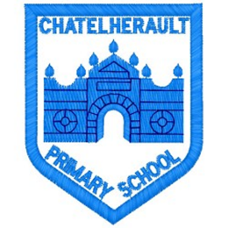
Chatelherault Primary School
Pupil Groups

Group: Eco Committee

Date: 26.1.22

points from previous meeting:

Main discussion points from today:

- This meetings focus : Pop-up Pocket Garden competition
- Mrs Stewart and Mrs Corns informed children of the garden competition
- Set out the area allowed in the guidelines to be aware of size
- Discussed timeline of events – garden has to be completed by June 30th
- Pupils brainstormed ideas for a garden using recyclable products e.g. wellies, old pots, plastic bottles , egg cartons, tyres, etc.
- Pupils listed ideas of plants that we could use to encouraged bees wildlife
- Discussed possibility of creating garden indoors and transferring outside as the foxes may destroy our creation.
- Zara suggested a small plastic greenhouse may keep our garden safe and also warm enough for seeds to grow.
- Discussed where garden should ‘live’ – possibly front of school or beside playground gates.

Focus Article:

I have the right to an education which develops my personality, respect for others’ rights and the environment

Action Points:
- Pupils in Eco group to create plan of possible garden for homework
- Send email to parents for green house /recycled products and any leftover seeds
- Research some plants that could be used in our design.

Minute Taker:

