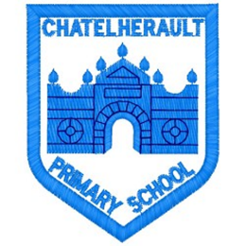
Chatelherault Primary School
Pupil Groups

Group: Maths

Date: 26.1.22

Attendees:
Emelia Sandilands, Caitlin Leiper, Mila Flaherty, Connor Watson, Darcy Queen, Ollie Spence, Jordan Lefeuvre, Riley Sandilands and Mrs Bear (minute taker).

Points from previous meeting:

Main discussion points from today:

- Welcome to the Maths Group

- We discussed ‘World Maths Day’ which takes place on March 23rd.

- The children had lots of ideas including: making posters to promote the day, a sumdog competition, a quiz, a times table challenge.

- The children suggested having different types of questions for children of different ages. They also suggested different prizes such as geometry sets, protractors, pencils and pens.

Focus Article:

Article 19 – Every child has the right to be protected.
Action Points:

- Children to create and display posters around the school to promote World Maths Day.

