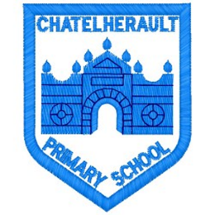
Chatelherault Primary School
Pupil Groups

Group: HGIOS

Date: 24.11.21

Points from previous meeting:

We discussed our strengths and priorities in our learning and teaching against the qualities of effective practise. We looked at what elements of a numeracy lesson engages us and helps us to learn.
Focus next session on what engagement in Literacy looks like.
Main discussion points from today:

- We went over what engagement in a numeracy lesson looks like and what pupils require from the teacher and classroom to learn best.
- Thinking about Literacy, the pupil group gave the following ideas as to what engages them during lessons:
- Taking learning outdoors
- Having a quiet space to read
- Word mats available to help when writing
- Opportunities to work together and share learning and ideas
- Using technology such as chrome books and Ipads
- Opportunities to work in a small group with the teacher to go over anything that isn’t understood
- The option to decide where to work – in the open area, picnic benches or in the classroom.

Focus Article:

Including the Article number and the description
Article 12 Every child has the right to express their views, feelings and wishes in all matters affecting them, and to have their views considered and taken seriously.
Article 28 (right to education) Every child has the right to an education.
Article 29 (goals of education) Education must develop every child’s personality, talents and abilities to the full.
Action Points:

- Focus on developing our engagement characters to encourage pupils across the school to reflect on learning and talk about their levels of engagement and participation.

Minute Taker:

