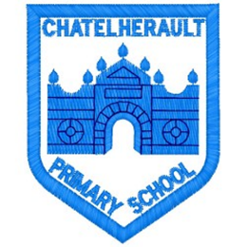
Chatelherault Primary School
Pupil Groups

Group: How Good Is our School?

Date: 20.10.21

Points from previous meeting:
- Focus on HWB and developing mental health – links to Out Right campaign .
- Motivational HWB posters completed for pupils to put up around key areas of the school to welcome visitors.

Main discussion points from today:

- Looked at finished posters. Pupil group will meet one lunchtime to put these around school in the next few weeks.
- Encourage class to look out for these.
- Focus now moving to Theme 2 – Our Learning and Teaching with a focus on Pupil Engagement.
- Looked at the features of highly effective practice in Learning and Teaching and sorted these into strengths and action points going forward. Agreed that these statements weren’t overly child friendly and quite wordy. Worked together to talk about each of these and what this looks like in our school.
- Smaller sub group began looking at what makes an engaging maths lesson. This should be completed next meeting.
- Shared some ideas on what good learning and teaching means for pupils and for teachers.
Focus Article:

Including the Article number and the description

28 YOU HAVE THE RIGHT TO EDUCATION
29 YOUR EDUCATION SHOULD HELP YOU DEVELOP YOUR PERSONALITY.
Action Points:

- Next meeting, we will look more closely at what engagement means.
- Think about what makes an engaging Literacy and Numeracy session and note down things from lessons in class that made it enjoyable.
- Discussion around this next meeting to create a checklist for staff and pupils.

Minute Taker: Mrs Dunbar

