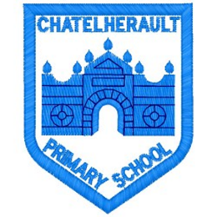
Chatelherault Primary School
Pupil Groups

Group: How Good is OUR School?

Date: 22.09.21

Points from previous meeting:
- Pupils voted for a Health and Wellbeing focus for this month We discussed what this would look like – making the school welcoming so people feel happy when coming to school.
- Focus on developing our wellbeing and happiness when coming to and being in school.

Main discussion points from today:

- The first place we see when we enter the school is the office or playground so we agreed that we should focus on these areas. How can we make these welcoming and start our day off positively?
- The group decided to make motivational welcome posters for everyone to see when the walk around the building.
- We talked about the purpose of these posters and what they would do for our wellbeing. These could be highlighted to each class so people know to look out for them around the school.
- We worked together on creating our posters.
- Mrs Dunbar to laminate and get pupils from the group to pin up around our school.
- All unfinished posters to be completed at Golden Time if possible and returned to Mrs Dunbar by next week.
Focus Article:

Including the Article number and the description

Article 12 – the right to an opinion and for it to be listened to and taken seriously.
Article 29 - You have the right to education which tries to develop your personality and abilities as much as possible and encourages you to respect other people’s rights and values and to respect the environment
Action Points:

- Put up posters with focus group next week in key areas around the school.
- Next month focus should be learning and teaching with a focus on pupil engagement.

Minute Taker: Mrs Dunbar

