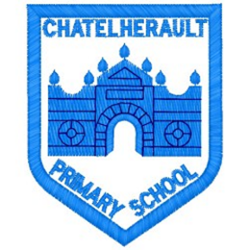
Chatelherault Primary School
Pupil Groups

Group: Literacy Pupil Group
Date: 30th August 2023

Points from previous meeting:

- All new members in the group
- Mrs Lochhead spoke to the group about what the literacy group role was in the school and that last years literacy group achieved the silver reading schools award.
Main discussion points from today:

- The purpose of the group was outlined: to help promote reading for pleasure across the school and get children, families and the community enjoying books.
- We discussed our school library and the layout, we labelled some books and made sure everything was well ordered.
- Members of the literacy group in P5-7 will accompany Mrs McCreadie to the ELC in Hamilton to make links within the community,
- Applications are also sort from all pupils in P5-7 for our new library helpers. Members of the literacy group were going to go back and tell the classes all about it and hand out application forms. The closing date is 6th September,

Focus Article: Article 12

Every child has the right to express their views, feelings and wishes in all matters affecting them, and to have their views considered and taken seriously. This right apples at all times, for example during immigration proceedings, housing decisions or the child’s day-to-day home life.
Action Points:

- Pupils to consider positive changes they would like to see in the library.
- Staff members of the gold reading school group will collate the library managers application forms and hold interviews.
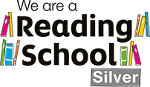
Minute Taker: Mrs Lochhead

