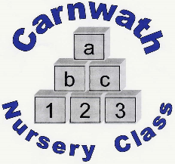
Carnwath Nursery Class – Transition into Nursery Process
Settling in events are key to a smooth transition and ensuring good communication and information sharing.
They are a great opportunity for families to see the nursery, meet staff and the other children.

It is our aim for children to start nursery on the first Monday following their 3rd birthday. During the August intake, we will operate in a staggered start system with two children starting per day to allow staff the opportunity to spend more time with the children ensuring that they are happy and settled.

Day 5 – The child will attend nursery for a full session 9.00am – 3.00pm.

Day 4 – Parents/carers will bring their child to nursery at 9.00am starting with all the other children and they will be collected at 2.00pm.

Day 3 – Parents/carers will bring their child to nursery again at 9.15am and they will stay for lunch and then be collected at 1.00pm.

Day 2 - Parents/carers will bring their child to nursery for 9.15am after all other children are in and settled to ensure that they have a calm start and do not feel overwhelmed. The parent/carer will leave the child in nursery and return to collect them at 11.00am.

Day 1 - The key worker will initially welcome the child and their parent/carer into the nursery for their first visit. They will spend some time interacting with the child and will introduce them to the staff team before taking time off the floor (approx. 1 hour) to complete the Child’s care plan with the parent/carer. The child will go home with their parent/carer following the completion of all necessary information.

We recognise that every child is individual and therefore this process can be flexible. The key worker will work closely together with the family discussing how the child is getting on throughout their settling in period to help them form a secure attachment and the understanding that they are cared for, respected, and understood.

