Decorate your window for Easter.

Easter Wreath

1.

Draw round a plate or bowl and cut out the circle. Put a smaller plate or bowl in the middle of your circle, draw round it and cut it out to make your wreath shape.

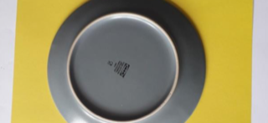

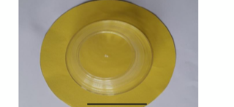

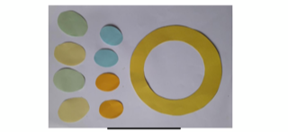2.

Cut out 4 large egg shapes and 4 smaller egg shapes.

3.

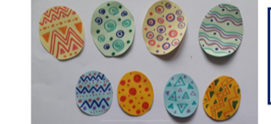

Decorate you eggs. Can you make them all look different?

4.

Stick your eggs on the wreath. Sellotape a loop of string to the back so you can hang up your wreath.

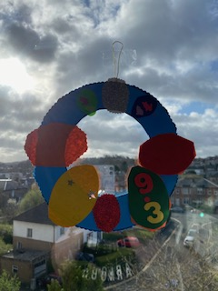

**Remember to send a picture of your wreath.**