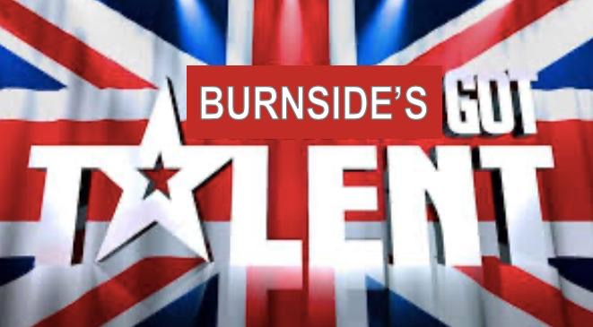

Welcome to Burnside’s Got Talent!

Usually around this time, we start to prepare our auditions for the event of the year As we obviously will not get to share our talents on stage this year, we thought we would bring the stage to you!
This is just a message to get you thinking – do you have a talent that you would like to share? We are going to ask for video clips (20 seconds maximum) to collate and put together nearer the end of the term.
We will share your talents on our private Twitter page. The video will have music playing over the top; therefore your video entry cannot have any audio (for example you won’t be able to speak / sing in your entry).
You do not have to send in any video clips just yet… I’ll let you know when
But get thinking… I’m sure you all have some amazing talents that you would like to share!

