Set up a tent  Try setting up an indoor/outdoor tent with an adult – this requires lots of problem solving skills! If you don’t have the equipment to do this, try designing a tent to include the following criteria: sleeps 8 people, dining area, toilet area. You can design this on paper or digitally. Make your design as unique as possible!  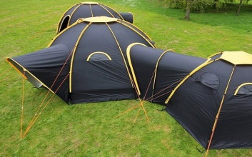 | Build a Fort  Create an indoor or outdoor fort with cushions, blankets and sheets, clothesline, branches or other items. Use your imagination. Your fantasy fort can be a treehouse, a blanket fort, a cushion castle, a fairy house or a teepee. This activity will help you develop construction and engineering skills and concepts around sustainability.  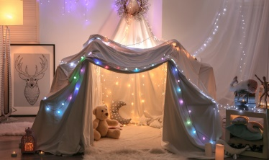 | Explore your garden  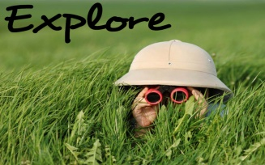  Go on an exploration of the area to discover the many different types of insects, plants, flowers and trees in the yard. Note down what you see. If you are unsure about what something is, carry out some research to help you. A magnifying glass or binoculars are sure to add an element of fun to your adventure! | Make a nature collage  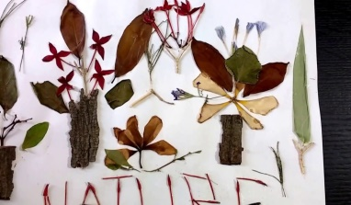  During the exploration of the yard, it is a good idea to collect interesting and odd things in a bag or bucket. When the exploration is over, engage in an art activity using your collections. Use glue to stick items to a piece of cardboard or paper. Use the items to create different animals and creatures using additional supplies that you may have at home.
Treasure Hunt  Create a treasure hunt for someone to complete with clues that will lead them around the garden/house and to a final destination. Each clue can be geared to a nature reference, family activity reference (swing set, garage, flowerbed, etc.), or possibly as a treasure map complete with numbered paces, geographical direction and an "X" to mark the spot! You can download treasure maps from the Internet as well.  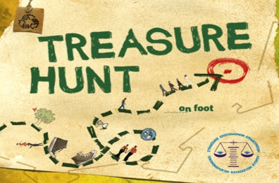 | Blinded Obstacle Course  Create an obstacle course in your house or garden using different objects. Try it out yourself un-blindfolded so you know what the expectations are. Then, try to get someone in the house to complete it blind folded. Your instructions will need to be clear and simple for them to follow the course successfully. Have fun!  . | Al Fresco dining  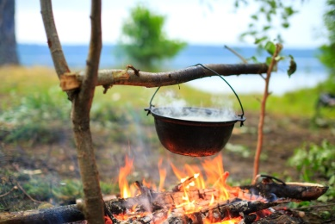  Great chefs know that there is no substitute for cooking over an open flame. If you are able to, plan the family meal to include items that can be cooked over a fire, such as hot dogs, chili, beans or any other family favourite. After the food has been cleaned off the plates, it is time for the sticky sweetness that only S’mores can bring to a campfire. Even simply eating the meal outdoors is enjoyable – al fresco style! | Campfire Songs  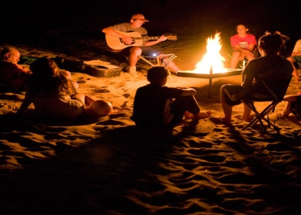  Sing your favourite songs outdoors and try to get others to join in. You might want to make up your own tune about what you can see/hear/smell etc. If someone plays a guitar, harmonica or kazoo this can add a little extra fun to the activity!

Campfire Stories  Engage the family around the ‘fire’ with some campfire stories. These stories can be scary ones told with the addition of the theatrics created with a flashlight shining under your chin. Or, you can tell a story in which each person around the campfire adds some content to the fable as you go around the circle. Allow a certain amount of speaking time for each person or number of words that can be added to the circle story for added fun.  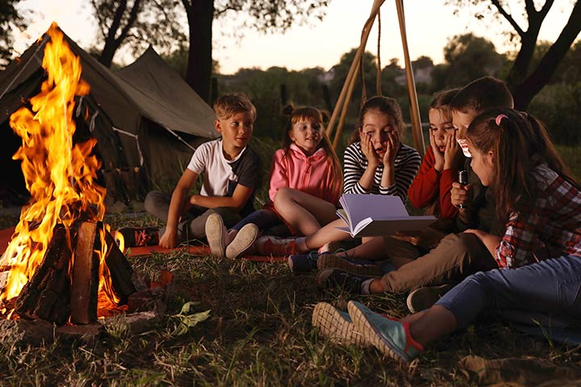 | Mini Raft Making  Using materials from around the house and garden e.g. twigs, design a small raft that will float on water.  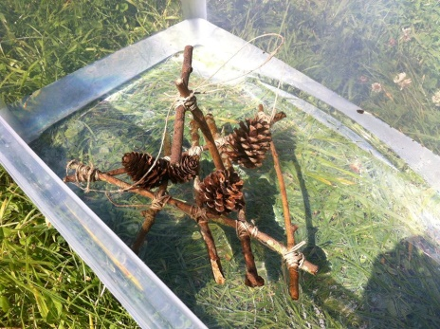 | Evening Entertainment  Play some quizzes/games with the family. You might even want to make your own! | Go Stargazing!  Enjoy the night sky! Count the stars and draw the constellations you see. Try and identify those constellations. Why not try to draw the shapes you see in the sky and create your own constellations.  