Outdoor or Indoor Assault Course | Rainbow Scavenger Hunt | Garden/House Orienteering | Natural Noughts and Crosses
Build an assault course using anything you can find to use as obstacles. You can add activities too like “when you get to the stepping stone do 10 star jumps”. Be creative! Using a timer, have a race with your family members to see who can complete it fastest. | Go outside in the garden or for a walk, and collect something or a few things for each colour of the rainbow. | Draw a birds eye map of your garden and/or your house. Ask someone in your family to hide a few small objects and mark them with an X on the map. Can you find the objects? | 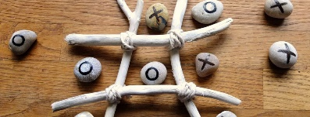  Create a noughts and crosses board and pieces out of natural materials and ask someone to play with you. One idea is using painted stones and sticks.
Marble/Tennis Ball Run | Campfire/BBQ | Build a Shelter/Den | Build a Shelter/Den for an Animal
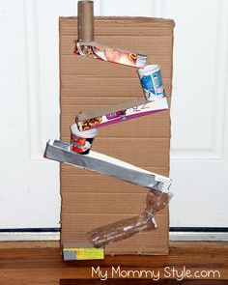  Using any materials you can find, make a track or a run for either a marble or a tennis ball to travel along. Your run must have at least 2 different heights, change direction at least once and the marble must roll all the way to the end. | Have a camp fire or a BBQ in the garden with your family. Toast some marshmallows or heat some hot dogs, and maybe sing a couple of your favourite campfire songs!  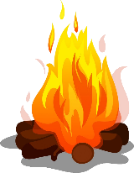 | Go to the woods during your daily exercise time. Use materials you can find to build a den large enough to fit 2 people. Can you make it waterproof?  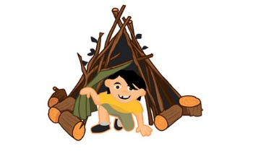 | In the woods or your garden, can you make a home for a woodland creature of your choice? (mouse, rabbit, bird…)  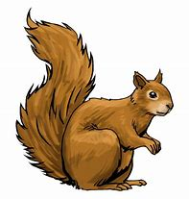  Use natural materials you can find and some string. Can you make it waterproof? Can you add any furniture?
Pitch a Tent in the Garden | Planting/Gardening | Go for a Cycle/Scooter Ride | Go on a Nature Hike
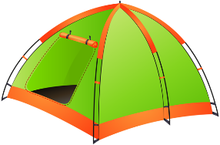  Pitch a tent in your garden and spend a bit of time in it. You could even sleep in it if the weather allows! When you’re finished, you’ll need to take it down and pack it away too. If you don’t have a tent, build a den in your house instead! | 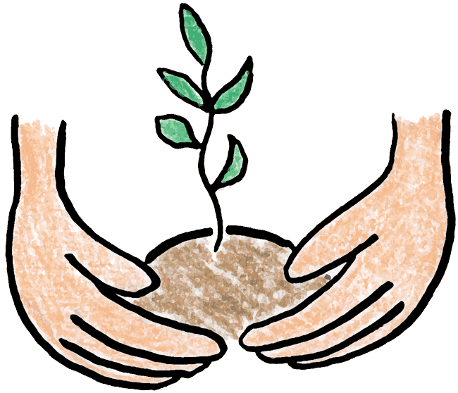  This is the perfect time of year to do some planting in the garden. Get some seeds or bulbs and find a patch of soil to plant them. Or you could plant them in plant pots. You could also do some weeding! | Go for a long cycle or scooter ride with a member of your family.  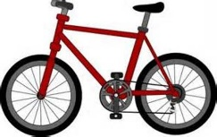 | 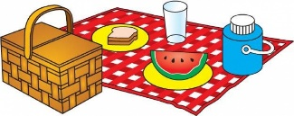  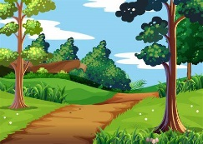  Go on a long nature hike with a member of your family. You could even prepare and take a picnic with you.
Tallest Natural Structure | Natural Art Picture | Make and Fly a Kite | Make a Bird Feeder
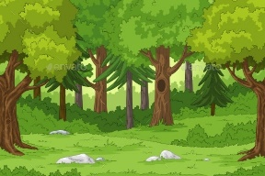  Go to the woods and try to make the tallest standing structure you can using only natural materials you find and some string. | 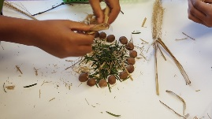  Collect some natural materials from the garden or while you are out on a walk. Use them to create a piece of artwork. | Design and make your own kite using any materials you like! Can you make it fly on a windy day?  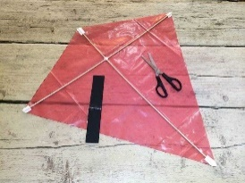 | 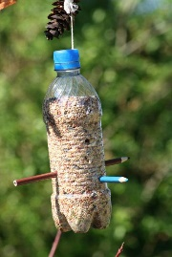  Design and make your own bird feeder. Some ideas are using a hollowed out orange or a plastic bottle. You’ll find lots of designs on the internet.  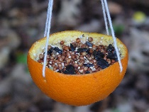
Make A Bird House | Blindfold Challenge | Minibeast Hunt | Make A Mini Raft
Make and decorate a bird house from wood or cardboard (or any other materials you want to use). Remember cardboard won’t be waterproof so don’t leave it out in the rain!  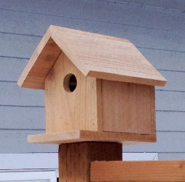 | Create an obstacle course in your house or garden, or find a safe space outdoors. Put on a blindfold and ask a member of your family to guide you around the obstacle course. Then swap over.  Alternatively, you could put a bucket somewhere and ask someone to guide you to the bucket to put a ball inside. | Go on a nature walk and try to find and identify different types of minibeasts. Good places to look are under large rocks or tree stumps, because minibeasts like damp, dark spaces.  Take pictures of draw them.  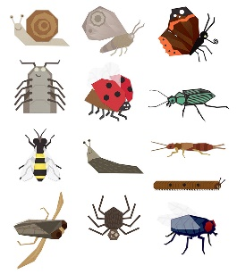 | Make a mini raft for one of your toys using any materials you like. (Sticks and string would be a good example). Test it in the sink/bath/bucket of water. Does it float? Does it take the weight of the toy? (Choose a toy you don’t mind getting a bit wet!)  