Exercise 3 A
- What numbers are located at positions a) to i) on theses number lines?
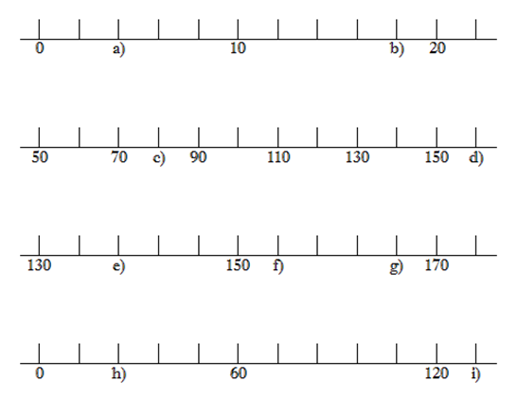
Page Break
Exercise 3 B
1) State the capacity shown in ml, for each of the following:
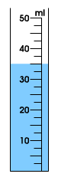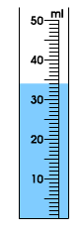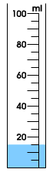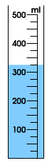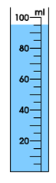 a) b) c)d) e)
Exercise 3 C
1) State and interpret the following scales, make sure you give the correct unit (litres/millilitres/grams/kilograms):
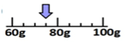
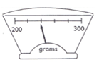
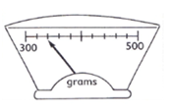
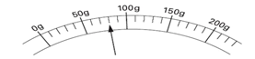

2) State and interpret the following scales, make sure you give the correct unit (litres/millilitres/grams/kilograms):

