Spelling Homework – Groups are listed at the top of each column.
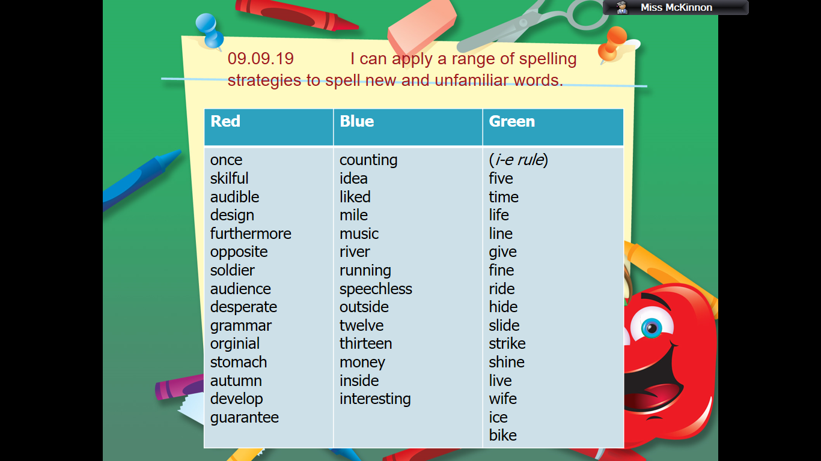Words to be written out three times in your homework jotter (neatest writing possible). Please ALSO choose three words and complete the rainbow writing or pyramid writing task. If you forget what these are, please ask me about them in class before Thursday.

Green group – The 5 extra spelling words you create will be written in your homework diary on Monday morning, after your spelling lesson.

