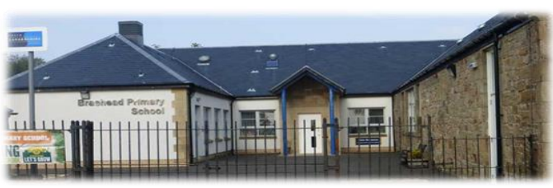
Strategic Improvement Priorities Plan over 3-year cycle Timescale: 2023-2026
Strategic Priority | Year 1 | Year 2 | Year 3
1. | Revising our school vision, values and aims with our school community and partners. | Increase attainment in writing. | Embed new writing programme across all stages
2. | Extending the opportunities for pupil participation through the use of HGIOURS and participating in the Young Leaders of Learning programme. | Improve/embed approaches to nurture and trauma informed practice. | Develop interdisciplinary Learning through enquiry approaches and innovative curriculum design. (SLC offer)
3. | Development of play pedagogy in our infant class linking to South Lanarkshire’s Skills Framework. | Improve digital literacy across our school community. | Further extend digital skills across our school community and evaluate use of South Lanarkshire ICT planners.
4. |  | Implement the Circle Framework for Inclusion across school.

Maintenance Agenda
Key actions | Relevant stakeholder involvement | Timeline for completion
Continue to work on Attachment Informed and Trauma Sensitive Accreditation, achieving at least one additional pledge by May 2026. |  | May 2026
Develop use and interpretation of GWMP to accurately reflect context and ensure understanding of young people.
Progress with audit and relevant action in relation to Making Rights Real programme (having transferred from Rights Respecting Schools)

