Standards and Quality Report 2018-19
Braehead Primary School
Our Values
School Values
Kindness
Resilience
Ambition

Our Vision
Our vision at Braehead is to provide a positive and engaging learning environment which challenges and supports all children to be the best they can be.
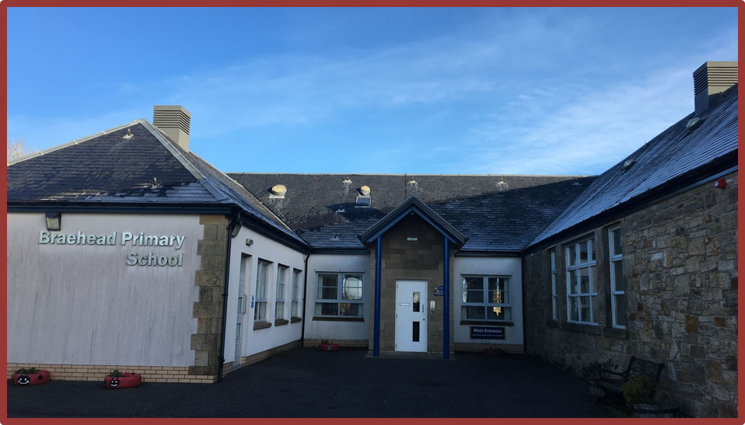
Braehead Primary School
Small School, Big Ambition

Context of the school:

Braehead Primary School is a small school in a very rural area of Clydesdale in South Lanarkshire. The current roll is 40 pupils over 2 classes with provision for 3 classes most mornings. In the local area there is a mixture of privately-owned housing, social housing and farms as well as a village hall. There is limited public transport available for the village of Braehead. The new school building was opened in 2009 and provides a bright, modern environment in which our children can learn and thrive.

Our vision for Braehead Primary is to provide a positive and engaging learning environment which challenges and supports learners. Our school values are kindess, resilience and ambition and we aim to promote these throughout our school community and the curriculum. Last year, in consultation with all stakeholders we chose a motto for Braehead, we wanted this to be representative of the whole school community and reflect our aspirations for all the children in the school. Our new motto is Small School, Big Ambition.
Staffing in Braehead has become more settled this session. Our Principal Teacher returned from maternity leave and previously area cover staff were made permanent to the school. We look forward to 2019/2020 with a more settled permanent staff.

Two P1 pupils started with us last August taking our role to 40 pupils. Our numbers are currently quite small in the lower stages but next session we are expecting seven new pupils into our P1.

We have a very active and engaged Parent Council who play an integral role in school life. All of our parents support the school in many ways including fundraising and attendance at school events. As well as the Parent Council we have 2 sub-committees; School Improvement Team and the Playground Improvement Team. Both groups have been instrumental in some important changes throughout the session and play an active role in whole school improvement.

We are part of the Lanark Learning Community and have developed strong links with local schools, mostly with Carmichael Primary which shares our Head Teacher. We actively participate in moderation activities within Lanark Learning Community and share good practice with colleagues based on our Learning Community Improvement Plan. We work very well with local nurseries and secondary schools to ensure that smooth transitions are planned for.

Review of SIP progress session 2018-2019

Priority 1: Raise attainment in literacy with a focus on writing at early and first levels.

National Improvement Framework Key Priorities  - Improvement in attainment, particularly in literacy and numeracy;  - Closing the attainment gap between the most and least disadvantaged children;  - Improvement in children and young people’s health and wellbeing; and  - Improvement in employability skills and sustained positive school leaver destinations for all young people. | National Improvement Framework Key Drivers  - School leadership  - Teacher professionalism  - Parental engagement  - Assessment of children’s progress  - School improvement  - Performance information
HGIOS 4 QI: 2.3, 3.2

Progress and Impact:
- Attainment in writing within first level has increased at P3 and P4 quite significantly. At Primary 3 there has been a 40% increase in attainment and at Primary 4 this increase has been 63.4%. This has been largely due to smaller class sizes, additional staffing and a greater focus on both writing itself and read to write activities.
- Within second level there has been very little change in writing attainment from session 2017-2018 and those identified within the target group have additional support needs which have been identified and addressed.
- While those children in the target group are not meeting the expected levels of attainment, they have made individual progress at their own level. We will continue to implement strategies to support closing the attainment gap.
- All permanent staff have been trained in Talk 4 Writing and have begun to implement some of the suggested pedagogy with success. We will continue to adapt the guidance to suit our multi-composite setting.
- All staff are now fully implementing the Active Literacy programme and strategies for spelling. This has shown a significant rise in attainment particularly at Primary 3 and Primary 4.
- Participation and engagement across all stages in reading is high. Our reading attainment currently sits at 82.5%, this has increased from 76.5% last session. At stages P1-5 there is a distinct increase in pupil participation and engagement as a result of the active literacy approach. Reading attainment has either stayed the same or risen in most stages across the school.
- Due to staff absence at Braehead there has been limited opportunity for peer visits when they were planned for however there has been an increase in dialogue for shared planning, evaluation and moderation within writing at early and first level with mutual benefit for staff and pupils.

Next Steps:
- Continue to work with the principles of Talk 4 Writing and adapt this to suit our multi-composite setting.
- Work in partnership with Carmichael Primary to co-construct a literacy programme reflective of our literacy attainment, development needs, current theory and pedagogy.
- Continue to build on participation and engagement through purchase of reading material, particularly for P4/5 keeping in mind engagement and participation.
- Encourage partnership working to enhance motivation in reading through fortnightly readathons, weekly paired reading sessions and an increased opportunity for pupils, particularly in target groups to experience literacy rich learning environments.
- Host active literacy sessions for parents to visit to allow them to better support their children at home; particularly at stages p1-3.

Priority 2: Extend tracking and monitoring of the curriculum to include all areas of Health and Wellbeing.

National Improvement Framework Key Priorities  - Improvement in attainment, particularly in literacy and numeracy;  - Closing the attainment gap between the most and least disadvantaged children;  - Improvement in children and young people’s health and wellbeing; and  - Improvement in employability skills and sustained positive school leaver destinations for all young people. | National Improvement Framework Key Drivers  - School leadership  - Teacher professionalism  - Parental engagement  - Assessment of children’s progress  - School improvement  - Performance information
HGIOS 4 QI: 2.4, 3.1
Progress and Impact:
- Robust tracking and monitoring of all pupils and an embedded quality improvement calendar ensures all pupils who require support in health and wellbeing are identified early and support allocated as appropriate.
- Those pupils in the target group have been clearly identified with wellbeing targets assigned using the wellbeing application tool.
- Support from external agencies has been utilized for those identified within the target group and individual work will result where required.
- All children participate in monthly self-assessment following work on the wellbeing indicators. This is used in pupil progress meetings to identify next steps, notify those required.
- Our successes and achievements are recorded in the school and shared with all stakeholders using out Twitter and Facebook pages. This ensures wider achievements remains a focus as a context for learning.

Next Steps:
- Allocate time within the assessment pathway for small group learning conversations around health and wellbeing to ensure those aspects within the wellbeing indicators are always current and relevant in terms of our pupil assessment.
- Incorporate Pupil Learning Plans for all children which will be reviewed bi-monthly and used to communicate next steps in learning with parents.
- Implement Nurture principles across all stages following whole school training from Nurture UK.

Priority 3: Review curriculum design and rationale in line with national guidance.

National Improvement Framework Key Priorities  - Improvement in attainment, particularly in literacy and numeracy;  - Closing the attainment gap between the most and least disadvantaged children;  - Improvement in children and young people’s health and wellbeing; and  - Improvement in employability skills and sustained positive school leaver destinations for all young people. | National Improvement Framework Key Drivers  - School leadership  - Teacher professionalism  - Parental engagement  - Assessment of children’s progress  - School improvement  - Performance information
HGIOS 4 QI: 2.2

Progress and Impact:
- All stakeholders were invited to contribute to the work undertaken on curriculum design and the review of our school vision and values. There was a limited return from parents however all staff and pupils contributed to the revised vision and values.
- Our new curriculum rationale is reflective of the staff, pupils and parents of Braehead Primary. We have carefully considered the area in which the school is situated, the factors which make Braehead unique, attainment data and other intelligence to inform our rationale. This will be reviewed annually to ensure it is remains fit for purpose.

Next Steps:
- Share the curriculum rationale with all stakeholders.
- Provide greater opportunities for pupil leadership teams to meet to look at self-evaluation for whole school improvement.
- Review curriculum rationale annually to ensure it continues to be relevant and fit for purpose following analysis of attainment data.

Priority 4: Improve pedagogy for equity – raising attainment and achievement through highly effective formative assessment strategies.

National Improvement Framework Key Priorities  - Improvement in attainment, particularly in literacy and numeracy;  - Closing the attainment gap between the most and least disadvantaged children;  - Improvement in children and young people’s health and wellbeing; and  - Improvement in employability skills and sustained positive school leaver destinations for all young people. | National Improvement Framework Key Drivers  - School leadership  - Teacher professionalism  - Parental engagement  - Assessment of children’s progress  - School improvement  - Performance information
HGIOS 4 QI: 2.3, 3.2

Progress and Impact:
- Classroom observations as outlined in the quality improvement calendar have been carried out throughout the session providing evidence that AifL strategies are being used to enhance pupils’ understanding of what is being taught, why and how they can further improve their learning. This can be further evidenced through jotter monitoring and feedback offered to pupils, particularly in writing.
- The majority of pupils are familiar with higher order questioning and can use Blooms buttons to ask appropriate questions in pairs and groups.
- All staff engage with the Tapestry training materials and regularly meet with staff from Carmichael Primary to reflect on strategies implemented, sharing good practice.

Next Steps:
- Continue with Year 2 of the Improving pedagogy for equity Tapestry Group.

Achieving Excellence: Overall Progress towards National Improvement Framework Priorities
Session 2018-19
Literacy:
Progress | satisfactory | good | very good | excellent
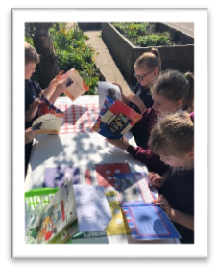
Strengths
- Attainment in reading has either risen or remained the same for most stages across the school.
- All staff are confident in Active Literacy and this is now fully embedded at all stages.
- Reading attainment at Primary 3 has significantly risen from 60% to 100% due to Active Literacy and 1:1 interventions with learners to support reading in early years.
- Writing in stages P3 and P4 continues to rise significantly to 100% and 80% respectively.
- Attainment in listening and talking has risen at P4 from 66.6% to 80%. Work undertaken at Lanark Learning Community level has deepened staff understanding of attainment of a level and the type of assessments used across the schools as well as providing opportunity to assess collaboratively.
- Our writing workshop help earlier this session left all parents who attended feeling more confident in supporting their child in story writing.
- All permanent staff have received training in Talk 4 Writing which has impacted on both attainment and participation and engagement within writing across the school. We will continue with this next session considering how best to embed this in a multi-composite setting.

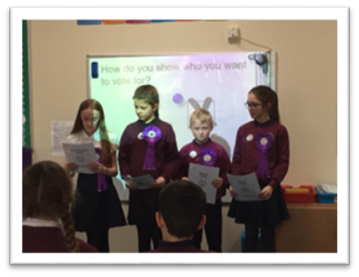
Next steps
- Continue to engage with pedagogy of Talk 4 Writing to further enhance writing quality at all stages.
- Include listening and talking at school level on out school improvement plan to ensure the next steps are fit for purpose in a multi-composite and reflective of the needs within our stages.
- Continue to embed a literacy rich culture across the school with greater opportunities for sharing reading, paired reading and reading for pleasure.

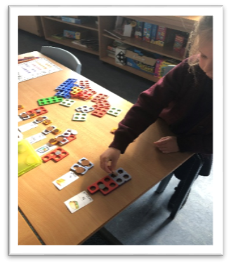
Numeracy:
Progress | satisfactory | good | very good | excellent

Strengths
- Numeracy attainment across the school is very good with attainment overall at 97.5%.
- A few pupils are working beyond their stages to ensure adequate challenge is provided, this has been successful in our multi-composite setting and will continue next session.
- We have established successful links with Lanark Grammar School to support one of our learners who will be working on National 5 maths next session.
- Those children within the targeted group continue to make progress at their own level which is contributing to closing the attainment gap. Interventions and supports have been identified and will continue to be used next session.
- Maths Bags have been created to support numeracy at home and further encourage parental engagement. These will start going home at the beginning of session 2019/2020.

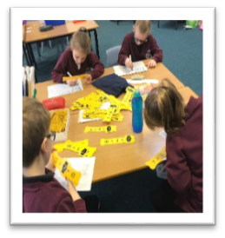

Next steps
- Continue with interventions and 1:1 supports to help close the attainment gap of those pupils in the target group (2.5%).
- Introduce the numeracy bags created this session across early and first level to further encourage parental engagement and help raise attainment through games based learning.

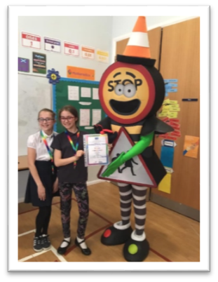
Health and Wellbeing
Progress | satisfactory | good | very good | excellent

Strengths
- We have a adopted a whole school programme for Health and Wellbeing using the Healthy Schools programme,
- All pupils are involved in assessment of the wellbeing indicators throughout the school session which allows for early identification of needs.
- The wellbeing application tool is being used effectively to highlight individual needs, set targets and assist with a multi-agency approach to meeting children’s needs.
- Discussions around pupil wellbeing at pupil progress meetings are more greatly informed following individual assessment work around health and wellbeing.

Next steps
- Include within the assessment pathway, opportunities to meet with focus groups to keep assessment of wellbeing indicators current and relevant for all children.
- Attend whole staff training, led by Nurture UK on the key principles of nurture to be implemented across the school.
- Set up, within the school, an area where pupils will be supported in small groups to promote wellbeing, resilience and managing emotions.

Employability Skills/Positive Destinations
Progress | satisfactory | good | very good | excellent

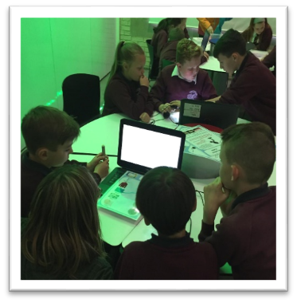
Strengths
- Most pupils across the school are able to determine the skills they are working on throughout their school day and can articulate these during plenary sessions.
- All children are encouraged to reflect upon their learning in relation to skills for learning, life and work.
- Our pupil leadership teams for children at all stages have developed key principles of participation.
- Pupils, particularly at P5-7 are highly skilled in self-evaluation and can identify next steps in learning.
- Our creative choice champions from P7 are able to lead learning while setting clear learning intentions for pupils and are skilled in offering feedback to their peers.

Next steps
- Continue to work with pupil leadership teams for continuous improvement at Braehead Primary School.
- Further embed individual target setting through the introduction of personal learning plans for all pupils to be reviewed and discussed with parents.

Overall quality of our learners’ achievements
Highlights of session 2017-18
Session 2018-2019 has been a very busy session indeed with many highlights. We welcomed 2 children into our Primary 1 in August taking our role to 40 pupils.

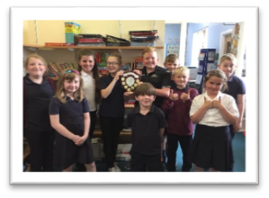
Pupil Leadership
Pupil leadership is widely encouraged at Braehead Primary. The session started with the election of House Captains for our newly created House Teams. Following consultation with staff and pupils it was decided that we wanted our Houses to reflect the village of Braehead and be more meaningful to the school community. The final decision was to name the House Teams; The Moss, Tashieburn, Winnieknowe and Shodshill which are widely known areas of the school catchment. All school captains this session came from Primary 7 with 2 captains for each house. The children do a wonderful job in helping their teams gain more points by encouraging them to display our school values. They have been highly competitive throughout the year and were keen to see who would be awarded winners of the House Shield for 2018-2019 – well done to The Moss!
Creative choices provides an opportunity for pupils in P7 to lead learning with the younger children in the school. Over the course of the session the children have each led many different activities ranging from cooking, sports, den building, outdoor learning and crafts to name a few. These master classes planned, delivered and reviewed by the senior children enables pupils to showcase their skills and talents while developing leadership skills. Children are capable of set learning intentions and success criteria for their sessions and regularly provide feedback to learners to help them further develop their skills and talents.

Lanark Learning Community Competitions
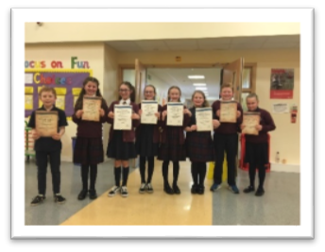
Braehead entered a team of pupils into Lanark Grammar School’s Spelling Bee and we were delighted to win second place – a fabulous achievement for our small school. Later in the year we entered two teams in the Rotary Quiz which this year saw a record number of schools from Lanark Learning Community participate in. This event took place in February in Robert Owen Memorial Primary School.
Once again the children were fabulous with one team missing out on the top spot by one mark!

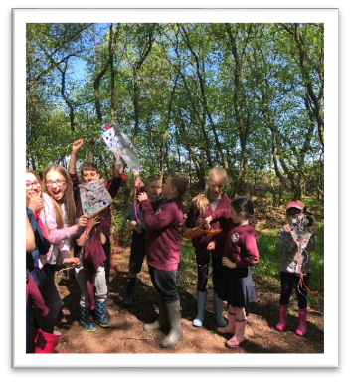
Outdoor Learning
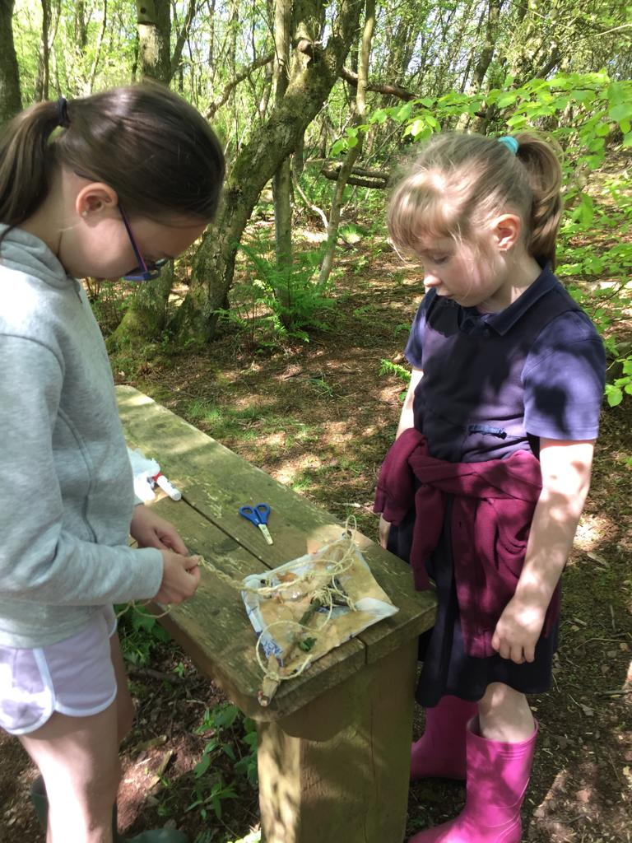
Our local area provides the perfect stimulus for Outdoor Learning as we are situated in front of Braehead Moss. Outdoor Learning once again has contributed to learners’ successes and achievements. Both classes use the woodlands in Braehead Moss to develop pupil skills in working collaboratively, assessing risk, creating and building as well as to enhance learning in teaching across the curricular areas. The outdoors really brings learning to life for our pupils who thrive on the challenges it presents. Careful planning and differentiation ensures learners’ individual needs are met and appropriate challenge is presented to ensure progression of skills at all levels. We increased the provision of outdoor learning this session with pupils visiting the woodlands every week.

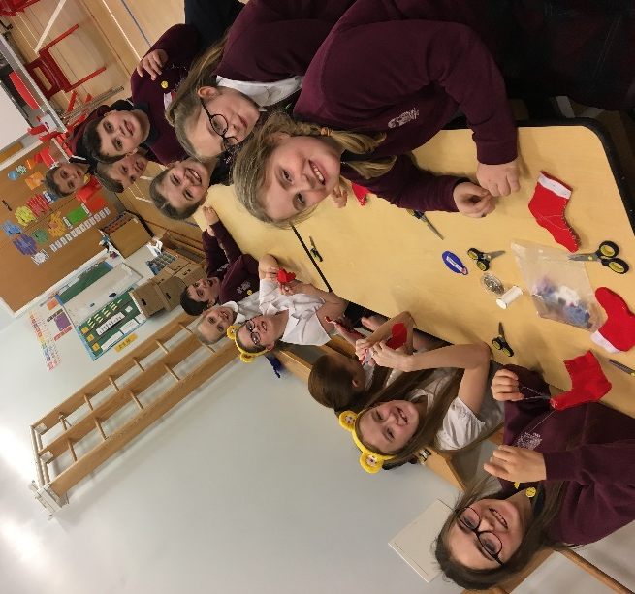
After School Clubs
Due to the rural location of Braehead we have tried to provide a wide range of lunch and after school clubs. This session we have successfully held Dance, Multi-Sports, Sewing and Netball clubs. These clubs are well attended and run by teaching staff or South Lanarkshire Leisure. We look to further increase this provision next session.

Whole School Celebrations

Braehead Flower Show kick started our new session with all children having their work on display. We had been looking for opportunities to get more involved with local community groups and this was the ideal situation. It was great to see the children interact with members of Braehead Rural Group and from now on we will contribute to the syllabus for this event to ensure we can participate as fully as possible.

In our attempts to do something a bit different at Christmas we had the children from all 3 teaching areas performing songs, drama, poetry as well as some whole school songs at out Step into Christmas performance. The children, as always, were excellent – really giving it their all! There was a lovely festive atmosphere in the school and the event raised £409.83 – amazing!

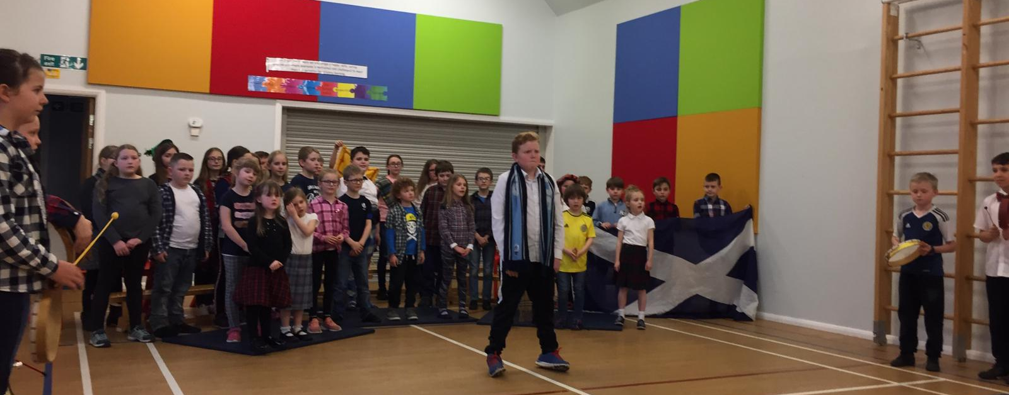
Our Scottish Celebration on 25 January allowed our pupils to showcase what they had been learning in school – there were songs, drama and poetry which provided an opportunity for every child in the school to shine. Once again parents were keen to express how much they had enjoyed the event and we look forward to a similar programme next year.

Our summer celebration entitled ‘Braehead Reunion 2049’ involved the whole school performing songs and memories of their time at Braehead Primary. Along with the pupil awards ceremony and farewell to our Primary 7 children this was an afternoon filled with special memories.

World Book Day
To promote reading for pleasure as part of our World Book Day Celebrations this year we held a Readathon for all pupils. Children brought their novels from home as well as some comfortable pillows and blankets and turned the hall into a cosy reading space. This has been voted as one of the highlight for the children and will definitely feature more often in the new session. Here is what some of the children had to say:
I liked the readathon because you got to relax.
Sebastian P3
I like Mrs Wallace reading the stories.
Danica P3

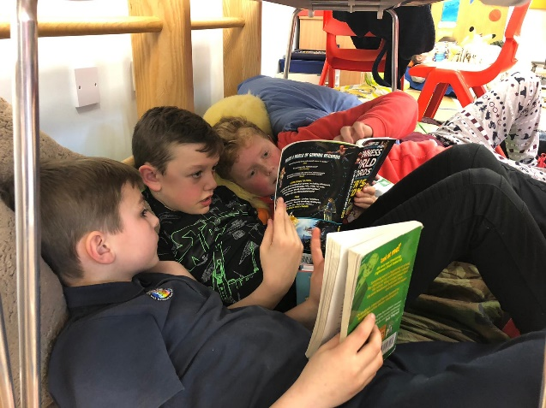
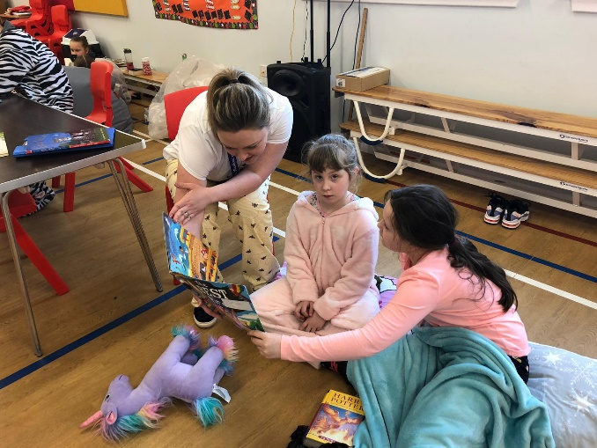

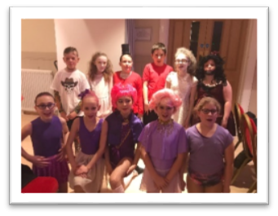
Community Sporting Events

Once again we took a group of keen dancers to the Clydesdale Dance Festival where they performed a number from ‘The Greatest Showman.’ It was both creative, skilful and greatly enjoyed by everyone who took part.

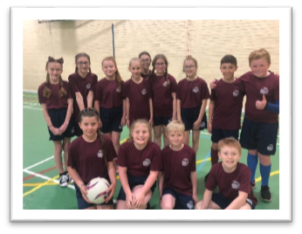
The spring and summer terms have provided lots of opportunities for the children to participate in sporting events within Clydesdale. For the first time we decided to participate in the Fun 5z Netball Festivals throughout the year which ends with a tournament for Lanark Learning Community at which Braehead were runners up.
The small schools’ cross country event was uninterrupted by snow this year! Once again we took all children from P4-7 and were delighted to take home 10 medals from the event. As well as an individual bronze and individual silver for the P5 boys we won individual silver and bronze for P6 girls and an overall team gold for P6 girls and bronze for P7 girls teams.

The football tournament held at Lanark Racecourse was a 7-a-side event for pupils in P4-7. The sun shone as did the children of Braehead. The worked hard as a team to draw or win all their matches finishes the event in third place. Once again our new school kits were modelled by the children raising their confidence while promoting school identity.
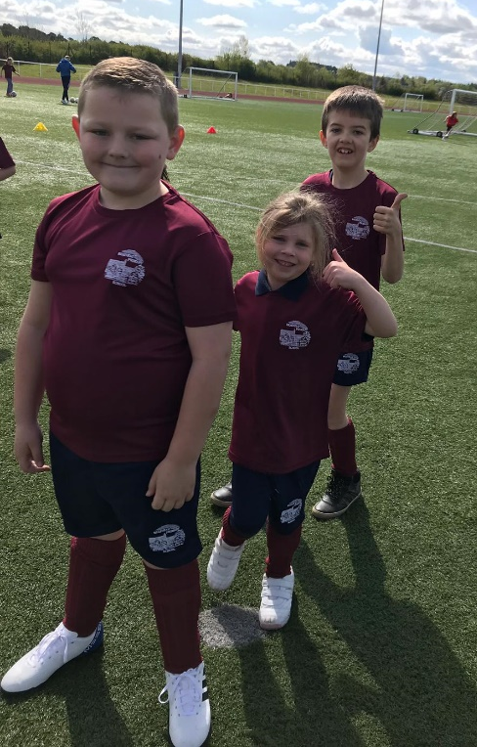
The following week our P2/3 participated in a fun skills festival at John Cummings Stadium in Carluke where they learned some new football skills and took part in some fun 5-a-side games.

The annual triathlon proved to be another fun-filled event. Held in Carluke, it featured a swim, cycle and run for all pupils in P5-7. While enjoyable to participate in these events have been worthwhile in allowing our children to get to know other pupils in Lanark Learning Community and to build links, particularly with the pupils from Carmichael Primary School in preparation for going to Lanark Grammar School.

Our Health week in June was a wonderful way of celebrating all things sport, health and wellbeing. The children participated in daily fitness programmes, work around sexual health, relationships and parenting, dangers associated with substance abuse and enjoyed a visit from a paramedic.

Comment on strategies that have been successful in engaging with children and young people, staff, parents and the wider community and the impact of these.

This session has been filled with many events and strategies to promote engagement across the whole school community. Some of the highlights of this session include:

Improved Communication
In our bid to share learning experiences more widely with parents we have extended our communications by including Twitter and Facebook. Both are closed groups which are used to share experiences, successes both in and out with school and wider achievements thus embracing the four contexts for learning. Parents value the information shared and are grateful to see what is happening in school as a means of further engaging with their children at home to help extend and consolidate learning from school.

Assessment Pathway
In response to parental questionnaires around understanding when and how primary children are assessed we created an assessment pathway for pupils from Primary 1 to Primary 7.This pathway clearly identifies what will be assessed and when. Parents are keen to be involved in their child’s learning and having this information provides them with a greater understanding of the assessment process.
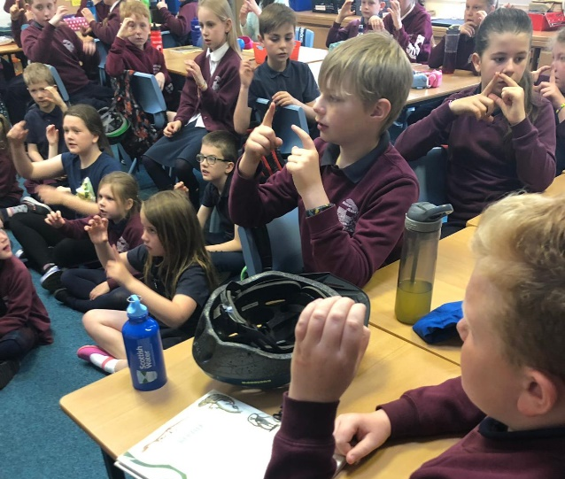
Sign Language
As a school, we have decided that our third language in prepration for the full roll out of 1+2 will be British Sign Language. Mrs Macrae is currently carrying out professional learning, which will be rolled out to all teaching staff to help support pupil learning in sign. The children started this in the summer term this session and have been so quick to embrace it, teaching what they have learned to the younger children and performing a song with accompanying sign language at the summer celebration. We very much look forward to seeing this continue to develop at Braehead.

Outdoor Learning
Outdoor learning continues as an area of strength for our school and motivates and engages all children. The pupils from P1-P7 thrive in the outdoor learning environment of Braehead Moss and use this space as an extension of the school in terms of further enhancing experiences and outcomes throughout our weekly visits.
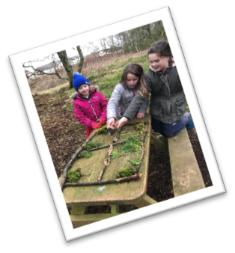
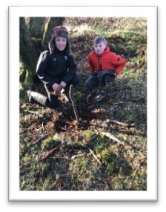
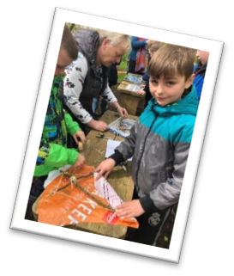

Writing
All permanent teaching staff have been trained in Talk 4 Writing this session and have begun to implement the strategies particularly around imitation, innovation and invention at stages P1-3. All pupils in these stages have been motivated and engaged by the use of the story maps, ‘saying the story’ has improved use of story-telling vocabulary and having the opportunity to create their own maps and stories from an original tale has helped not only with maintaining enthusiasm and interest but also in the story structure. We will continue to roll this out throughout the school and look to have this fully embedded by session 2020-2021 with all staff having undertaken the necessary training.

Readathon – World Book Day 2019
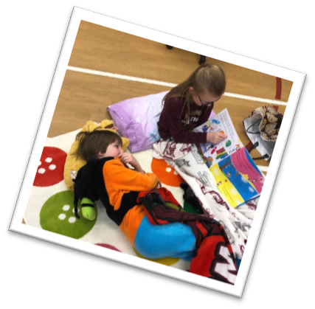
We participate annually in WBD but this year had something different….We held a readathon in the hall for all pupils at which they could bring along a reader from home to read themselves, they could share a text with friends that they were enjoying or they could come along and listen to adults reading if they preferred. Allowing for personalisation and choice meant all children were keen to participate, even reluctant readers as they felt they could listen rather than read. This had us thinking on how we can continue to provide that motivation for pupils to read for pleasure and we are delighted to include this fortnightly within out timetable for pupils to enjoy. Any exposure to literacy rich environments is worthwhile if it enhances pupil enjoyment and engagement.
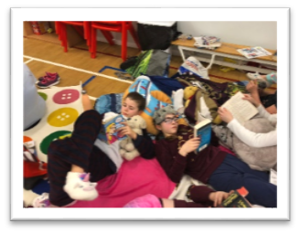

STEM Event with Lanark Grammar School
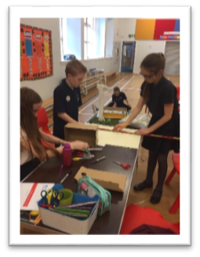
Our Primary 7 pupils were invited to attend a STEM transition event at Lanark Grammar School this session. All primaries within the learning community were participating and we felt this would be a good opportunity for our pupils to make new friends and become familiar with the secondary learning environment. The event asked the groups to consider energy saving methods in our school and they were tasked with creating a model and a plan to fulfil this task. All pupils worked collaboratively showcasing excellent creative skills. Their models and presentations were well delivered and highly commended by the external judging panel. This opportunity allowed the children to work to a specific design brief with deadlines – an excellent experience as they prepare for their next steps at Lanark Grammar.

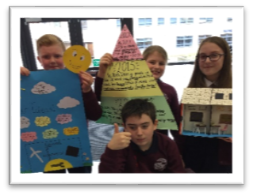
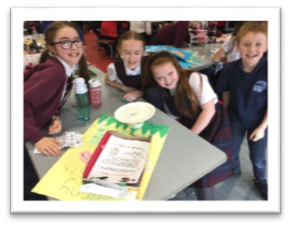

Curriculum Rationale – Revisiting our Vision and Values
Our work on curriculum design and rationale led us off in another direction this term as we carefully considered the importance of our school vision and values and how these ultimately underpin the work of the school and therefore inform our curriculum rationale and design. Parents and pupils were invited to consider what makes Braehead unique, the statements they feel should be incorporated in the school’s vision and the values relevant as we aspire to develop the ‘whole child’. Staff were involved in a similar exercise however their task included analysis of attainment data, SIMD information and other intelligence to inform how we proceed. We are delighted with our new vision:

Our vision at Braehead Primary is to provide a positive and engaging learning environment which challenges and supports all children to be the best they can be.

Feedback from pupils indicated they felt there were too many values similar in nature – our aim as a school community was to consider what we all felt were the most important values to instil in our pupils to enable them to develop as successful learners, effective contributors, responsible citizens and confident individuals. We believe we will do this by promoting 3 core values of kindness, ambition and resilience.

Quality Indicator | How are we doing? | How do we know? | School Self-Evaluation
1.1  Self-Evaluation for Self-Improvement | Theme 1: COLLABORATIVE APPROACHES TO SELF-EVALUATION  - Self-evaluation is an integral part of the school’s improvement calendar.  - Opportunities for staff, pupils and parents to participate in self-evaluation for continuous school improvement are planned throughout the session.  - An initial SWOT analysis of the school identified areas of strength and areas for improvement. Following that we issue an HMIe style questionnaire for parents to provide their views.  Theme 2: ANALYSIS AND EVALUATION OF INTELLIGENCE AND DATA  - Within the school and wider learning community all staff regularly engage in moderation activity where agreed standards and expectations have been reached.  - Attainment data, formative assessment and staff professional judgements inform interventions undertaken to ensure greatest impact on all learners.  - Pupil progress meetings provided opportunities for staff to discuss attainment, interventions, target pupils and ensure attainment and achievement of all remains a priority.  - An electronic tracking and monitoring system is in place which provides valid, current information on attainment in literacy and numeracy of all learners.  Theme 3: ENSURING IMPACT ON LEARNERS’ SUCCESSES AND ACHIEVEMENTS  - Our quality improvement calendar outlines a rigorous approach to self-evaluation at all levels. This is adhered to and continually informs future practice. | Theme 1: COLLABORATIVE APPROACHES TO SELF-EVALUATION  - Our quality improvement calendar ensures continuous self-evaluation to ensure the highest quality learning and teaching.  - Staff regularly engage with HGIOS 4 to ensure our self-evaluation is current.  - A School Improvement Team has been established for parents and pupils which provides a platform to discuss improvements required particularly those arising from the HMIe questionnaires.  Theme 2: ANALYSIS AND EVALUATION OF INTELLIGENCE AND DATA  - Within the school and across the wider learning community there is a strong ethos of sharing practice and peer support.  - Pupil progress meetings provide the platform for discussions around attainment, support and challenge. All staff are committed to ensuring this has the interests of the pupils at heart. This has been extended this session to include health and wellbeing.  - All staff write evaluative statements for literacy and numeracy at the end of each planning block; these outline progress made, by how many, how much and a clear direction for moving forward.  Theme 3: ENSURING IMPACT ON LEARNERS’ SUCCESSES AND ACHIEVEMENTS  - A range of assessment techniques are used to measure children’s progress across the curriculum.  - An assessment pathway is in place for all learners.  - Children are beginning to engage in reviewing their learning, further work on this is required. | Very Good
1.3  Leadership of Change | Theme 1 – developing a shared vision, values and aims relevant to the school and its community  - Our vision statement and values were reviewed this session with all stakeholders and a new curriculum rationale developed reflective of the work that goes on in Braehead.  - All staff and most children are aware of the values and reference is made to them regularly in the life of the school and visible on school displays and correspondence. Further work on living these values is ongoing.  - Weekly assemblies allow us to focus on bringing the values of the school to life.  - Our parent council is very active and supportive. A subgroup has been formed from the parent council and now meet with the HT as a School Improvement Team when required.  - All staff are committed to achieving the highest possible standards based on their clear understanding of the social, economic and cultural context of our children and families in the school community. This has also helped shape our new curriculum rationale.  Theme 2 – strategic planning for continuous improvement  - School Improvement priorities are shared with the parent council and parent forum annually. A School Improvement Team has been established this session to evaluate practice and set future priorities.  - Regular updates on school improvement appear in the weekly newsletter.  - The pace of change is managed to ensure time to embed and evaluate impact.  - The school calendar allows time for self-evaluation with all stakeholders.  - All teaching staff have taken part in CLPL to support writing evaluative statements to aid the planning and identification of next steps for learners.  - All teaching staff engage with HGIOS 4 regularly to facilitate self-evaluation and identify areas for improvement.  Theme 3 implementing improvement and change  - All teaching staff work collaboratively on self-evaluation, reflecting on the SIP priorities and progress within these.  - All staff are committed to professional development which impacts directly on learning and teaching.  - All staff frequently engage in professional discussions around learning and teaching and are keen to lead and support their colleagues in areas where they feel they have strengths.  - All staff have leadership roles across all areas of the curriculum as well as the wider life and ethos of the school. | Theme 1– developing a shared vision, values and aims relevant to the school and its community  - Most pupils are aware of the school values and what these mean for them as Braehead pupils. Almost all pupils behave in a positive, respectful way.  - Parents report the school has a happy, safe, welcoming environment.  - All teachers regularly reflect against the standards in an ongoing manner, and strive at all times to meet the needs of all learners.  - Planned pupil progress meetings with staff have allowed for early identification of any concerns.  - Appropriate interventions are implemented to ensure the best possible outcomes for our learners. These are continually reviewed to ensure they remain relevant.  - Staff members take an active role in leading improvement across curricular areas. Pupils lead master classes in the form of Creative Choices and are actively involved in pupil committees across the school. This has led to an increased understanding of leadership roles within the school. This has also developed pupils’ confidence.  - Staff actively participate in teacher leadership  modules which increases their knowledge and understanding of leadership styles and leading change in a primary school.  - Our curriculum rationale is fully reflective of our school community and with be reviewed annually to ensure this is current.  Theme 2 – strategic planning for continuous improvement  - Regular engagement with self-evaluation informs future change. This guarantees staff have a shared understanding and ownership of the priorities needed to take the school forward and build the school improvement plan.  - Staff report confidence in writing effective evaluations. This has allowed them to identify next steps for learners and be more reflective in their practice.  Theme 3 implementing improvement and change  - All staff have a sound awareness of the National Improvement Framework and how this links with our SIP.  - The priorities within our SIP are based on self-evaluation and data.  - All staff engage in professional dialogue, professional learning and share knowledge, experience and resources. PRDs reflect personal and school targets and are linked to GTCS Standards to ensure maximum impact on learners. | Very Good
2.3  Learning, teaching and assessment | Theme 1 learning and engagement  Almost all children actively participate in their learning and show high levels of engagement.  - The majority of children demonstrate a level of resilience when faced with challenge or constructive feedback.  - All staff plan differentiated learning experiences which are appropriate for almost all children.  - P7 pupils choose, plan and lead a block of sessions around a ‘Creative Choice’ for the whole school to select and participate in.  - Formative assessment is used by all staff to inform pupils of next steps in learning and to promote independence.  - Almost all children are making good progress over time and are confident and responsible citizens.  Theme 2 quality of teaching  - Learning intentions and success criteria are always shared either orally or in writing with the children to help them understand what success looks like and how they too can be successful.  - Feedback is provided in line with the success criteria to help learners understand how they can improve. All staff use feedback to alert learners of next steps.  - Questioning is used effectively to support and challenge most pupils. All staff are using questioning to enable higher order thinking skills.  - The use of digital technology to support learning is an area of strength at all stages.  Theme 3 effective use of assessment  - Moderation activities between Braehead and Carmichael Primary and within Lanark Learning Community have allowed staff to fully engage in professional dialogue around standards and expectations in writing and listening and talking.  - Almost all staff are confident in using assessment information/data to support learners’ next steps in learning and ensure appropriate learning needs are being met.  - Learners are keen to discuss their learning and can do so at a high level.  - A pathway for assessment has been created for Braehead based on a clear rationale, identifying what and when will be assessed to allow for continuous progression and on early identification of needs.  Theme 4 planning, tracking & monitoring  - Pupil progress meetings are held with all teaching staff at regular points in the session to help review and evaluate progress of all learners.  - As a result of monitoring and evaluating learners’ progress we have clearer information on attainment within literacy and numeracy.  - A tracking system is in place which informs us of personal data, attainment, participation, engagement in learning and wider achievements.  - Support is in place for pupils and is based on the professional judgement of staff and intelligence from formative and summative assessment. | Theme 1 learning and engagement  - Classroom observations and participation in professional dialogue evidence very good quality learning and teaching with appropriate pace, challenge and differentiation for almost all learners. This was further commented upon at our VSE and HMIe inspection (January 2018)  - Pupils use language to encourage and develop a growth mindset which in turn is helping build resilience in most pupils.  - Almost all children receive appropriately challenging and enjoyable learning experiences, and these are increasing opportunities for learners to exercise their own choice within some curricular areas.  - Planning to meet the needs and abilities of all learners is evident through classroom observations, forward planning and daily planning.  - Parental feedback reports the advantages of a multi-composite setting for pupils and opportunities for differentiation. Parents commented:  “Differentiated levels on offer particularly in Maths and Literacy”  “Multi-composite classes can encourage and stretch learners.”  - Plenary sessions, feedback both orally and in jotters help children identify next steps and promote independent learning.  - Tracking and monitoring of literacy and numeracy shows consistent progress over time.  Theme 2 quality of teaching  - Learners are able to articulate what they need to do to improve. The impact of this can be seen in their ability to reflect on themselves as learners and in their resilience.  - Classroom observations show effective use of digital technology to enhance and motivate learners throughout the school.  - Pupils from P5-7 are highly skilled in working collaboratively to complete tasks.  - Through classroom observations, jotter monitoring and learner conversations, pupils are clear on their areas of strength and areas they are working to improve on.  Theme 3 effective use of assessment  - Moderation activities across both schools and within the Lanark Learning Community are building staff confidence in progression within and achievement of a level. This leads to clearer next steps for learners and is resulting in more accurate teacher judgements.  - Peer and self-assessment is evident across the school. This is helping learners become more aware of areas of strength/areas to work on.  - Opportunities for assessment are planned at identified points throughout the session and data is gathered for analysis to ensure learning and teaching is matched to learners’ needs.  Theme 4 planning, tracking & monitoring  - Using the SLC tracking system, informed by other data including SIMD, FME and ASN information, staff identify the most vulnerable pupils in their class and provide appropriate support and strategies to increase attainment and achievement.  - Tracking and monitoring allows us to track attainment of individual pupils over time and intervene as early as possible where required and secure improved outcomes for all learners. | Very Good
3.1  Ensuring wellbeing, equity and inclusion | Theme 1 WELLBEING  - Almost all pupils in the school demonstrate positive behavior and are happy in school.  - Learners are developing knowledge and vocabulary associated with children’s rights and how these relate to the wellbeing indicators.  - Parental feedback states the school is a strong part of the community. The school are actively looking for ways to become more involved with local groups.  - Planning for individual needs is recognised and adhered to in Braehead. Plans are shared with pupils and their views as well as their parents’ views are sought at regular intervals.  - Wellbeing indicators are looked at through a monthly focus with opportunities identified for exploration at early, first and second level.  - Our local environment is used to support outdoor learning which develops skills for learning, life and work and wellbeing.  - The school has a very welcoming, nurturing ethos where all staff are committed to ensuring the wellbeing of all learners.  Theme 2 FULFILMENT OF STATUTORY DUTIES  - Staff are aware of key documents. statutory duties, code of conduct, GTCS standards, Child Protection and are committed to the principles of GIRFEC.  - Provision for staff to undertake professional learning around statutory requirements is incorporated within the working time agreement.  - All staff are committed to best practice which maximises the impact wellbeing can have on attainment and achievement.  Theme 3 INCLUSION AND EQUALITY  - Most pupils are supportive and inclusive of their peers. This is evident in the care and compassion they show one another.  - Staff are confident in identifying barriers to learning and regularly reflect on strategies to support these.  - All teaching staff are aware of data around ASN, SIMD and FME and we use this information, along with our knowledge of each individual learner and their families to ensure inclusion and equity which impacts positively on all.  - Support for learning is actively reviewed following pupil progress meetings and discussions with school support assistants.  - All staff have been trained on ASD Lens and had experience on planning to meet learners’ needs. | Theme 1 WELLBEING  - Parents and pupils report that pupils feel safe in school and pupil/staff relationships are positive.  - Growth mindset is encouraged and most pupils are confident and resilient. Feedback on pupil learning also reminds children of the principles of growth mindset.  - The majority of pupils demonstrate an understanding of the wellbeing indicators and can use these to evaluate their own wellbeing.  - Staff are responsive to any allegations of bullying and will always support positive outcomes.  - External agencies are used to support wellbeing and individual families identified within staged intervention.  Theme 2 FULFILMENT OF STATUTORY DUTIES  - Annual child protection update at the start of each session for all staff provides staff with confidence to act on any concerns.  - Pupil Progress meetings are held termly to allow for early identification of pupil needs in line with GIRFEC.  - Supports are in place to meet pupil needs: effective planning, ASPs, time with Specialist Support Teacher, interventions, School Support Assistant timetables.  - Very clear school procedures and where possible multi-agency support, have ensured care and welfare concerns are addressed as a priority. These are dealt with sensitively and confidentially.  Theme 3 INCLUSION AND EQUALITY  - Staff are able to identify most vulnerable learners and discuss how they are adapting learning and teaching to meet needs, ensuring progress for all.  - The curriculum offers all learners opportunities to recognise and value diversity and challenge discrimination.  - Differentiation to meet the needs of all learners within a multi-composite class was praised during a recent VSE and HMIe.  - Regular review and evaluation of additional support plans confirm progress and identify next steps to support our most vulnerable pupils. | Good
3.2 Raising attainment and achievement | Theme 1 ATTAINMENT IN LITERACY AND NUMERACY  - Our CfE levels show attainment in reading, writing and listening and talking is good with most learners achieving at the expected levels and some exceeding this.  - Interventions to support literacy have had a very positive impact for most pupils involved.  - There is a clear focus on raising attainment in literacy within the school improvement plan.  - Our CfE levels show attainment in numeracy is very good with almost all learners achieving at an appropriate level and some exceeding this.  - Attendance levels for almost all children are very good.  Theme 2 ATTAINMENT OVER TIME  - Attainment in literacy and numeracy has demonstrated added value for most learners however due to the small numbers this is not always reflected in overall attainment figures.  - Staff engage with the benchmarks for literacy and numeracy to support planning and making professional judgements on learners’ progress, next steps and achievement of a level.  - A number of tracking approaches are used by class teachers to monitor progress in literacy and numeracy, these are used to help inform teacher professional judgements.  - The school use SLC tracking and monitoring tool to ensure consistency across the local authority.  - Assessment data is shared across stages and at transition time from primary/secondary to ensure continued progressive learning.  Theme 3 OVERALL QUALITY OF LEARNERS’ ACHIEVMENT  - Most learners are confident and successful.  - Our learners have opportunities to exercise responsibility and contribute to the life of the school through pupil committees, creative choices and the life of the school.  - Achievements within and outwith school are recorded, recognised, and celebrated at our Wider Achievements Assembly and displayed on our achievement wall and folder.  Theme 4 EQUITY FOR ALL LEARNERS  - Braehead is a very inclusive, supportive environment.  - Support for learners is allocated according to need in order to raise attainment for all.  - The attainment gap is carefully analysed to ensure support is allocated where required.  - Opportunities for pupils to develop their skills across the learning community are offered to pupils as appropriate. | Theme 1 ATTAINMENT IN LITERACY AND NUMERACY  - Tracking, which reflects assessments and professional judgements, is showing progress over time for most learners in literacy and numeracy.  - Catch Up Literacy and 5 Minute Box for Literacy and Numeracy have led to an increase in attainment for most of the targeted group.  - Approaches to literacy teaching have been reviewed to allow more active engagement in literacy.  - Development of higher order thinking skills and reciprocal reading continues to impact positively on learner motivation, and independence.  Theme 2 ATTAINMENT OVER TIME  - Attainment is discussed and reviewed termly with the Head Teacher during Pupil Progress Meetings which results in dialogue and action planning around meeting the needs of all learners.  - Where necessary, interventions are put in place to remove barriers to learning and support learner engagement, achievement and attainment. These interventions are reviewed regularly with the Class Teacher and School Support Assistant to evaluate appropriateness for each learner and to identify next steps.  - Learning is matched to needs for almost all pupils which results in relevant learning experiences.  - Our tracking tool allows us to look at groups of children within each stage, helps inform decisions on achievement of a level based on assessments and professional judgements and monitor progress over time for individuals and groups.  Theme 3 OVERALL QUALITY OF LEARNERS’ ACHIEVMENT  - Throughout the school year learners contribute to the life of the school through Pupil Committees, House Captain duties, involvement in community events and Creative Choice Champions which allows them to develop the 4 capacities and their leadership skills.  Theme 4 EQUITY FOR ALL LEARNERS  - Pupils feel safe and valued in school, this is reported in their wellbeing self-evaluation, their SWOT analysis of the school and in the pupil HMIe questionnaires.  - Individual learning needs are being met for almost all pupils. | Good (Literacy)  Very Good (Numeracy)

Overall evaluation of establishment’s capacity for continuous improvement
Having an additional class teacher for session 2018/2019 has had a very positive impact on all our learners at Braehead. Having the flexibility to decrease the number of stages in each class has really allowed us to support and challenge all learners across the school which has improved attainment, particularly in writing which we will continue to work on.

Having undertaken training in Talk 4 Writing and Active Literacy across this session we feel equipped to further embed this practice at all stages. Targeted approaches to improving attainment in writing at specific stages will remain a priority moving forward.

Work undertaken in Lanark Learning Community regarding Listening and Talking provided an opportunity for staff to self-evaluate and consider approaches to delivering listening and talking skills progressively across all stages and as a result we will look further at this, ensuring it is appropriate and relevant for our setting.

Leadership continues to develop across the school with all staff having responsibility for leading improvement. Mrs Macrae attended the newly established Leadership Academy run by myself, Mrs Crook, HT Lanark Primary School and Miss Pollok, DHT Lanark Grammar. This gave all in attendance an opportunity to network with fellow middle leaders and consider the implications and leadership styles required to further improve learning and teaching in our school.

Signed:

Date: June 2019

