
Black Mount Primary School
🍂 Autumn Newsletter 2026 🍂

🍂 Welcome from Mrs Shields
Dear Parents and Carers,
It's hard to believe that we've only been back at school for less than six weeks! Looking around the school, it feels as though we've packed months' worth of learning, opportunities and achievements into a very short space of time! The children have settled brilliantly into the new session, and it has been wonderful to see their enthusiasm, confidence and eagerness to learn shining through every day. There really is a lovely buzz around Black Mount just now. From new pupil leadership opportunities and curriculum developments to improvements in our outdoor spaces and technology, there is a great deal happening across the school.

Thank you, as always, for your continued support.

Lisa Shields
Head Teacher

🍁 Autumn Reminder
As the weather becomes cooler and wetter, please ensure children come to school with:
✅ A warm waterproof jacket
✅ Sturdy footwear suitable for outdoor learning and playtimes
✅ Additional layers for colder mornings
Outdoor learning continues throughout the year and being dressed appropriately helps children get the most from every experience.

🟧 Meet the Teacher Session
Thank you to all parents and carers who attended our Meet the Teacher event. We were delighted with the fantastic turnout and greatly appreciated the opportunity to welcome so many families into school. Strong partnerships between home and school are incredibly important, and it was wonderful to share our learning spaces with you all.

🟩 Our New Pergoda is Here!
We're delighted that our new pergoda has now been installed and will become an important addition to our school grounds. While it will provide a fantastic outdoor space for learning, discussion and small group activities, its role extends far beyond this. The pergoda forms part of our ongoing commitment to ensuring that Black Mount is an inclusive, nurturing and supportive environment for every child. This welcoming space will offer opportunities for pupils to take time out when needed, regulate their emotions, help build positive relationships and access support in a calm outdoor setting. As we continue to develop our nurturing approaches across the school, we know this valuable new resource will help us further strengthen our work in ensuring every child feels safe, supported and ready to learn. We look forward to seeing the positive impact this space will have for our children in the years ahead. 🍂

🟨 Pupil Voice & Leadership
Our pupil leadership groups are getting up and running, and the children have shown great enthusiasm in taking on responsibilities across the school. From House Captains representing their Houses, to supporting school improvement and community partnership, our children are already demonstrating impressive leadership skills and helping shape the future of Black Mount. Watch this space to see our leadership in action later this term!

Pupil Voice
At the beginning of the session, all pupils were invited to share their views on school life and help shape our priorities for the year ahead. Their feedback highlighted three key themes.

Firstly, the children told us how much they value opportunities to learn beyond the classroom, with educational visits and exciting experiences featuring strongly in their responses. They also expressed a desire for further investment in outdoor play, active learning and playground resources. Finally, the survey highlighted just how much they enjoy coming together for whole-school events such as Wheelie Wednesdays, Fun Fridays and Pyjama Days.

Authentic pupil voice is at the heart of life at Black Mount, and the ideas shared by our children will help inform future developments across the school. We are grateful to our Parent Council for their ongoing support in helping us turn some of these aspirations into reality!

🟧 South Lanarkshire Active Schools Clubs
We're so pleased to see Mhairi and Active Schools Clubs back in action this term with the P1-3 multi-sports club on a Tuesday after school. These clubs offer excellent opportunities for the children to stay active, develop new skills, build confidence and most importantly, have fun!

🟩 Curriculum Improvement Cycle (CIC)
This week, Mrs Shields has been out of school working alongside other South Lanarkshire headteachers to learn more about the national Curriculum Improvement Cycle (CIC), which is reviewing and refreshing Scotland's curriculum over the coming year. The aim is to build on the strengths of Curriculum for Excellence, ensuring it continues to meet the needs of children and young people both now and in the future.
While the work is still developing nationally, we look forward to receiving more information in due course and exploring how the refreshed guidance can further enhance the rich learning experiences already on offer at Black Mount Primary School. As always, our focus will remain on providing a curriculum that is engaging, inclusive and supports every child to achieve their full potential.

🟨 Improving Our Writing
Developing high-quality writing remains a key improvement priority for Black Mount this year. As part of this work, staff have been engaging with the PM Writing approach, which supports a consistent and structured progression in writing across all stages. This week, our teaching staff visited Machanhill Primary School to observe PM Writing in action. The visit provided a valuable opportunity to watch live modelled writing lessons across Early, First and Second Level classes, delivered by writing specialist Stephen Graham. Seeing expert teaching and high-quality writing approaches in real classrooms supported our staff as we continue to strengthen writing experiences for all our learners. We are excited about the opportunities this professional learning will bring and look forward to seeing our pupils grow in confidence, creativity, and skill as writers throughout the year. ✏️📚

🟧 IT Refresh
We're excited to be benefiting from the SLC IT refresh. As new devices arrive, pupils will have access to some more modern IT equipment, helping them further develop important digital skills while supporting learning across the curriculum.

🟩 Parent Council News
Our Parent Council continues to play a vital role in supporting school life, and we are incredibly grateful for their ongoing commitment and enthusiasm. Whether organising events, supporting fundraising initiatives or offering valuable feedback, their contribution helps enhance opportunities for all of our pupils. They are always keen to welcome new members. Whether you can help regularly or occasionally, every contribution is appreciated.

🟨 A Fond Farewell to Mrs Gibb
At the end of this term, we will say goodbye to Mrs Gibb as she begins a new chapter.
Mrs Gibb has been a valued member of the Black Mount family for many years, supporting generations of children and making a lasting difference to our school community through her kindness, dedication, and care. We thank Mrs Gibb for her years of service and wish her every happiness and good health as she embarks on this new chapter in her life.

🍂 Thank You for Your Continued Support 🍂
Together we continue to make Black Mount Primary School a happy, nurturing, and ambitious place where every child can thrive. Thank you for your support!
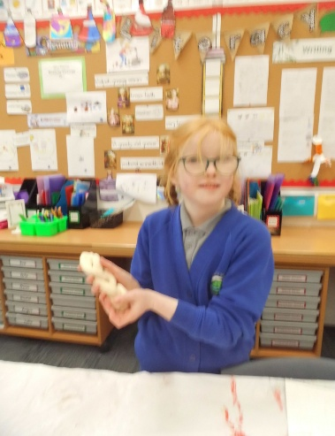
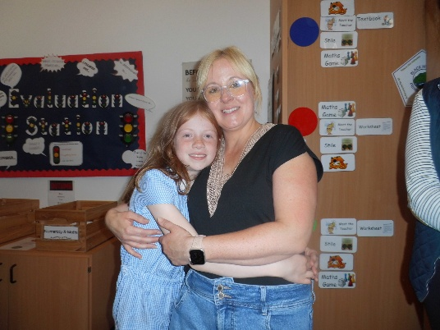
The Black Mount Staff Team
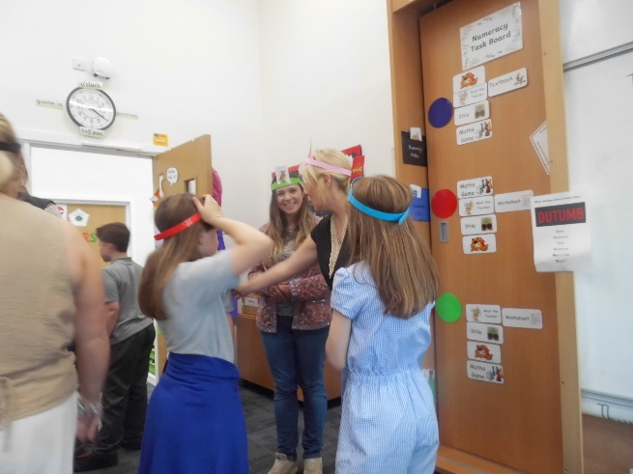


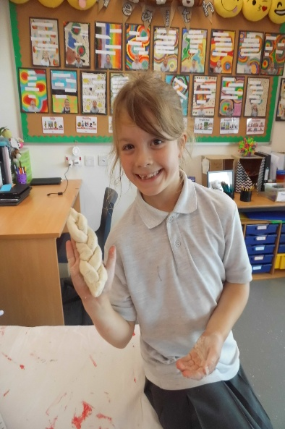
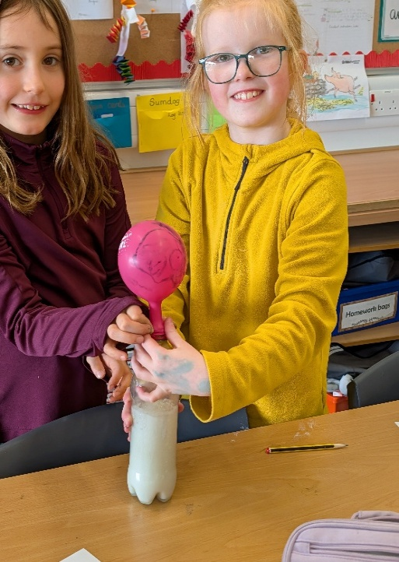
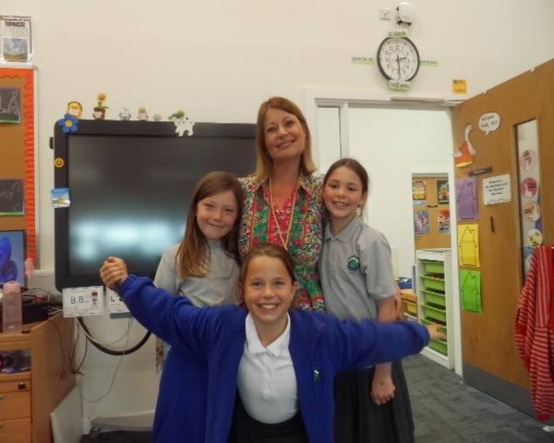
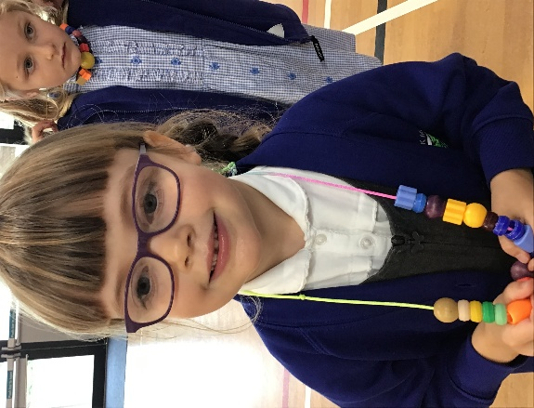
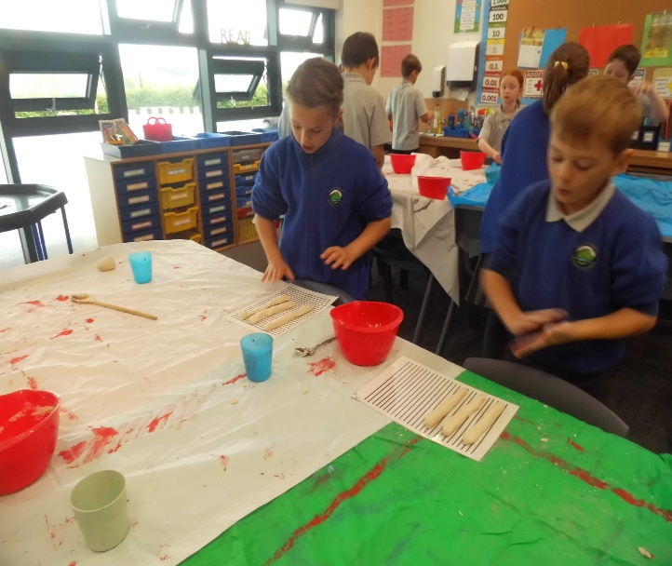
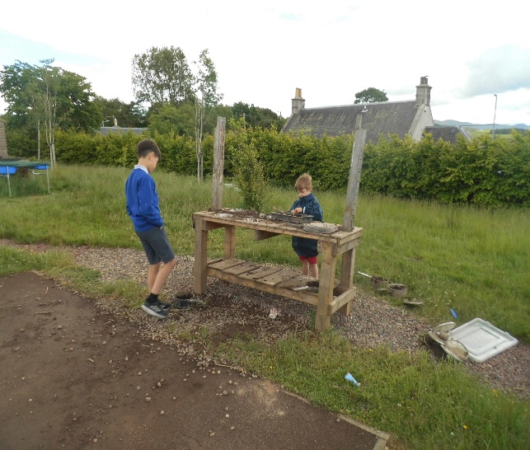
A few highlights of our term so far….

