

**Standards and Quality Report 2021 - 2022**

**Black Mount Primary School**

**Elsrickle**

**Biggar**

**ML12 6QZ**

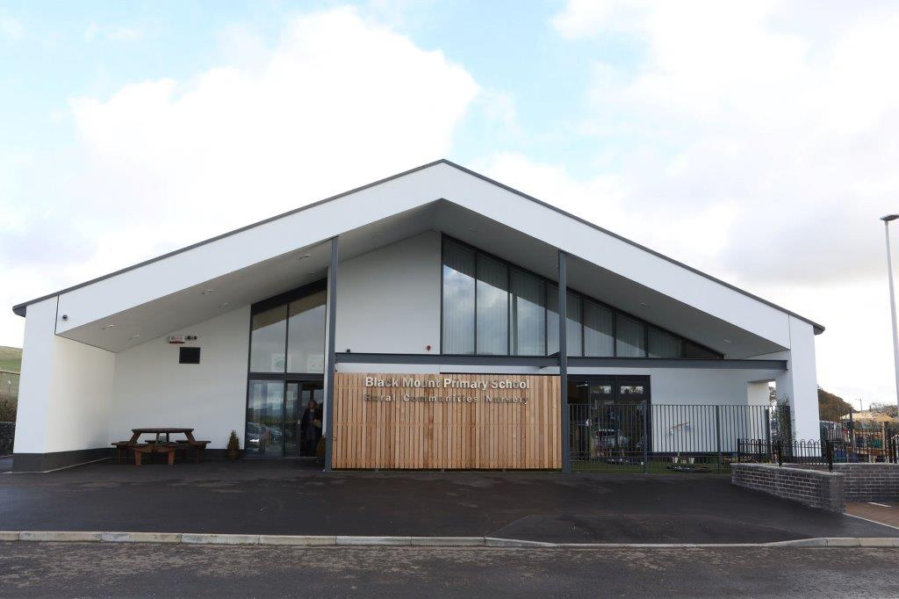

**Our School Vision**

Our vision is to provide all our pupils with education and care of the highest quality which fosters confidence; cultivates personality and talents and develops skills for learning, life and work, ensuring they achieve their full potential in a safe, happy and motivating learning environment which is at the heart of our community.



|  |
| --- |
| **Context of the school:** |
| **Our School:**  Black Mount Primary School serves the rural communities of Elsrickle, Walston, Dunsyre, Dolphinton, Candy Mill, and outlying farms in the surrounding areas. The school roll for the session 2021/2022 has been 32 organised in two multi-composite classes – a Primary 1 to 3 and a Primary 4 – 7.  The SIMD range from 4 to 9, with 6% of pupils FME. 50% of pupils are as a result of placing requests.  The school is part of Biggar Learning Community and has strong links with all feeder primary schools.  The transition to Biggar High School was able to be supported by a 3 day visit this session, along with a number of virtual activities and 3 day visits to Wiston Lodge (financed by the local Woman’s Aid).  At **Black Mount Primary** we promote an ethos of respect across the whole school and wider community. We have high expectations in terms of behaviour, attitude and effort, with every child encouraged to be actively responsible for their learning.  We **value**; Respectful Attitudes; Creativity in Individuals; Community Spirit; A Nurturing Environment and Achievement for All. These values underpin everything we do within the school and wider community.  Our **vision** is that all pupils achieve their full potential as well as developing Skills for Learning, Life and Work within an inclusive, supportive, safe, stimulating and motivating environment.  In order to realise our **vision**, we **aim** to have a clear focus on learning and teaching and provide the highest quality of teaching in order to promote the most effective learning in the core skills of Literacy, Numeracy and Health and Wellbeing. We strive to ensure pupils are provided with real contexts for learning to support their understanding of the world around them. We will endeavour to fully develop the key personal qualities of resilience, perseverance and a positive attitude to learning within all pupils. |



**Review of progress for session Aug 2021- June 2022**

|  |  |
| --- | --- |
| **School priority 1**: **Continuity of Learning** | |
| **NIF Priority** (select from drop down menus)  Improvements in attainment, particularly in literacy and numeracy  **NIF Driver**  School Improvement  Assessment of children's progress | **HGIOS?4 QIs** (select from drop down menus)  2.3 Learning, teaching and assessment  3.2 Raising attainment and achievement   * 1. 2.2 Curriculum |
| **Strategy**  **What did we set out to do?**  Black Mount Primary School will have a curriculum that is relevant and targeted to our context and needs of our pupils. Pupils and parents will be more involved in learning and have a greater understanding of what steps need to be taken to enable improvements to be made in pupils’ attainment  Pupils will be able to use their tools for writing skills in extended pieces of writing across the curriculum and will maintain a portfolio of extended pieces of writing in line with the school writing policy. Parents will have a clear understanding of the importance placed on writing at Black Mount Primary School and will have a clear understanding of the expectations across each of the stages  Pupils will develop a range of strategies to enable them to use their numeracy knowledge in real-life situations and contexts. Pupils will use skills developed in differing contexts. They will be engaged in learning across all areas of the curriculum leading to improvements in attainment  **Progress and Impact**  **What difference did we see? What did we achieve?**  Due to ongoing Covid restrictions and absences the Curriculum Rationale for Black Mount Primary School was not revisited in the session 2021/22, there for this is carried forward to session 2022/23 and its re-evaluation of what is important to our school community and thus curriculum will be addressed as a priority.  Assessment calendar reviewed and adapted to ensure most appropriate forms for assessments are being utilised. This has allowed us to implement the use of standardised assessment at two set times of the year, allowing comparison year on year which helps support teachers’ professional judgement. A range of Assessment is for Learning strategies are in use across the school, ensuring consistency of use and again supports teachers’ professional judgement.  We considered the type, timing and purpose of reporting for parents. We developed a Reporting to Parents calendar, ensuring that a wide range of reporting activities are used across the school year. This ensures that parents are regularly informed of the progress of their children.  The collection of professional judgement data has been amended from collection of On-track /Not on-track information to being in-line with Progress and Achievement levels. This data is collected at 3 times per year, ensuring pupils are working at correct levels. This has also increased staff confidence in the use of Progress and Achievement reporting tool.  A draft school writing policy has been produced. This outlines the expectations expected at all stages across Black Mount Primary School. This will be piloted across session 22/23 and will be shared with parents.  The use of the Scottish Government funded additionality has enabled small group teaching for numeracy and mathematics across the school, with a particular focus on the upper school pupils. This means most pupils are on track in Numeracy and Mathematics across the school. | |
| **Next Step(s) to inform SIP for 2022/2023:**   * Develop a Curriculum Rationale. * Training in Number Talks for teaching staff * Implement Number Talks as our primary mental maths approach * Access training in Maths Recovery programme as the preferred SLC Numeracy and Mathematics approach to the teaching and learning of Numeracy and Mathematics * Parent workshops to support numeracy and maths | |

|  |  |
| --- | --- |
| **School priority 2**: ­  **Promote the positive health and wellbeing of children & young people, parents/carers and staff** | |
| NIF Priority (select from drop down menus)  Improvements in attainment, particularly in literacy and numeracy  NIF Driver  Assessment of children's progress  Teacher professionalism | HGIOS?4 QIs (select from drop down menus)  3.2 Raising attainment and achievement  2.3 Learning, teaching and assessment  2.4 Personalised support |
| **Strategy**  **What did we set out to do?**  A nurturing ethos will be apparent in all aspects of school life and all members of the school community will be aware of the links between school values, nurture, attachment and the UNCRC  Robust Tracking and Monitoring of Pupils’ HWB  Staff are confident in promoting the HWB of all pupils  Pupil Voice will be embedded in the school ethos. Pupils will feel valued and supported  **Progress and Impact**  **What difference did we see? What did we achieve?**  School Get Together times across the year have been focused around the school values and the link between these, the Wellbeing Indicators and the UNCRC. This has developed a greater awareness in all pupils of their rights and an understanding of how the school works with them to ensure these and provides a nurturing environment in which they can learn. Monthly newsletters to parents had an Article of Month, along with details of a Wellbeing Indicator of the month and information of how we live the school values in our day to day experiences in school. School activities are also highlighted through a weekly update on the school app and recorded on our website.  … has progressed really well and it is testament to not only her but also to the teachers and staff who create the environment for her to thrive.  What a lovely email to receive! Huge well done to -----. She works super hard on her homework and is always full of determination to do her best.  We are both extremely proud of her!  The Glasgow Motivational and Wellbeing Profile completed by all pupils. All four areas were equal in scores of 34/40 apart from Autonomy at 33/40. We implemented a whole school Get Together Time and used this time to celebrate achievements from across the school. At the end of the session, Affiliation, agency and Feeling Healthy and Safe had all increased in points, however Autonomy has stayed the same.  Staged interventions are reviewed termly enabling early identification of and response to Support for Learning Needs, targeted at specific pupils. Parents have been involved in this process initially, however there is a greater need to include parents and pupils at all stages of this process.  The Boxall Profile was completed by staff for all pupils, this provided staff, along with their own observations, an in-depth picture of their pupils’ health and wellbeing. This enabled fine tuning of approaches to the teaching of HWB, along with individual interventions to ensure the best outcomes for all of our pupils. Most the pupils agree with the statement that adults look out for them in the school and all most all pupils stated they feel safe in school. | |
| **Next Step(s) to inform SIP for 2022/2023:**   * Implement daily check-ins and tracking to observe patterns * Ensure that parents and pupils who are on the Staged Intervention Process are fully involved across the school year and that their opinions are sought and recorded. * Move from a blanket profiling of all pupils to a more targeted approach using the Boxall Profile. * Consider ways in which the opinions of visitors regarding their experience of the ethos of school can be collected. * Reintroduce our Pupil Groups to enable pupil voice to be more explicit across the school and to encourage pupils to feel more autonomous within the school setting. * Continue to use regularly the GMWP to monitor pupils’ wellbeing. | |

|  |  |
| --- | --- |
| **School priority 3**: **Planning for Equity** | |
| NIF Priority (select from drop down menus)  Improvements in attainment, particularly in literacy and numeracy  NIF Driver  Assessment of children's progress  Teacher professionalism | HGIOS?4 QIs (select from drop down menus)  3.2 Raising attainment and achievement  2.3 Learning, teaching and assessment  2.2 Curriculum |
| **Strategy**  **What did we set out to do?**  Due to the small number of pupils and the nature of our ‘Gap’ we will aim to ensure all pupils have improved health and wellbeing and barriers to learning identified.  Pupils have a lack of access to wider experiences outwith the school setting due to rural isolation. The school provided a range of opportunities in order to ensure achievements across the four contexts of learning.  Pupils identified using a range of assessment data along with wellbeing and engagement information collected from teachers’ evidence. This enabled us to identify pupils who need targeted support.  CoSD group to be established – links to participatory budgeting. This will identify the 7% allocated spend which will focus on identifying the most appropriate use of this funding.  **Progress and Impact**  **What difference did we see? What did we achieve?**  The rural location of our community is a barrier to some of our pupils participating in wider out of school hours learning and leisure opportunities. This element of our Gap was also identified by our CoSD committee and there was an overwhelming majority for using this spend to provide pupils with trips to widen their experiences and which they could access with their friends.  Using teachers’ observations, along with attainment data and information gained through a number of surveys we have been able to target support for pupils with differing needs over the course of the session.  Due to the small numbers of pupils and the pupil/staff ratio this session, we have been able to provide 1:1 support as and when it has been needed. This has resulted in most pupils being on track in literacy and numeracy, including our disadvantaged pupils.  Dynamic Earth  Trip to North Berwick  Theatre Trip | |
| **Next Step(s) to inform SIP for 2022/2023:**   * Continue to monitor pupil engagement in wider school activities * Update Cost of the School Day position statement, for session 22-23 | |

|  |
| --- |
| **National priority: How we are ensuring Excellence and Equity?** |
| **Strategy**  **Brief commentary on context and identified barriers to learning which affect progress and attainment, key interventions undertaken**  We recognise the rural location of our community as a barrier to our children participating in wider out of school hours learning and leisure opportunities.  We have a pre-loved clothing rail which has also includes special event clothing at appropriate times, such Halloween and Christmas. We have ensured that we have a wide range of inclement weather clothing for pupils use across the school as and when is needed.  We have been able to provide free of charge; a range of educational visits for all pupils; swimming, including travel, free to P4 - 7 pupils and all school equipment including stationery.  We considered how to further support families by signposting them to financial supports or by supporting them as a school community on a need-by-need basis/need to know basis.  We are committed to enhancing our staffing, increasing support staff hours and providing strong universal and targeted support to best meet children’s needs.  **Progress and Impact**  **What difference did we see? What did we achieve?**  A range of effective strategies are in place to ensure equity for our disadvantaged pupils.  We aimed to be ‘cost neutral’ to parents, whilst we didn’t quite achieve this, the ‘cost’ items to parents were all voluntary.  We have flexible and varied additional support timetable due to the increase of SSA hours, which support pupils’ needs with minimum impact in other curricular areas. This is important to support their self-esteem. |
| **Next Step(s) to inform SIP for 2022/2023:**   * Continue to provide appropriate support and signpost access to partner agencies * Continue to maximise potential of support assistant hours in support of attainment and achievement. * Maximise partnerships with other agencies and parents, to help continued provision of a wide and varied range of additional out of school hour activities. * Continue to minimise cost to parents of all school activities with an aim of being cost neutral |