Impact Staff confidence in teaching writing has increased.
Writing programme now in place to ensure progression and continuity.
Evidence from learning conversations indicates that pupils are more engaged in writing and are applying knowledge and understanding.
Writing attainment has increased across the school.


Standards and Qualities 24-25


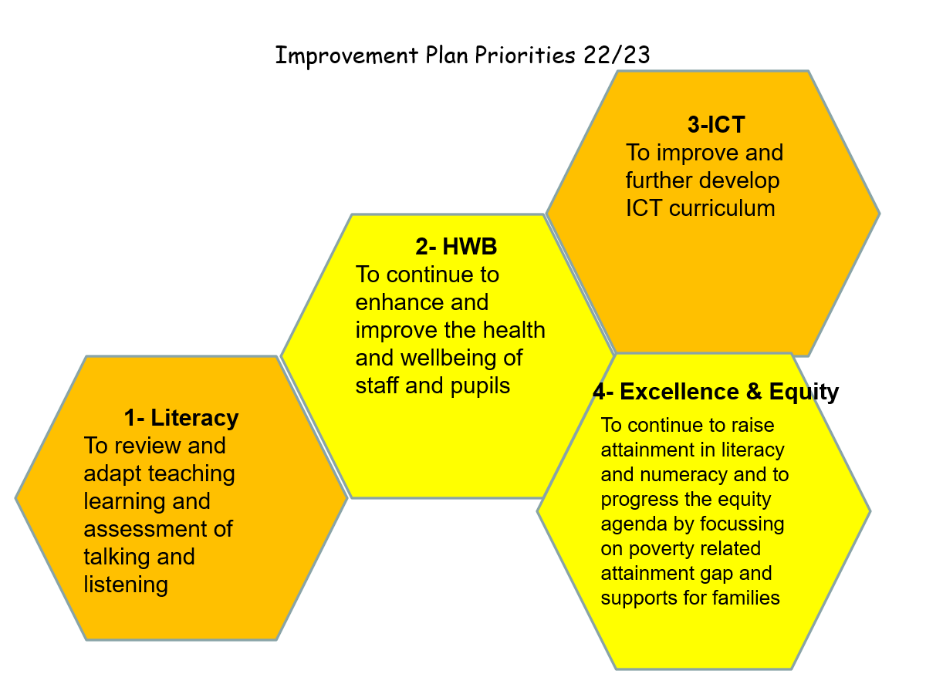
Priority 1- Literacy, School
To raise attainment in writing through continuing to engage in Explicitly Teaching Writing, Year 2

Next Steps
Full implementation of Explicitly Teaching 2 year rolling programme
Drawing on success of Improving our schools approach with Targeted Intervention groups extend system of using data to inform targeted interventions within each class, in writing.
Progress All staff participated in training for Explicitly teaching writing focussing on the following text types- description, narrative, procedure, recount and information.
Text specific marking criteria developed.
All staff piloted new text types with classes.

Impact Staff awareness has been raised in the fact, story, action approach and most staff have started to use this approach as evidenced in learning conversations.
Almost all staff are more confident in engaging in professional dialogue with colleagues and value purpose of quality assurance more having a specific focus
Almost all children improved in writing within Targeted Intervention group in relation to core writing targets.
Priority 2- Improving our classrooms/Improving our school, School
To promote collective responsibility in the use of data to inform targeted interventions to raise attainment and achievement.

Next Steps
Further extend IOS approach including:
-Fact, story, action -Diagnostic assessments -Peer visits -Identify features of highly effective practice.

Progress HT and DHT attended IOS training. 1 teacher attended training on IOC.
Writing was identified as area of focus with Targeted Intervention Groups
Differentiation was identified as feature of highly effective practice and peer visits focussed on this area for development. Member of staff worked with TIG group using IOS suggested format.

Next Steps Staff to carry out environmental audit on annual basis at start of year.
Continue to embed consistency of approach and use of language to support children to regulate emotions
Continue to gather evidence for Act to Make a Difference.
Investigate further opportunities for parental involvement in emotion coaching
Revise Anti bullying policy in line with SLC revised Treat Me Well guidance, Nov 25.
Impact Staff awareness raised in relation to frameworks.
There is now consistency of approach across the nursery and school.
Almost all parents found pilot of Emotion Coaching training to be valuable.
Environmental audits resulted in improved environments to meet children’s needs.
Priority 3- Attachment
Emotion Coaching/ Circle framework, School & Nursery
To upskill all staff using the CIRCLE Framework of Inclusion and Emotion Coaching.

Progress Almost all staff participated in training for Emotion Coaching and either Circle Framework or Up, Up and Away.
Parents involved in pilot for Emotion Coaching
Staff carried out environmental audits Links made to existing restorative practice

Evidence gathering has started for – Act to make a difference pledge

Priority 4- Building Racial literacy, School & Nursery
Raise awareness of racial literacy of staff
We want pupils to see themselves reflected in our school’s curriculum and that of others- Mirrors and Windows analogy.

Impact Staff awareness raised in building racial literacy.
Audit started on resources within school.

Progress All staff participated in building racial literacy CLPL sessions.

Pre questionnaire completed by all staff to gather baseline data
Next Steps
Extend building racial literacy to pupils within curriculum design.
Continue to purchase resources to reflect diversity and equalities including anti racist education
Engage in further CLPL.
Complete post questionnaire to measure impact on knowledge and practice.

Impact
Almost all children were able to recognise the elephant characters relating to the 4 capacities.

Priority 1
Development of ELC Curriculum rationale, Nursery

Next Steps
Continue to develop rationale through other projects eg home link Simoa
Progress
School rationale was adapted to be more age and stage appropriate and to include Simoa.
Parent awareness raised in newsletter and through display.

Impact
Awareness raised of and awareness raised of assessing and tracking children’s learning.
Improved transition data from nursery to Primary 1.
Consistent tracking approach now in place across nursery and school.
Priority 2
Introduce new tracking system, Nursery

Next Steps
Develop systems to analyse data and implement interventions where necessary.
Continue to implement tracking system and moderate achievement levels for children.
Continue to improve transition data.
Progress
All staff trained in new tracking system.
All staff engaged with system and piloted approach.

