South Lanarkshire Council: Education Resources

Biggar Primary School & ELC
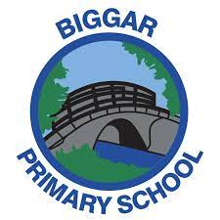

Food Policy

Related content links to UNCRC Article 3, 12, 24 and 27
Related content links to Sustainable Development Goal
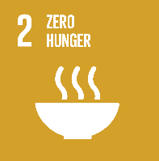

Introduction

At Biggar Primary School and Nursery, we aim to provide a wide and varied curriculum for all our children that promotes a healthy attitude towards food and nutrition. It is important this message permeates everything we do and that our agreed values relating to the serving of, and the education about food and nutrition are reflected in practice, and in decisions made on an annual, termly and day-to-day basis. A shared understanding of an effective approach to food standards will ensure a positive impact upon the health and well-being of our children, families, staff and wider school community. It is also important that our policy is inclusive and therefore will make mention of cultural diversity in relation to food. This policy will ensure consistency of approach throughout the nursery and school by making our vision and intentions relating to food standards clear.

In creating this policy, it was ensured that the Nutritional Requirements for Food and Drink in Schools (Scotland) Regulations 2020 were discussed with school staff, facilities staff, pupils and the parent council. They were also shared with the wider Parent Forum. The Learning Community was involved in creating and evaluating the policy. The policy will be reviewed and updated as required.

In summary, our aims are to
- provide our children/young people with nutritious food
- build knowledge and skills enabling our children/young people to make well informed food choices in school and beyond and
- promote good food choices in an environment that supports all children and young people’s health, wellbeing and participation in decision making.

We will achieve this by taking a whole school approach to food provision, food education and the food experience of children and young people attending Biggar Primary School and Nursery by:

- providing food choices throughout the school day that meet the requirements of the Nutritional Regulations in The Schools (Health Promotion and Nutrition) (Scotland) Act 2007 ('the Act')
- ensuring that everyone involved in the provision of food at school, or educating children/young people about food, is presenting a consistent whole school, health promoting approach
- working together with school food providers, pupils, families and partners
- ensuring that our approach is based on current dietary advice to support children/young people to have the knowledge and skills required to make well informed dietary choices.
- Our whole school food policy is based on a partnership approach that reflects the views of children/young people, parents, school food providers and school staff

Responsibility for the school food policy

In Biggar Primary School and Nursery, this policy is relevant to everyone involved with food and drink on our school premises. Everyone has a role to play in supporting our policy and ensuring compliance with the required Nutritional Regulations.

This policy was created by the Head Teacher. All staff have completed the Learn Online course provided by the Local Authority that details the Nutritional Standards and were part of professional discussions around how these would be adhered to consistently throughout the school. These were also shared and discussed with the Parent and Pupil Councils who disseminated the information to the wider school community and provided feedback to the policy writer.

The Head Teacher will work in partnership with the Cook in Charge to ensure standards are maintained as well as having the overview of food standards and education throughout the rest of the school. Updates will be shared promptly to ensure all stakeholders have an understanding of the current policy.

New members of staff will receive a copy of the policy and signposted to training on the systems in place as part of their induction. Fusion/ Oracle- course- Guidance on food and drink in schools (Scotland) Regulations

We will ensure that parent groups organising events for pupils, staff delivering practical food activities, partners working with the school or private providers running clubs in the school are aware of the policy and adhere to the guidance.

Where the school food policy applies throughout the school day

The School and Nursery Food Policy will be adhered to at any point of the day where food or drink is consumed and/or provided.

- Breakfast
Breakfast is provided every day in our school canteen from 8.15-8.45. This is operated by the Facilities Department and overseen by the Cook in Charge. This service is free to all pupils. They are provided with a choice of cereal or toast to eat and milk or water to drink along with fruit – everything provided is in line with the Nutritional Standards.
A ‘Toast and Go’ service is also available when required.

- Morning and other break times
Children are actively encouraged to bring healthy snacks from home and this is regularly discussed during Health and Well-Being lessons as well as being encouraged through newsletters and events such as Induction, Meet the teacher etc..
There is free fruit (apples, bananas, satsumas) available from the canteen for children who do not have a morning snack.
Plans are put in place for parents to provide healthy snacks for neurodivergent children who may require snacks throughout the day.

- School lunches
School lunches are provided by South Lanarkshire Council’s Facilities Department and follow the Local Authority Menu plan which has been developed to adhere to the Nutritional Standards. School lunches operate on a three week cycle. When selecting a school meal, children are actively encouraged to take a variety of options from what is on offer to ensure a balanced meal. They are offered vegetables with a hot meal, and can also choose what they want from a range of salad and fruit offerings. The current menu can be found here:
SLC School Lunch Menu

Getting it right for every child is at the heart of our practice therefore lunchtime
is flexible around the child’s needs. Children who require support whilst eating
are given adequate provision to ensure that they eat the lunch provided. This
may mean 1 to 1 support to help them eat or monitoring of food intake.

Specific information about allergens and nutrition per meal provided can
be found here:
Allergens and Nutrition

If a child requires a special diet for medical reasons, their parent/carer
should complete a ‘Special, medically prescribed diet, or intolerance
registration form’ which can be collected at the school office and send this
with an accompanying letter from a medical practitioner or dietician
confirming the specific details of the diagnosis to Facilities Services. More
information about this can be found here:
Special Dietary Requirements

Most schools in South Lanarkshire now operate a cashless system.
Families are provided with a Parent Pay account and can pay for school
meals and milk via this online system. Children order their lunch when they
arrive at school in the morning. This ensures that there is no difference
between how children who pay for meals and those who receive free school
meals order their lunch. The provision of Free School Meals is available to
families who are on low income. These can be applied for here:
Free School Meal Application

As of January 2022, free school meals are available for all pupils in Nursery
and P1-P5. However, there are other advantages to applying for means
tested free school meals such as clothing grants and therefore we
encourage all families who are entitled to this benefit, to apply for it.

- Packed lunches from home
The school does not have specific guidelines for parents who choose to provide their children with a packed lunch from home. However, we do encourage healthy choices when discussing packed lunches and will regularly share guidance in newsletters or at events such as Induction, Meet the teacher etc..
that helps with this:
Healthy Packed Lunch Options 1
Healthy Packed Lunch Options 2

Children are encouraged to take home uneaten items to enable parents/carers to monitor their child’s food intake at school.

- Food brought into school at lunchtime
This tends not to be an issue in a primary school as children either stay in school for lunch or go home and eat lunch there. However, we would actively discourage parents to bring take-away foods into school for their children as this would go against the healthy eating ethos we are working to create and maintain.

- Drinks
All children are encouraged to bring a water bottle to school each day that is filled with water and they are able to refill these at water fountains installed through out the building. Cups are provided for children should they not have a water bottle.
Children are only permitted to bring water with them water; diluting juice and flavoured water is not permitted. Fizzy juices and energy juices are not permitted for pupils at any time.
Milk and water are on offer for children having a school breakfast and /or lunch.

- School day trips
All children who are in receipt of Free School Meals are given the opportunity to order a school packed lunch for day trips. We encourage parents to ensure packed lunches brought from home for these occasions are healthy and balanced.

- Nuture Class ( Dependent on staffing and need)
Food provided at these groups is specifically chosen so it complies with the Nutritional Standards and is chosen from sections that do not limit the number of times per week or fortnight that children can be offered these foods. Snacks are exclusively selected from the following groups:
      - Fruit and vegetables
      - Breakfast Cereals
      - Savoury Snacks
      - Bread
      - Yogurts and fromage frais
and will always comply with the nutritional values in the guidance.

Specific dietary requirements

- Medical dietary requirements
If a child requires a special diet for medical reasons, their parent/carer
should complete a ‘Special, medically prescribed diet, or intolerance
registration form’ which can be collected at the school office and send this
with an accompanying letter from a medical practitioner or dietician
confirming the specific details of the diagnosis to Facilities Services. More
information about this can be found here:
Special Dietary Requirements

The information regarding the needs of the child will be kept securely in the office. Required information will be made available to any staff who work with the child. This will be routinely shared with any visiting staff who will be working directly with the child.

- Other dietary preferences

Cultural dietary needs including Halal are also catered for and the
application for this can be collected from the school office.

Other aspects of school life

- Social, cultural or recreational events
As food is a large part of most social and cultural activities that the school may participate in, an annual calendar will be updated each time food or drink is supplied out with the normal daily running of the school. This will provide an overview of what the children are being given, along with a rationale for what has been provided.

For example: the school will record what has been supplied during Christmas parties, Easter celebrations, Scottish celebrations and any other events that may take place.

- School clubs and activities
Any food or drink provided during school clubs and activities will be in line with the nutritional standards.

- Rewards and celebrations
Food and drink is not used as a reward during any activity. Any food and drink provided during annual celebrations will be recorded on our annual overview.

- Learning and teaching
Biggar Primary and Nursery actively promote healthy eating and therefore, any food or drink that is provided as part of a lesson will be in line with the National Food Standards and will be provided to allow children to experience a wider range of healthy foods in a bid to help them develop the habit of enjoying a balanced and healthy diet throughout their lives.

- Consulting with stakeholders
We will continue to consult with all stakeholders, including children, young people and parents, to ensure they feel listened to and involved in actions and decisions that affect them around food and drink.

- Food waste
Children are encouraged not to waste food and as an establishment we are proactive in thinking of ways to reduce waste.
Families in need of food bank referrals are offered the extra food helpings from
lunch service for as long as required.

Monitoring our whole school food policy across the school day and throughout each school term.

This policy will only be effective when it is applied as intended. It will be shared with all stakeholders and its effectiveness evaluated. Stakeholders will be informed of any updates and a copy of the policy will always we available to view on the school website.

Date written: August 2022
Date review is due: August 2024/August 2026/August 2028
Member of SLT responsible: H Graham

BPS Food Calendar

Month | Occasion | Food /Drink | Notes
August
September
October | Halloween Disco | low salt crisps/ non sugar flavoured water | Parent Council provide
November
December | Christmas parties  Advent | low salt crisps/ non sugar flavoured water  chocolate in Advents calendars | Staff encouraged to have alternative advent calendar
January | Burns Supper | Haggis/ Neeps/Tatties
February
March
April | Spring fayre | Possible access to home baking and items containing confectionary for sale.
May
June

There will also be times during the school year where food is prepared as part of the learning ie WW11 recipes / harvesting produce from school gardens/ food made for religious festivals around the world etc..
Staff to record any additional food/ drink that pupils are given or are involved in making. Sheet to be kept in overview folder.

Food in Schools: Annual Overview
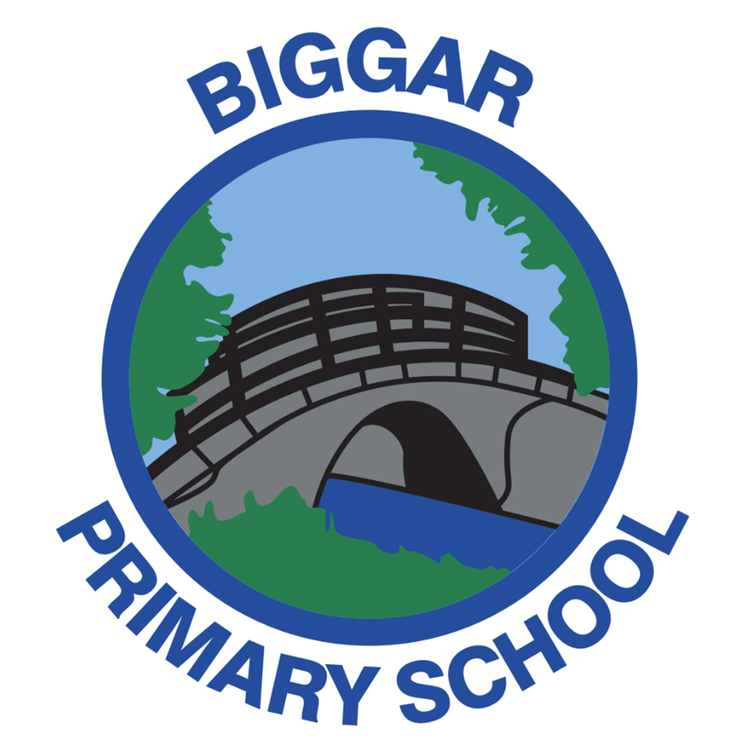
Please use this sheet to record any snacks/meals given to the children in your class
(Christmas parties, Easter celebrations, Scottish celebrations, Outdoor Learning, IDL, Discrete food technology lessons )
Please bear in mind these snacks must comply with the 14 nutritional standards from the authority:
https://www.southlanarkshire.gov.uk/info/200259/education_benefits/291/school_lunches/10
P1-7
Term 1

Term 2

Term 3

Term 4

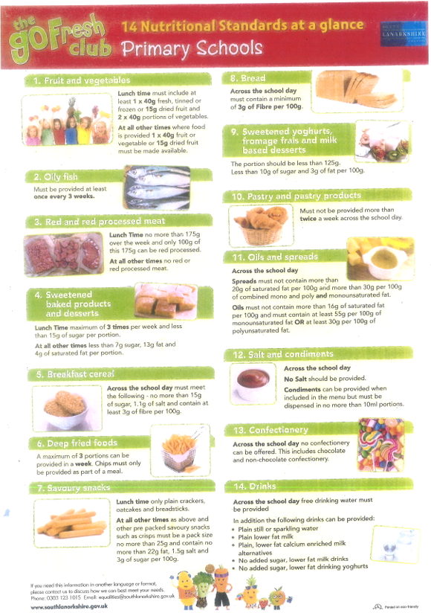

Reference material

Links to related articles and further information:

Nutritional Regulations - Healthy eating in schools: guidance 2020

Food in schools across Scotland: A self-evaluation resource

PDF file: Food in Schools sketchnote: Connections (1.4 MB)
PDF file: Food in Schools sketchnote: Contributions (1.2 MB)
Monitoring templates – Food in Schools across Scotland (glowscotland.org.uk)
https://www.foodstandards.gov.scot/downloads/Dietary_Goals_for_Scotland.pdf
Health Promotion Guidance: Nutritional Guidance for Children and Young People in Residential Care Settings - gov.scot (www.gov.scot)
Section 2 Ensuring appropriate food and drink choices for all children and young people - Healthy eating in schools: supplementary guidance - gov.scot (www.gov.scot)
Schools (Health Promotion and Nutrition) Scotland Act: Health promotion guidance for local authorities and schools - gov.scot (www.gov.scot)
Health and wellbeing: Experiences and outcomes (education.gov.scot)

