`

**Education Resources**

**Bent Primary School**

**Handbook 2022-23**

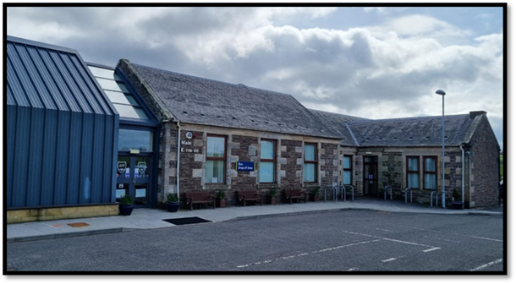

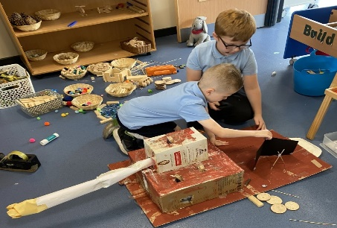

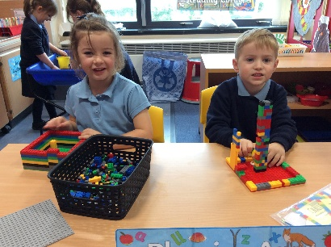

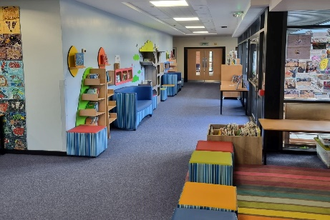

**Belong, Learn, Persevere, Aim High, Play, Seek Truth, and Respect.**

Contents

1. **Introduction**
2. **About our school**
3. **Parental involvement**
4. **School ethos**
5. **The curriculum**
6. **Assessment and Tracking Progress**
7. **Reporting**
8. **Transitions (Change of school / Placing requests)**
9. **Support for Pupils (Additional Support Needs)**

* **Getting it Right for every child**
* **Enquire**
* **Attachment Strategy**

1. **School Improvement**

* **Pupil Equity Funding**

1. **School Policies and Practical Information**

* **Free meals**
* **Uniform/dress code**
* **Clothing Grant**
* **Transport**

If you need this information in another language or format, please contact us to discuss how we can best meet your needs.

Phone: 0303 123 1023 Email: [education@southlanarkshire.gov.uk](mailto:education@southlanarkshire.gov.uk)

1) Introduction by the Head Teacher

Bent Primary School

Strathaven Road

Lesmahagow

ML11 0JD

Phone: 01555 892303

Website: [www.bent-pri.s-lanark.sch.uk](http://www.bent-pri.s-lanark.sch.uk)

Email – office@bent-pri.s-lanark.sch.uk

Dear Parent or Guardian,

On behalf of the staff and pupils I would like to welcome you to Bent Primary School. We are delighted that you are considering sending your child to our school and look forward to working with you in his/her education. It is our belief that partnership between home and school is vital if our children are going to have the best possible educational experience and we fully promote this in every possible way.

Bent Primary is part of the Lesmahagow Learning Community which encompasses Lesmahagow High School, Blackwood Primary, Coalburn Primary, Milton Primary and Woodpark Primary.

Bent Primary School is located in the Kirkmuirhill/Boghead areas of Lesmahagow. The original school dates back to the late eighteen hundreds and on the 10th May 2012, we moved in to our beautiful and new purpose built school.

The new school has 4 classrooms, a general purpose area and library, a dining room /gymnasium /assembly hall and a well resourced outdoor play area.

Bent Primary is situated within South Lanarkshire which is the fifth largest authority in Scotland. It covers the following main areas; Clydesdale in the south which features extensive rural areas, Cambuslang, Rutherglen, Blantyre and Uddingston to the north as well as the towns of East Kilbride and Hamilton.

The Council’s Plan Connect sets out the Council’s vision which is, “to improve the quality of life for all within South Lanarkshire”.

For Education Resources this means delivering services of the highest quality as well as striving to narrow the gap. It is about continually improving the services for everyone at the same time as giving priority to children, young people, families and communities in most need. The priorities for schools and services are set out in the Education Resources Plan which confirms the commitment to provide better learning opportunities and outcomes for children and young people.

Our parents and carers views are cherished and valued at Bent Primary and we endeavour to work in partnership with them at all times to provide the best possible educational experiences for our pupils.

If you have any questions about our school, please don’t hesitate to contact us.

Yours sincerely

Mr Colin Thomson

Head Teacher

2) About our school

* Bent Primary School
* Strathaven Road, Boghead, Lesmahagow, ML11 0JD
* Phone - 01555 892303
* Website – <http://bentps.schoolwebsite.scot/>
* School App for Parents: Can be downloaded at Google Play or Apple Store (Connect Us

Scotland Ltd)

* Email contact – [office@bent-pri.s-lanark.sch.uk](mailto:office@bent-pri.s-lanark.sch.uk)
* Bent Primary is a small, rural co-educational, non-denominational school
* As part of South Lanarkshire Council’s investment in improving school buildings our new school opened for pupils on 10th May 2012.

 

* Our pupils range from P1 – P7 and currently we have 4 classes
* Present roll – 82
* Head Teacher Mr Colin Thomson
* Teaching Staff Mrs. Margaret Bryson

Mrs. Alexis Coull

Miss Lucy Harris

Mrs Gillian McDonald

Ms Freya McWee

Ms Eve Walker

Miss. Hannah Wilson (Seconded to SLC HQ)

* School Support Assistants Mrs. Ann Reid (Team Leader)

Miss Susan Brown

Mrs Jillian Carney

Mrs. Veronica McEwan

Ms. Alison Smith

* Community Resources Mrs. Anne Donnelly
* Catering Mrs. Gillian Brown

Ms. Laura Thomson

* Our Parent Council may be contacted through our school office. The chairperson of our Parent Council is Mrs Lynsey Cosgrove.
* In the event of a pupil’s absence, **parents must phone to notify the school** first thing in the morning. A message may be left on the school answering machine. Should the school not be notified then the school office will phone home to confirm a pupil’s absence. Parents will also be contacted by phone, if their child falls ill in school and requires to go home.
* The Head Teacher should be the first point of contact for parents who wish to discuss issues about their child. All enquiries and concerns received from parents are taken seriously. In order to ensure that enquiries are dealt with effectively, contact should be made in the first instance with the school.
* Should you wish additional information about our school or need to discuss any other matter, please contact the Head Teacher.
* Parents of possible new pupils are welcomed and may phone to arrange a visit.

**3) Parental involvement**

South Lanarkshire Council recognises the importance of parents as partners in the education of their child and has published a strategy entitled, ‘Making a difference – working together to support children’s learning’. This is available from the Council’s website:

[www.southlanarkshire.gov.uk/downloads/file/13457/parents_as_partners_-_strategy_2019](http://www.southlanarkshire.gov.uk/downloads/file/13457/parents_as_partners_-_strategy_2019)

Parents, carers and family members are by far the most important influences on children’s lives. Children between the ages of 5 and 16 spend only 15% of their time in school! Research shows that when parents are involved in their child’s learning, children do better at school and throughout life. Parental involvement can take different forms but we hope you share the same aims and agree that by working together we can be partners in supporting children’s learning.

As a parent/carer we want you to be:

* Welcomed and given an opportunity to be involved in the life of the school;
* Fully informed about your child’s learning;
* Encouraged to make an active contribution to your child’s learning;
* Able to support learning at home;
* Encouraged to express your views and involved in forums and discussions on education related issues.

The school operates an ‘open door’ policy and parents are welcome to call at the school during school hours or telephone for an appointment, if they have concerns about their child’s progress or wish to have some educational method explained further. Problems shared are problems halved, and we are committed to dealing with any issues promptly, professionally and fairly.

**Parent Council**

Our Parent Council is a focussed and pro-active group. The members are fully involved and supportive of all aspects of school life. They are consulted on a wide variety of matters such as curriculum development, establishment planning, policy development, budget and council and government initiatives. The Parent Council enhances the relationships between both Parents/Carers and Teachers, providing various opportunities for us to work together in organising social events and fundraising activities.

To find out more on how to become a member of the Parent Council just contact the school or visit our website. The website provides information of upcoming meetings and events.

Some useful information contacts for parents to find out more on education are as follows:-

* Parentzone – [www.parentzonescotland.gov.uk](http://www.parentzonescotland.gov.uk)
* Engage Parent Forum – [www.engageforeducation.org](http://www.engageforeducation.org)
* National Parent Forum for Scotland – [www.educationscotland.gov.uk/parentzone](http://www.educationscotland.gov.uk/parentzone)
* South Lanarkshire Council – [www.southlanarkshire.gov.uk](http://www.southlanarkshire.gov.uk)

4) School Ethos

In Bent Primary our vision, created in partnership with parents and the wider community, is to provide excellent educational experiences to enable all learners to reach their full potential within a safe, inclusive and nurturing environment. Our values are; Belong, Respect, Play, Seek Truth, Aim High, Learn and Persevere.

To help achieve this we extend our activities beyond the classroom, ensuring that we provide opportunities for pupils to encounter a wide variety of experiences. These include sports, music, art, outings, workshops and community involvement.

The teacher’s role is to provide quality experiences and facilitate opportunities through which our pupils will learn.

We work to build pupils’ self-esteem and self-worth and to show that the whole school community celebrates their efforts and their special occasions.

Weekly awards are given to recognise a variety of achievements in numeracy and literacy as well as wider accomplishments out with school. We also place a high emphasis on recognising achievements linked to our school values.

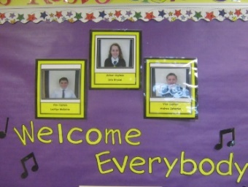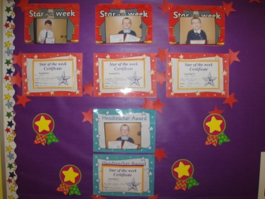

We work with colleagues in other sectors sharing information to plan a child’s ‘learning journey’ from 3-18 so that each individual continues to work at a pace they can cope with and experience challenge they can thrive on.

Each pupil has an ‘Achievement Passport’; where all personal achievements are recorded. These are celebrated at weekly assemblies and on our ‘Celebrating Success’ wall.

We strive to encourage all pupils to recognise and be proud of their own and others achievements.

**Pupil Voice**

We value the opinions of our children and there are opportunities available for all pupils in the school to be involved in the various pupil action groups – Pupil Council, Eco/Health, Book Ambassadors, Rights Respecting Schools, Junior Road Safety Officers, School Captain and Vice Captains. These groups meet regularly and their views and activities have a positive effect on the school and wider community.

**Some comments from our pupils**

We love to play, do our number talks and have fun learning about phonics and how to draw. Pupils at Bent PS are well behaved, work hard and work well together. The food is nice at lunchtime and we get time to play with our friends!

**Primary 1 & 2 Pupils**

Bent Primary is an amazing place. Everyone is so welcoming including the staff. The teachers are amazing; they help everyone and are very good at encouraging you to do your best. I think Bent Primary is an amazing school.

**Primary 6 pupils**

Our classroom is a brilliant place to learn as our teachers always help make our lessons fun and enjoyable. We love learning through play.

**Primary 3 Pupils**

The teachers and staff are always kind. We have a brilliant playgrounds with lovely views of the countryside. I really like how get chances to investigate things we want to learn about. **Mia P5**

Play time and lunch times are very good because you can play and talk with your friends. Staff always help us if we need support.

**Finn P6**

Learning is fun at Bent Primary. We do lots of outdoor learning with residential trips and visits to special places that help us make learning better.

**Primary 7 pupils**

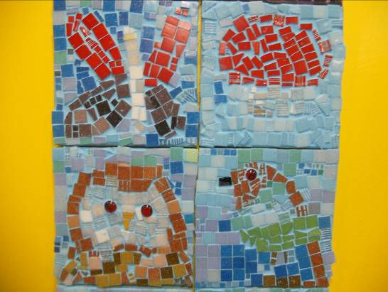

**5) The curriculum**

Curriculum for Excellence is the name given to the curriculum in Scotland for all children and young people aged 3-18. It is a forward; looking, coherent, more flexible and enriched curriculum that provides young people with opportunities to engage with the knowledge, skills and attributes they will need if they are to flourish in life, learning and work, now and in the future.

The curriculum includes all of the experiences that are planned for children and young people to support the development of their skills, wherever they are being educated, for example in the family and community, pre-school centre, nursery and school. This broad, general education will allow them to become successful learners, confident individuals, responsible citizens and effective contributors to life in the 21st century.

In taking this forward our school will work closely with South Lanarkshire Education Resources and other services to enable Curriculum for Excellence to be fully embedded, ensuring the best possible education for all children and young people. We wish you to feel confident that your child is encouraged and supported to develop their literacy, numeracy and other skills whilst they attend our school. The curricular areas are as follows:

* Expressive arts
* Languages and literacy
* Health and wellbeing
* Mathematics and numeracy
* Religious and moral education
* Science
* Social studies
* 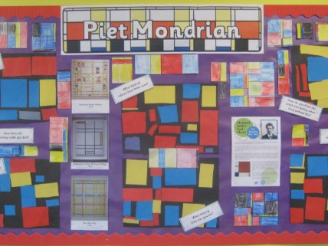Technologies

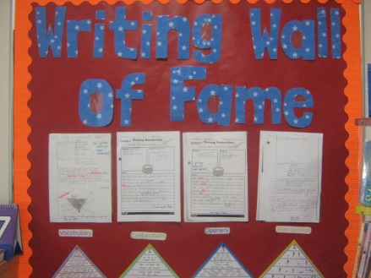



If you want to know more about Curriculum for Excellence, please visit [Scotland's Curriculum for Excellence (scotlandscurriculum.scot)](https://scotlandscurriculum.scot/)

Our learning and teaching activities are based on the outcomes and experiences in the guidelines that all schools have for Curriculum for Excellence.

**Level Stage**

Early The pre-school years and Primary 1 or later for some.

First To the end of Primary 4, but earlier or later for some.

Second To the end of Primary 7, but earlier or later for some.

**Spiritual, social, moral and cultural values (religious observance)**

**Religious and Moral Education**

Religious and Moral Education enables children and young people to explore the world’s major religions and views which are independent of religious belief and to consider the challenges posed by these beliefs and values. It supports them in developing and reflecting upon their values and their capacity for moral judgement. Through developing awareness and appreciation of the value of each individual in a diverse society, religious and moral education promotes responsible attitudes to other people. This awareness and appreciation will assist in counteracting prejudice and intolerance as children and young people consider issues such as sectarianism and discrimination more broadly.

**Rights of parents / carers**

Scottish Government Ministers consider that religious observance complements religious education and is an important contribution to pupils’ development.  It should also have a role in promoting the ethos of a school by bringing pupils together and creating a sense of community.

There is a statutory provision for parents to withdraw children from participation in religious observance. This right of parents’ wishes will be respected.

Where a child is withdrawn from religious observance, schools will make suitable arrangements for the child to participate in a worthwhile alternative activity.

Equalities

Integral to this guidance is the principle of mutual respect. The diversity of belief and tradition provides an ideal context in which pupils can learn about, and so learn from, what is important in the lives of themselves and others. South Lanarkshire’s guidance recognises and welcomes diversity and promotes respectful understanding.

Parents may request that their children be permitted to be absent in order to celebrate recognised religious events. Advance notice should be provided to the school when children will be absent. Appropriate requests will be granted and the pupil noted as an authorised absentee in the register.



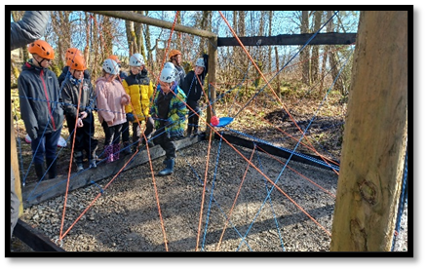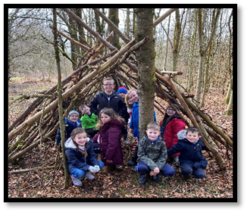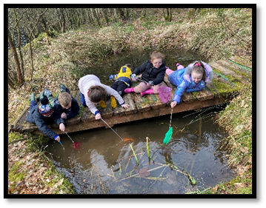

**6) Assessment and tracking progress**

We want to share with you on how your child’s learning is progressing. We do this through gathering, reflecting on and evaluating evidence of learning to enable our teachers to check on pupils' progress and support further learning.

C:\Users\Carol\AppData\Local\Microsoft\Windows\Temporary Internet Files\Content.IE5\4HUKKW85\MC900234134[1].wmfThe purposes of assessment include:

* supporting learning
* helping to plan next steps
* informing pupils and their parents of their progress
* summarising achievements
* monitoring the education system and influencing future developments.

At Bent Primary assessment takes place in a variety of forms. It happens informally on a daily basis when children’s work is discussed with their teacher and they receive feedback on their learning and progress. Children are encouraged to evaluate using specific success criteria and are also involved in a variety of peer and self-assessment opportunities. End of unit assessments may also take place.

More formal assessment procedures are also used. Information gained is used to identify children who need additional help to support their progress as well as developing next steps for those children who need to be challenged.

Assessment at Bent Primary supports our pupils in developing the four capacities of Curriculum for Excellence:

* Successful Learners
* Confident Individuals
* Effective Contributors
* Responsible Citizens

It also supports the development of the characteristics associated with the four capacities.

These include a range of personal qualities and skills that in the past may not always have been formally assessed, such as thinking creatively and independently, working in partnership and in teams, making informed decisions and evaluating environmental, scientific and technological issues. These skills and attributes are embedded in Curriculum for Excellence.

Assessment at Bent Primary aims to focus on these, as well as on measuring factual recall and routine procedures.

Tracking and monitoring of progress is an ongoing process in Bent Primary with progress regularly being discussed at planning meetings between staff and the Head Teacher.

Children identified at these meetings as needing extra support will continue to be monitored while the class teacher implements intervention strategies. This process is outlined in the section in this handbook on Additional Support for Learning.

Assessment procedures in Scottish education have become steadily more sophisticated and will be further developed with the completion of Scottish National Standardised Assessment at Primary 1, 4 and 7.

The Assessment is for Learning programme has encouraged diagnostic and formative approaches that directly support learning. They will remain at the heart of assessment in our school.

As professional dialogue is central to agreeing standards, opportunities are sought to meet with colleagues for moderation sessions during the school year.

7) Reporting

Bent Primary recognises that good partnerships between parents, children and the school are key to a successful education for all children.

Reporting will be ongoing and comprise of a range of activities which can include children showcasing their learning, newsletters and ongoing oral discussions.

We will provide parents with reports so that you can see what your child is doing and how they are progressing. In addition, there will be parents’ meetings which offer you the opportunity to discuss how your child’s progressing and how you can contact the school if you wish further information. The school will offer you an appointment time so that you can visit in person to discuss your child’s education.

Our ‘learner reports’ will help you to get to know more about the curriculum which each child follows and will describe their strengths, achievements and areas for development so you know what encouragement and support you can give.

We welcome any comments or additional information from parents to help us provide the best possible education for your child.

8) Transitions

Pupils normally transfer from primary to secondary school between the ages of 11½ and 12½, so that they will have the opportunity to complete at least 4 years of secondary education. Arrangements are made by the school to transfer children to the associated secondary school as determined by their home address. Parents of P7 children will be informed of the transfer arrangements made for their child to attend secondary school.



Lesmahagow High School

We will also provide you with information at this time and on events designed to support P7 children before they move on to secondary school.

**Change of School/Placing Request**

Normally children attend the school in their catchment area. However, there are times when parents may wish their children to go to other schools. If you wish your child to go to another school then you may make what is known as a ‘placing request’. If you live in South Lanarkshire and decide to submit a ‘placing request’, we are unable to reserve a place in your catchment school until the Council have made a decision on the ‘placing request’. Please note if your ‘placing request’ application is unsuccessful and all places at your catchment school are filled you will be offered a place at the next nearest appropriate South Lanarkshire School.

Please note that if an application for a ‘placing request’ is successful then school transport is not provided.

If you move out with your catchment primary school a ‘request to remain form’ must be completed. If you move out with your catchment primary, this may affect your right to transfer to the associated Secondary School. Please note the secondary school is determined by the pupil’s permanent home address and chosen denomination. If you require further information, please contact Education Support Services on [edsuppserv.helpline@southlanarkshire.gov.uk](mailto:edsuppserv.helpline@southlanarkshire.gov.uk) or **0303 123 1023**.

9) Support for pupils

**Getting it right for every child.**

Getting it right for every child (GIRFEC) supports families by making sure children and young people can receive the right help, at the right time, from the right people. The aim is to help them to grow up feeling loved, safe and respected so that they can realise their full potential.

Most children and young people get all the help and support they need from their parent(s), wider family and community but sometimes, perhaps unexpectedly, they may need a bit of extra help. GIRFEC is a way for families to work in partnership with people who can support them, such as teachers.

If you have any concerns about your child’s wellbeing, you can speak to the named person who will work with you to provide support and decide how to move forward. Your school will let you know who this is. It is likely to be the Head Teacher in a primary school and a principal teacher (pupil support) in Secondary.

More information can be found on: [www.scotland.gov.uk/gettingitright](http://www.scotland.gov.uk/gettingitright)

Support for all (Additional Support Needs)

Assessment of each child’s progress is reviewed regularly by the class teacher. Where specialist help is required, the parent is invited to the school to discuss the difficulty and Psychological Services may become involved if required. A support for learning teacher visits the school regularly to advise staff and assist with work for pupils who require additional support. Liaison with Nursery Schools and Lesmahagow High School ensure continuity for children experiencing any difficulties as they make the transition to Primary or Secondary Education.

South Lanarkshire Education Resources have published a series of leaflets available which cover information for parents and carers about the Additional Support for Learning Acts.

**Enquire – the Scottish advice service for additional support for learning.**

Enquire is funded by the Scottish Government to provide information on the framework for supporting children who require additional support for learning and to encourage positive partnerships between families, schools and local authorities to ensure children get the right support.

Enquire offers independent, confidential advice and information on additional support for learning through;

Phone Helpline: 0345 123 2303

Address: Enquire

Children in Scotland

Rosebery House

9 Haymarket Terrace

Edinburgh

EH12 5EZ

Email Enquiry Service: [info@enquire.org.uk](mailto:info@enquire.org.uk)

Advice and information is also available at [www.enquire.org.uk](http://www.enquire.org.uk)

Enquire provides a range of clear and easy to read guides and fact sheets including ‘The parents’ guide to additional support for learning’.

If you would like to order our leaflets, postcards or guides to share with parents and carers of pupils in your school, please contact us on [info@enquire.org.uk](mailto:info@enquire.org.uk)

**Attachment Strategy for Education Resources**

**Attachment – what we do to support children and young people**

South Lanarkshire Council Education Resources is committed to improving outcomes for children and young people by creating emotionally supportive learning experiences in our nurseries and schools.

The Education Resources Attachment Strategy supports the action in the ‘Getting it Right for Every Child in South Lanarkshire’s Children Services Plan 2021-23’, following the launch of the Attachment Strategy in 2020, to provide staff training in Attachment and Trauma based practice.

***What does it set out to do?***

The aim of the strategy is to promote better experiences of attachment for South Lanarkshire’s children and young people and to ensure that all education practitioners understand the importance of attachment theory and its application and how positive relationships can make a difference to outcomes.

***How can I find out more?***

South Lanarkshire Council Education Resources have published a series of leaflets and posters for establishments and for parents/carers, which aim to share information on attachment theory and on how this can inform the ways in which we support children and young people.

These are available from schools and we have plans to make them available on the SLC Staff Learning Centre Sway accessible by teachers and staff.

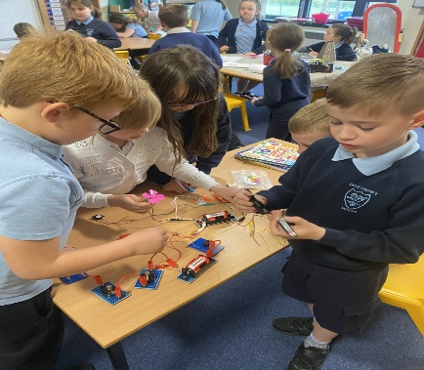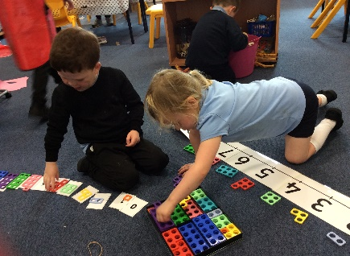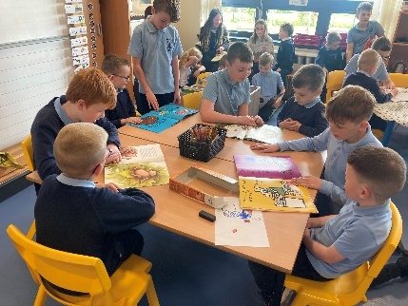

**10) School improvement**

The purpose of the school improvement plan is to improve the quality of teaching and learning in school. Through consultation, by reviewing current practice and evaluating which areas of Curriculum for Excellence require development, a school devises its improvement plan. The SLC Quality Improvement Officer for the school also plays a key part in ensuring Bent Primary is in line with South Lanarkshire’s implementation plan of Curriculum for Excellence.

The School Improvement Plan contains the targets the school has set for the next year. We are constantly looking at ways to improve the education and life chances of the pupils in our care.

We are always working on many different areas of improvement throughout the school year, but the school improvement plan focuses on the key priorities, which would bring about measureable outcomes for our pupils. This session our focus is on school recovery.

**Recovery Planning Session 2020-2021**

We returned in August to a full curricular delivery model. This means that schools and establishments need to prioritise, re-evaluate what they are setting out to deliver and be clear from the outset that they cannot do everything. A phased, proportionate approach is key.

We are clear that our number one priority should be around the Health and Wellbeing curriculum, followed by core elements such as Literacy and Numeracy. The National guidance clearly states, **“focusing on learning across literacy, numeracy and health and wellbeing will be the initial priority”**

* Improvement Priority 1 - Promote the positive health and wellbeing of children & young people, parents/carers and staff
* Improvement Priority 2 - Planning for Equity
* Improvement Priority 3 - Continuity of Learning

The school’s recovery plan is available on our school website. If you would like further information, please contact the Head Teacher.

**Response to Covid 19 Lockdown closure – March 2020 – June 2020**

Bent Primary staff had to work quickly and efficiently to put plans in place for the closure of the school in the short period available prior to the school closing.

This included:

* Agreed use of SeeSaw as our main home learning platform.
* Intensive staff training on the use of SeeSaw and staff worked to train the pupils.
* A learning pack/information booklet was sent home with; suggested activities for each curricular area, information about prior learning, advice for parents to support revision and recommended websites for further activities.
* SeeSaw, Sumdog and GLOW log in details and instructions were emailed to all parents. Detailed instructions were also sent out to highlight access to these from **all devices**.
* Families were reminded of contact details for school office and Mrs Fleming. This was also highlighted throughout the lockdown period.
* The school ensured that communication channels were open and support and advice was given where required.

**Our progress over the previous session as well as our response to the Covid 19 closure are detailed in our Standards and Quality Report and this is available on our school website or on application to the Head Teacher.**

**C:\Users\flemingc10\AppData\Local\Microsoft\Windows\Temporary Internet Files\Content.IE5\HLL3ZRSS\MC900413500[1].wmf**

**11) School policies and practical information**

**School Meals**

Healthy eating is something that the school supports and a range of meals are available at lunchtime that meet the Nutritional Requirements for Food and Drink in Schools (Scotland) Regulations 2020

All primary aged pupils are also offered a free breakfast within their school. The selection available includes cereal, toast, fruit and milk.

For their lunch each day pupils have the option to choose from two hot meal options, a snack option plus a vegan / vegetarian option. These are all served with vegetables or side salad. All **meals** also come with fresh chilled drinking water, salad, seasonal fruit and depending on the day - soup or a dessert.

Milk will be available for those pupils entitled to free school meals through the free school meal eligibility scheme at morning break or lunchtime

Pupils in:

* Primary 1 - 5 receive a free school lunch.
* Primary 6 - 7 meal cost is £2.00

School lunches and milk can be paid for through your Parentpay account or Paypoint facilities in local shops.

**NB** School Meal prices are reviewed annually and may be subject to change

**Special diets**

If your child within Nursery, Primary or Secondary requires a special diet for medical reasons please speak to the school/nursery office who will provide the request form for you to complete. In addition, if you have a cultural diet request for your child please speak to the school/nursery office who will provide you with a request form.

**Free School Meals**

Children of parents who receive the following benefits are entitled to a free lunchtime meal for their child

* Income Support, Universal Credit (where your take home pay is less than £660 per month), Job Seeker’s Allowance (income based), Employment and Support Allowance (income related), Working Tax Credit and Child Tax Credit (where your gross annual income does not exceed £7,920 as assessed by the HM Revenues and Customs), Child Tax Credit Only (where your gross annual income does not exceed £17,105 as assessed by the HM Revenues and Customs) or receive support under Part VI of the Immigration and Asylum Act 1999.

**If you are in receipt of Housing Benefit and/or Council Tax Reduction from us there is no need for you to apply online, we will use the information we hold to automatically award free school meals (P4 to S6) and/or school clothing grants (P1 to S6) to eligible families.**

We would encourage parents of children who are in receipt of any of the above benefits to take up this opportunity of having a meal provided for their child when they are at school.  Arrangements are in place so that children who receive free meals are not singled out and we encourage all children to remain in school at lunch time.

South Lanarkshire Council also offers a free Breakfast service. The service runs from 8.30am to 8.55am each school day.

**We would encourage parents of children who are in receipt of any of the above benefits to take up this opportunity of having a meal provided for their child when they are at school. Arrangements are in place so that children who receive free meals are not singled out and we encourage all children to remain in school at lunchtime.**

School uniform

We ask all parents/carers to support the school by encouraging your child(ren) to adhere to the agreed dress code and the wearing of our school uniform. The wearing of a school uniform helps promote the identity of the school in the local community and helps create an ethos of sharing and pride in the school.

In addition, the wearing of a uniform helps towards increasing the protection of all pupils. The wearing of a uniform helps staff and the pupils to distinguish between who belongs to the school and those who may be visitors. This enables staff to approach and identify visitors more readily and helps in trying to offer a safer environment for pupils and teachers alike.

Equality of opportunity is an important aspect of the life of the school. Any proposals on the dress code and on what constitutes the school uniform will be the subject of discussion with the Parent Council and where appropriate consultation with parents, pupils and staff.

There are forms of dress which are unacceptable in all schools such as:

* the wearing of football colours
* clothing with slogans that may cause offence (anti-religious, symbolism or political slogans)

1. clothing which advertises alcohol, tobacco or drugs
2. clothing which can be deemed unsuitable in terms of health and safety grounds such as shell suits, combat style clothing, dangling earrings, loose fitting clothes particularly in practical classes
3. C:\Users\flemingc10\AppData\Local\Microsoft\Windows\Temporary Internet Files\Content.IE5\IICXQXNF\MC900445736[1].wmfarticles of clothing that could be deemed to inflict damage on other pupils or be used by others to do so
4. footwear that may damage flooring.

The uniform worn by Bent Primary pupils is:

Jumper, cardigan or sweatshirt – navy blue

Trousers or skirt – grey or navy

Polo shirt, shirt or blouse – blue or white

School Tie available from AJL Work and Leisure Wear, 18 Bloomgate,Lanark.

Rain jackets are also available

Our pupils change into indoor shoes while inside the building. These can be the child’s gym shoes and are stored in small shoe boxes in the cloakroom areas.

PE kit – It is important that children are suitably dressed for PE. Gym shoes/trainers, shorts and t-shirts are the desired clothing. Trainers worn outside should not be worn for PE as this could prove to be a danger. Please note that jewellery should be removed before PE sessions.

School activities can involve the use of paint, glue and other messy materials so some sort of overall/old shirt is advisable.

**Please ensure you label all items clearly!**

**Allergies**

A significant number of children and young people in our schools will have allergies and it is important that parents keep the school fully informed on these matters.

Allergies can present in a variety of ways and can occur at any point in a person’s life. Symptoms range from mild to severe. Children and young people known to have an allergy with moderate to severe symptoms will likely have a Health Care Plan drawn up by the NHS. This will detail symptoms and appropriate interventions.

It is vital that parents share this information with the school and continue to provide any updated information.

Where symptoms are mild and a Health Care Plan is not in place, parents should still continue to liaise regularly with the school on any new triggers, medications and actions required.

In all cases, our employees need to know your child’s symptoms, treatments and any actions required to help prevent exposure to the allergen and minimise the risk of allergic reactions.

Employees in schools will receive training on allergies and will liaise with parents and NHS on any additional specialist training required.

In supporting children and young people with allergies, school employees will operate in accordance with South Lanarkshire Council’s Safe Systems of Work / risk assessment and national guidance on the administration of medicines.

**Support for parent/carers**

**Clothing grant**

In certain circumstances the Council provides support to parents/carers for the purchase of school wear. **(We would encourage families if they are eligible to apply for these benefits.)**

Applications can be made online at [www.southlanarkshire.gov.uk](http://www.southlanarkshire.gov.uk)

If you are required to submit evidence of your Tax Credit income it is important that a copy of this evidence is attached to your online application. Should you require further information or you are unable to submit an application online then please contact the helpline number 0303 123 1011 (option 5).

School hours/holiday dates



Bent Primary School hours are:

9.00am – 10.30am

10.30am – 10.45am Interval

10.45am – 12.15pm

12.15pm – 1.00pm Lunch

1.00pm – 3.00pm

**See attached appendices showing school holiday dates.**

**Enrolment – how to register your child for school**

Please provide information to parents on how to register their child for school.

To register your child for school you should complete our online registration form. This can be done using the South Lanarkshire website.

[www.southlanarkshire.gov.uk/info/200186/primary_school_information/392/enrolling_your_child_for_school](http://www.southlanarkshire.gov.uk/info/200186/primary_school_information/392/enrolling_your_child_for_school) If you have any difficulty in identifying your catchment school, please email [Edsuppserv.helpline@southlanarkshire.gov.uk](mailto:Edsuppserv.helpline@southlanarkshire.gov.uk)

The online registration form will ask you to provide each child’s full birth certificate and two pieces of recent official documentation both containing your permanent home address for example a utility bill, council tax statement, housing rent card, child benefit documentation.

Proof of where the child lives may also be needed.

Parents within the catchment area will be advised via social media that they can begin using the online registration form to enrol their child for school in August 2023. The registration form along with the child’s full birth certificate and 2 proofs of residency will be sent directly to the office email address will be available from 9 January 2023.

If your child attends nursery of your catchment school don’t assume that they will be automatically transferred. You must register them as normal.

If your child is starting school for the first time you must enrol your child at their catchment school in January. If parents want their child to go to another school, they must enrol in the first instance with their catchment school and ask for an information leaflet that provides details on how to make a placing request. An online placing request form is available from the SLC website – [www.southlanarkshire.gov.uk](http://www.southlanarkshire.gov.uk) or by [contacting edsuppserv.helpline@southlanarkshire.gov.uk](mailto:contacting%20edsuppserv.helpline@southlanarkshire.gov.uk) or phone **0303 123 1023**.

Enrolment date for 2022 is week commencing 16 January 2023.



Transport

**School transport**

South Lanarkshire Council has a policy of providing school transport to primary pupils who live more than one mile by the recognised shortest walking route from their catchment school. This policy is more generous than the law requires. This means that the provision of transport could be reviewed at any time. Parents who consider they are eligible should complete a form online [www.southlanarkshire.gov.uk](http://www.southlanarkshire.gov.uk) or contact **0303 123 1023.** These forms should be completed and returned before the end of March for those pupils starting the school in August to enable the appropriate arrangements to be made. Applications may be submitted at any time throughout the year and will be considered by Education Resources.

A privilege transport scheme is operated for mainstream school contracts where a pupil is not entitled to free school transport. Privilege transport will only be granted providing there is spare capacity on an existing school contract and will be from and to designated pick up and drop off points. Privilege transport will not be provided where a service bus is used on the school run. Any spare capacity will be allocated using agreed priorities. More information on school transport is available

[www.southlanarkshire.gov.uk/info/200188/secondary_school_information/545/school_transport](http://www.southlanarkshire.gov.uk/info/200188/secondary_school_information/545/school_transport) or phone **0303 123 1023.**

**Please note that all pupils who reside within our catchment area are entitled to free bus transport to and from the school due to safety issues on the main road. Pupils should not walk to and from the school without adult supervision. There are several bus stops which will be shared with families to decide where the best place may be for their child to be dropped off and collected from the bus. All of these details will be explained in more depth by contacting the school directly.**

**Pick-up points**

Where school transport is provided it may be necessary for pupils to walk a certain distance to the vehicle pick-up point. Walking distance in total, including the distance from home to the pick-up point and from the drop-off point to the school in any one direction, will not exceed the authority’s distance limit for school transport.

It should be noted that it is the parent’s responsibility to ensure their child behaves in a safe and acceptable manner while travelling in and alighting from the vehicle. Misbehaviour can result in your child losing the right to school transport.

Parents are asked to note that South Lanarkshire Council does not provide transport for those pupils who attend school via a placing request.

**Insurance for schools – pupils’ personal effects**

South Lanarkshire Council is concerned at the level of claims being received for loss or damage to pupils’ clothing or personal effects. Parents are asked to note the Council’s position in terms of insurance for pupils’ personal effects:

(i) **Theft/loss of personal effects**

The Council is not liable for the loss or theft of pupils’ clothing or personal effects for example mobile phones, tablets etc. and any items are therefore brought into the school at the pupil/parents’ own risk.

Parents can assist by ensuring that valuable items and unnecessarily expensive items of clothing are not brought to school.

Teachers and other staff have been advised not to accept custody of any such items.

The same principle applies to musical instruments and other equipment used for activities within the school, which belong to the pupil, but are brought into the school. Parents should be aware that if such equipment is left in school, it is done at the pupil/parents’ own risk.

In the case of valuable items such as musical instruments, parents should ensure that these items are covered by their own household insurance.

(ii) **Damage to clothing**

The Council is only liable for damage caused to pupils’ clothing where the damage has resulted from the negligence of the Council or one of its employees. Claims arising otherwise will not be accepted by the Council’s insurers.

Family holidays during term time

Every effort should be made to ensure that your child attends school during term time. Please contact the school as soon as possible if your child is unable to attend school.

Family holidays should be avoided during term time as this both disrupts the child’s education and reduces learning time. If holidays are taken during times when the school is open parents should inform the school in advance by letter.

If your child is taken on a family holiday during term time then in line with Scottish Government advice this will be classified as an unauthorised absence. However, in exceptional circumstances schools may register a family holiday during term time as an authorised absence when for example, parents are unable to obtain leave during the school holiday period.

Clearly, absence with no explanation from parents will mean that the absence will be recorded as unauthorised.

In our approach to raising attainment and achievement it is recognised that attendance at school is something that should be continuously encouraged. Parents/carers, children and the school all have a part to play in encouraging and stressing the importance of attendance at school.

The school holiday dates and in-service dates are available from the website [www.southlanarkshire.gov.uk](http://www.southlanarkshire.gov.uk)

**Promoting positive behaviour**

It is the responsibility of staff within the school to ensure that parent council members, parents and pupils are involved in the creation of a positive school ethos that encourages good behaviour. Equally, the school whilst trying to promote positive behaviour must support young people should incidents of bullying occur. Parents have a significant role to play in working with the school so that teachers, parents and pupils know what is expected of them in trying to change the behaviour and attitudes that contribute to bullying behaviour.

Our approach is to create an environment where better behaviour will encourage better learning. The school, along with the support of parents, can work together to create a learning environment which young people can enjoy and feel safe.

[](http://www.google.co.uk/imgres?q=promoting+positive+behaviour&start=389&um=1&hl=en&sa=N&tbo=d&biw=1346&bih=577&tbm=isch&tbnid=vTPPh0o6Hmkn5M:&imgrefurl=http://www.bitc.org.uk/wales/what_we_do/workplace/index.html&docid=PQKKn1n7TMajoM&imgurl=http://www.bitc.org.uk/images/maincolumnlarge/7841_People-shapes-linked.jpg&w=320&h=250&ei=b0jSUOroL6OI0AX5n4CQAg&zoom=1&iact=hc&vpx=828&vpy=249&dur=2079&hovh=198&hovw=254&tx=130&ty=124&sig=113825852881640410776&page=14&tbnh=150&tbnw=203&ndsp=7&ved=1t:429,r:94,s:300,i:286)

Incidents of bullying should be reported to the school immediately so that each alleged incident can be looked at. Together we can work towards creating a safer school for children and staff.

In addition, a guideline (Promoting Positive Relationships and Behaviour) has been produced to support all teaching and support staff and inform them of their roles and responsibilities in respect of dealing with the small number of children and young people who display challenging behaviour.

Early identification is crucial so that intervention can be provided to support children and young people to help them address their issues and concerns. Staff training is provided to help develop the skills needed to respond to and manage challenging behaviour. A wide range of appropriate staff development opportunities has been developed for this purpose.

Child protection

All staff in educational establishments in South Lanarkshire Council receive an annual Child Protection update and are required to follow the advice and guidance contained within relevant Education Operating Procedures. They must also complete a mandatory Learn on Line Course “Child Protection in Education”.



South Lanarkshire’s children’s services partnership works together to support children, young people and their families so that children grow up in communities where they are safe, healthy, active, achieving, respected, responsible and included, and have the opportunity to achieve their full potential. They are committed to continuously improve our services to ensure children, young people and their families get the right support at the right time.

Sometimes children and young people need additional help to make sure that they are *“cared for and protected from abuse and harm in a safe environment in which their rights are respected” (*CPC South Lanarkshire Child Protection shared vision). The Child Protection Committee has the overarching responsibility to ensure that agencies individually and collectively work to protect children and young people as effectively as possible.

All staff have a responsibility to report any suspicions that a child has been abused or is at risk of harm, abuse, or neglect. Robust procedures and guidance are in place to support education staff to: -

* be alert to signs that a child may be experiencing risks to their wellbeing,
* report concerns to the head of establishment or the child protection coordinator without delay.
* be actively engaged in support and protection and development of wellbeing.

If you would like more information~~,~~ or have a concern of a child protection nature, please contact the head of the educational establishment which your child attends.

The Child Protection Committee’s website has a range of useful information for parents/carers to help them keep their children safe. [www.childprotectionsouthlanarkshire.org.uk](http://www.childprotectionsouthlanarkshire.org.uk)

C:\Program Files\Microsoft Office\MEDIA\CAGCAT10\j0195384.wmf

Mobile phones

The use of mobile phones within the school is not permitted. Phones, if sent, are not the responsibility of the school. They must be switched off at all times and kept in school bags for emergency use outside school. Any parent who wishes to contact their child during the school day should do so through the school office.

Information on emergencies

We make every effort to ensure the school remains open during term-time for pupils. However, on occasions circumstances may arise which can affect the school. Schools may be affected by, for example, severe weather, power failures or through any other circumstances that may impact on the school day. In such cases we shall do all we can to let you know if this happens. We shall keep you in touch by phone, text, where appropriate, letters, web news and through local radio stations particularly if there are prolonged periods of severe weather.

The Council’s website [www.southlanarkshire.gov.uk](http://www.southlanarkshire.gov.uk) will be used to let you know if the school is closed and when it will re-open.

**It is important for parents/carers to let the school know of any change to your mobile/home phone number and change of address.**

If for any reason, you are unsure if the school is open, please visit the website [www.southlanarkshire.gov.uk](http://www.southlanarkshire.gov.uk) or email us at: [education@southlanarkshire.gov.uk](mailto:education@southlanarkshire.gov.uk)

**Your commitments**

We ask that you:

* support and encourage your child’s learning
* respect and adhere to the schools policies and guidance
* let the school know if you change your mobile/phone number and/or address
* enjoy and take part in school activities
* accept your responsibility to respect staff who work in the school and for the school to be proactive in taking forward its commitment to care for and educate your child.

**General Data Protection Regulation as supplemented by the Data Protection Act 2018 (GDPR)**

Information on pupils, parents and guardians is held by the school to enable the teaching, registration and assessment of pupils as well as associated administrative duties. The information is stored and used as per the requirements of the GDPR, with South Lanarkshire Council defined as the data controller. The Council have established a data protection policy that applies to all of its school.

Education Resources has also prepared a privacy notice (below) which sets out how we will deal with personal information as part of our statutory function as an education authority. For more information, please contact the school.

**Privacy Notice**

**Introduction**

In line with the General Data Protection (GDPR) we have produced this privacy notice to inform you how we deal with personal information as part of our statutory function as an education authority.

The Council has a legal obligation to deliver effective education services to children, young people and adult learners in South Lanarkshire. In order to do this, we need to collect personal information about children, young people and their families so that we can help them to learn and keep them safe.

**Using your personal information**

The Council is a “controller” of the personal information you provide when enrolling for a nursery or school, applying for an education service or participating in groups or activities provided by Education Resources.

**Information we collect from you about you and your child at enrolment**

When you enrol for a nursery or school, we ask for the following information:

* parent/carer contact details (name, address, phone, email);
* the child’s name, date of birth, gender and address;
* information about medical conditions, additional support needs, religion and ethnicity;
* any information you may wish to provide about family circumstances.

**Information we collect at other times**

We will also collect information at other times such as when you apply for a benefit, request a services or other support. We will provide an additional privacy notice at these times.

* If you apply for an education service or benefit, such as school transport, free school meals, clothing grant, placing request or EMA, we will also ask for personal information as set out above. We will also ask for information about your income for education benefits applications.
* If you make a request for additional support such as an educational psychologist or other support for learning, we will ask for more detailed information to allow us to provide the most appropriate support for your family. This may include information about family circumstances or medical conditions.
* If there are concerns about your child’s wellbeing and/or your child has needs that may require additional support, we will wish to work with you to collect and consider information to enable us to help you get the right support at the right time in line with the Getting it right for every child approach.

We require this information to ensure that children and young people are educated appropriately, supported, and that we take account of their health and wellbeing. We will also ask you to update this information annually and to tell us when there are changes to your details.

**Information that we collect from other sources**

As an education authority and as part of our statutory function in accordance with our legal obligations, we receive information from other sources such as the SQA, the NHS or Social Work about you or your child, this includes:

* exam results and assessment information;
* information about health, wellbeing or child protection.

**Why do we need this information?**

We need this information so the Council can ensure it is delivering education services appropriately to all learners:

* for the education of children, young people and adult learners;
* for teaching, enrolment and assessment purposes and to monitor the educational progress of children, young people and adult learners ;
* to keep children and young people safe and provide guidance services in school;
* to identify where additional support is needed to help children, young people and adult learners with their learning;
* to maintain records of attendance, absence and behaviour of children and young people (including exclusions);
* to support children and young people moving on each year from nursery to primary, primary to secondary and when they move or leave school;
* to help us develop and improve education services provided for young people, adult learners or families
* In accordance with our legitimate interests as an education authority we will also use your information to create statistical reports.

**We will share your information with:**

As an education authority and as part of our statutory function in accordance with our legal obligations we will share information with other bodies or parts of the Council, including:

* The Scottish Government and bodies such as Education Scotland, Scottish Qualifications Authority, Skills Development Scotland and other organisations that support children and young people’s learning;
* Other parts of the Council when required for services such as school meals, school transport, education benefits and with Social work in connection with any child protection concerns we become aware of;
* The NHS, to support health initiatives in accordance with the legal obligation on the Council in terms of section 39(3) of the National Health Service Scotland Act 1978;
* South Lanarkshire Leisure and Culture Limited, where children and young people are participating in sports and leisure activities;
* Other schools/local authorities – if a child moves or transfers to another school the Council has an obligation to pass on information with regards to pupil records to the new school/local authority.

You have the right to access your personal information as well as the rights of rectification, erasure, restriction and the right to object. For information on these rights and how to exercise them or for information about how we manage your personal information, you can get a copy of our full privacy notice from our website: (<https://www.southlanarkshire.gov.uk/info/200235/meta/1730/general_privacy>).

Our full privacy notice will also provide information on how to make a complaint or to request a paper copy of the privacy notice from the Data Protection Officer.

Appendix A

**This annex gives a list of useful information and the links to the content is now available from the Council’s website by accessing the following link**

[**http://www.southlanarkshire.gov.uk/info/200186/primary_school_information/1264/curriculum_for_excellence/3**](http://www.southlanarkshire.gov.uk/info/200186/primary_school_information/1264/curriculum_for_excellence/3)

**Parental involvement**

• [Education Scotland's Communication Toolkit for engaging with parents](https://education.gov.scot/improvement/Documents/Parental%20involvement/PAR2_EngagingParentsandFamiliesToolkit/par2-engaging-parents-toolkit-section3-060416.pdf)

• The Scottish Government guide Principles of Inclusive Communications

provides information on communications and a self-assessment tool for public

authorities - <http://bit.ly/1LVdWD3>

• Choosing a School: A Guide for Parents - information on choosing a school

and the placing request system - <http://bit.ly/1layFKn>

• A guide for parents about school attendance explains parental responsibilities

with regard to children's attendance at school - <http://bit.ly/1XUxblB>

• Guidance on the Scottish Schools (Parental Involvement) Act 2006 provides

guidance on the act for education authorities, Parent Councils and others -

<http://bit.ly/1LVeetx>

• Parentzone provides information and resource for parents and Parent

Councils National Parent Forum for Scotland; [www.npfs.org.uk](http://www.npfs.org.uk)

**School ethos**

• [Supporting Learners - guidance on the identification, planning and provision of](https://www.education.gov.scot/Documents/supporting-learners-framework.pdf)

[support](https://www.education.gov.scot/Documents/supporting-learners-framework.pdf)

• Health and wellbeing guidance on healthy living for local authorities and

schools - <http://bit.ly/1Qj98dS>

• Building Curriculum for Excellence Through Positive Behaviour and

Relationships outlines the Scottish Government's priority actions around

positive behaviour in schools and is also a source of support -

<http://bit.ly/1RBzx4Y>

**Transitions**

• Career Information, Advice and Guidance in Scotland: A Framework for

Service Redesign and Improvement provides guidance on career information,

advice and guidance strategy -

<http://www.scotland.gov.uk/Publications/2011/03/11110615/0>

• [The Additional support for learning page](https://www.gov.scot/policies/schools/additional-support-for-learning/) provides links to relevant legislation

and guidance, including the arrangements that should be in place to support

pupils with additional support needs

• Supporting Children's Learning Code of Practice includes specific

requirements on education authorities and others under the new legislation in

relation to transition – <http://bit.ly/1PsoBHC>

• [Enquire](https://enquire.org.uk/) is the Scottish advice service for additional support for learning

• [Parenting Across Scotland](https://www.parentingacrossscotland.org/) offers support to children and families in Scotland

**Support for Pupils**

• The Education Scotland [Additional support for learning page](https://www.gov.scot/policies/schools/additional-support-for-learning/) provides links to

relevant legislation and guidance, including the arrangements that should be

in place to support pupils with additional support needs

• Supporting Children's Learning Code of Practice (Revised edition): provides

Statutory guidance relating to the Education (Additional Support for Learning)

(Scotland) Act 2004 (as amended) - <http://bit.ly/1PsoBHC>

• [Getting It Right For Every Child and Young Person](https://www.gov.scot/policies/girfec/), is essential reading for

anyone involved or working with children and young people, including

practitioners working in adult services with parents and carers

**School improvement**

• Education Scotland's [Inspection and review page](https://education.gov.scot/education-scotland/what-we-do/inspection-and-review) provides information on the

inspection process

• [National Standardised Assessments for Scotland](https://standardisedassessment.gov.scot/): P1, P4, P7 and S3 complete online standardised assessments in literacy and numeracy. The assessments help to identify children’s progress, providing diagnostic information to support teachers' professional judgement is an annual sample.

survey which will monitor national performance in literacy and numeracy

• [Scottish Credit and Qualifications Framework](https://scqf.org.uk/) (SCQF)

• [Scottish Qualifications Authority](https://www.sqa.org.uk/sqa/70972.html) provides information for teachers, parents,

employers and young people on qualifications

• Information about youth awards in Scotland - <http://bit.ly/1Q8tJCz>

• Information on how to access statistics relating to School Education –

<http://bit.ly/1SvV6Vl>

**School Policies and Practical Information**

**National policies, information and guidance can be accessed from the Scottish Government website at** [**www.gov.scot**](http://www.gov.scot)



**Education Resources**

**School holiday Dates Session 2023/2024**

|  |  |  |  |
| --- | --- | --- | --- |
| Break | Holiday dates | | |
| **First Term** | ***Teachers In-service*** | ***Monday*** | ***14 August 2023*** |
|  | ***In-service day*** | ***Tuesday*** | ***15 August 2023*** |
|  | Pupils return | Wednesday | 16 August 2023 |
| September Weekend | Closed on  Re-open | Friday  Tuesday | 22 September 2023  26 September 2023 |
| October Break | Closed on  Re-open | Monday  Monday | 16 October 2023  24 October 2023 |
|  | ***In-service day*** | ***Monday*** | ***13 November 2023*** |
| Christmas | Closed on  Re-open | Monday  Monday | 25 December 2023  8 January 2024 |
| **Second Term** |  |  |  |
| February break | Closed on | Monday & Tuesday | 12 February 2024  13 February 2024 |
|  | ***In-service day*** | ***Wednesday*** | ***14 February 2024*** |
| Spring break/Easter | Closed on  Re-open | Friday  Monday | 29 March 2024  15 April 2024 |
| **Third Term** |  |  |  |
|  | ***In-service day*** | ***Thursday*** | ***2 May 2024*** |
| Local Holiday | Closed | Monday | 6 May 2024 |
| Local Holiday | Closed on  Re-open | Friday  Tuesday | 24 May 2024  28 May 2024 |
| Summer break | Close on | Wednesday | 26 June 2024 |
| Proposed in-service  days | 15 & 16 August 2024 | | |

Notes

* Good Friday falls on Friday, 29 March 2024
* *Lanark schools will close Thursday, 6 June 2024 and Friday, 7 June 2024*
* Schools will close at 2.30pm on the last day of terms 1 and 2

(Friday, 22 December 2023 and Thursday, 28 March 2024)

* Schools will close at 1pm on the last day of term 3 Wednesday 26 June 2024)

*Two in-service days proposed 15 & 16 August 2024.