

South Lanarkshire Council

ELC Improvement Plan and Standards and Quality Report
2026/2027

Ballerup Nursery Centre



Context of ELC setting

Our ELC setting:
Ballerup Nursery Centre is an Early Learning and Childcare Centre based in the Greenhills area of East Kilbride, which has a mix of private and local authority housing and local amenities such as shops, a supermarket and park half a mile from the nursery.
We offer extended day provision 52 weeks of the year between the hours of 8am – 6pm. Children attend from 6 weeks old to school age. We currently have 124 children on our roll and cater for 9 0–2-year-olds, 15 2–3-year-olds and 56 3–5-year-olds at any one time. Children can attend for morning, afternoon, or full day sessions.
Our staff team consists of 33 members of staff – 1 Head of establishment, 2 job sharing Depute heads of establishment, 1 Team leader, 18 Early years’ workers (13 FTE), 3 Early years support workers (2 FTE), 5 support assistants and 2 part time clerical workers.

ELC Profile

 | Manager/  Head of Establishment | Depute | Team Leader | Early Years Practitioners | Early Years Support Worker | Trainee/  Apprentice | Nursery roll | From Aug 2024
 | 1 | 2 | 1 | 18 | 3 | 0 | N2 (0-2 year olds) | 16
 |  |  |  |  |  |  | N3 (2-3 year olds) | 22
 |  |  |  |  |  |  | N4 (3 years olds) | 29
 |  |  |  |  |  |  | N5 (4 years olds) | 53
 |  |  |  |  |  |  | Deferred | 3

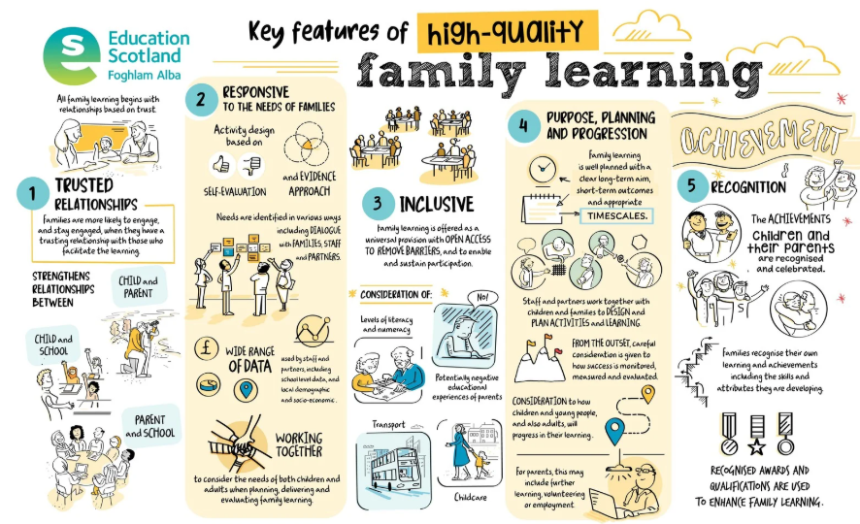
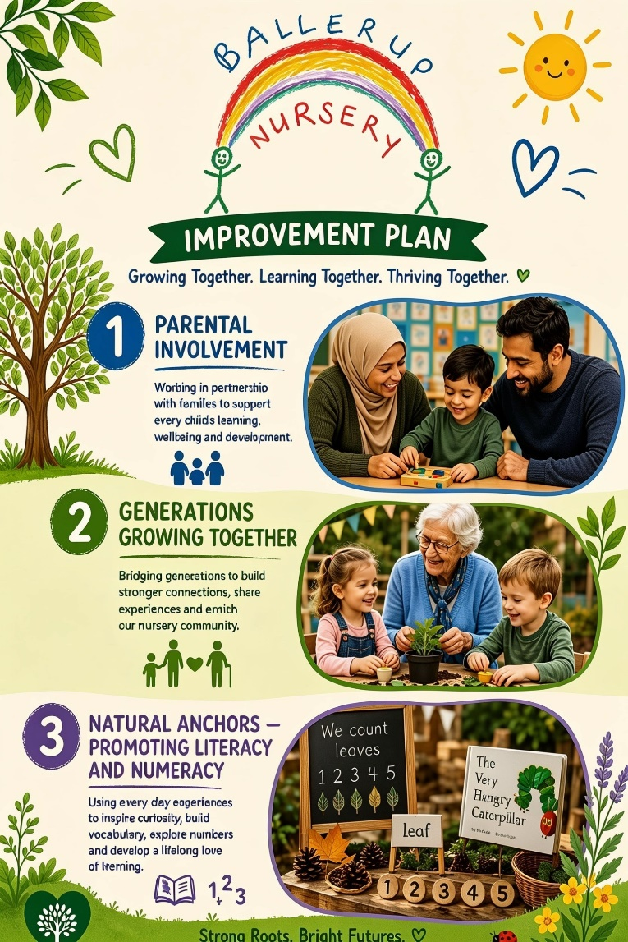

Strategic Priority 1 Improvement Planning and Standards and Quality Reporting for 2026/2027
Priority 1: Building Natural Anchors into the Nursery Day to Promote Literacy, Numeracy and Health and Wellbeing
NIF Priority (select from drop down menus)  Closing the attainment gap between the most and least disadvantaged children and young people  NIF Outcomes  Inclusive and relevant curriculum and assessment  Inclusive and relevant curriculum and assessment | Education Resources Priority (select from drop down menus)  Curriculum  Oustanding Learning, Teaching and Assessment |  | Quality Improvement Framework QI’s (select from drop down menus)  Learning, Teaching and Assessment  Curriculum (not childminders)  Staff skills, knowledge, values and deployment
Rationale for strategic priority | What difference do we want to make?  Outcome (Intended impact) | What will we do?  Operational activity and  Time scale | How will we measure success?  Measures |  | ELC Lead
Ballerup is committed to fostering a holistic approach to children’s development by embedding literacy, numeracy, and health and wellbeing across all aspects of learning. We recognise that strong partnerships with families, practitioners, and the wider community are essential in achieving positive outcomes for children.  We actively promote literacy, Numeracy, Health and Wellbeing through meaningful, real-life contexts as well as designated Natural Anchors in the nursery session.  Health and wellbeing are at the heart of our practice. We strive to create spaces that nurture positive mental health, mindfulness and emotional wellbeing for children, families, and staff.  These environments support children to connect with nature while developing confidence, independence and emotional awareness. | Through this approach, we aim to:  Support children to become confident, capable learners by developing strong literacy and numeracy skills in meaningful, real-life contexts as well as our Natural Anchors throughout the nursery session.  Promote positive health and wellbeing, ensuring children feel safe, valued, and emotionally supported.  Foster resilience, independence, and confidence through engaging experiential learning opportunities.  Encourage children to build strong relationships and a sense of belonging within a nurturing, inclusive environment. | *Resources to promote UNCRC for all children and families ensure that children’s voice is heard and at the heart of the relational pedagogy at Ballerup. Display the article 12 rights of the child promoting Child’s Voice.  *Create a catalogue of child-led/ adult initiated resources that can be utilised throughout the day to promote Literacy, Numeracy and Health and Wellbeing. Staff can access these with the children and promote a love of learning and curiosity.  * Promote time in the nursey session for Wellbeing and Emotional support such as Emotional Check-ins, rest periods, Sensory opportunities and Mindful practices.  *Staff are supported to develop a deeper understanding of the use of Data when tracking children’s development through the SLC Learning Trackers. Staff training and Drop- In Sessions will be available to promote staff’s understanding and Professional dialogue can take place between practitioners and management to gain an insight into the progress and next steps for the children.  * Planning Evaluations and Drop-In sessions for Staff to seek advice and support on developing and enhancing children’s learning and development. | *Self-evaluation  *Reflection through professional discussions to measure Staff’s Understanding/ Confidence using the Tracking Tools  *Feedback to staff/parents/children from Questionnaires, Consultations and Drop-in Discussions  *Tracking data will be reviewed termly and progress/ Next steps for learning can be identified and discussed  *Create opportunities at meetings and in-service days for staff to share their skills and knowledge.  *Staff sharing opportunities to lend support to colleagues, personal research, and in-house development.  *Staff create learning termly learning targets within the Curriculum to promote Literacy, Numeracy and Health and Wellbeing. These will be set and shared with the children and their families as well as the wider team during GIRFEC meetings.  *ACEL Data is gathered and discussed at Staff Meetings and areas for development or challenge are identified and planned for the learning environment. |  | *All staff  *Support from Management Team  *Support from EEL Team and Literacy Leads  *All staff  *Support from Management Team  *All Key Worker Staff  *Support and guidance from Management
Progress and Impact |  |  |  | Next Step(s) and rationale to inform SIP for 2027/2028 or establishment maintenance agenda

Strategic Priority 2 Improvement Planning and Standards and Quality Reporting for 2026/2027
Priority 2: Growing Generations Together – Intergenerational Work with Local Primary School and Care Home
NIF Priority (select from drop down menus)  Placing the human rights and needs of every child and young person at the centre of education  NIF Outcomes  Globally respected empowered, responsive education system; leadership, accountability and improvement  Young people's Health and Wellbeing; enhance impact of GIRFEC and partnership working | Education Resources Priorities (select from drop down menus)  Wellbeing, Equality and Inclusion  Self-evaluation for self-improvment |  | Quality Improvement Framework QI’s (select from drop down menus)  Leadership and Management of staff and resources  Nurturing Care and Support  Wellbeing, inclusion and equality (not childminders)
Rationale for strategic priority | What difference do we want to make?  Outcome (Intended impact) | What will we do?  Operational activity and  Time scale | How will we measure success?  Measures |  | ELC Lead
Promoting Inclusive Family Learning  We will create planned opportunities for siblings to learn, play, and explore together. These experiences will:  Encourage positive male engagement in early learning  Provide opportunities for shared activities, both indoors and outdoors  Support children’s emotional, social, and developmental wellbeing through Froebel Inspired Practice.  Build confidence family members to engage in learning environment through Intergenerational Work. | *To work in partnership with the local/wider community in the completion of the nursery garden of reflection.  * To encourage and celebrate the positive impact that family and intergenerational learning can have on the nursery community.  *To promote positive mental  health and a space of serenity and mindfulness for our children, staff, and families.  *Foster a sense of belonging for the whole family and provide inclusive activities that accommodate different developmental stages  *Support family bonds and shared learning  *Supporting a child’s wellbeing while simultaneously building family confidence through intergenerational work is a powerful, holistic approach to community education. When generations learn together, children gain a deeper sense of identity and security, while parents and elders feel valued and empowered to actively participate in the educational journey. | *To work in partnership with the local/wider community in the completion of the nursery garden of reflection.  * To encourage and celebrate the positive impact that family and intergenerational learning can have on the nursery community.  *Create a community space in the outdoor area Ballerup Buzzing Garden (Zen Garden) to promote wellbeing, calmness and musicality and wildlife. Using the  sustainability goals while working in collaboration with the wider community and stake holders within the nursery.  *Develop a FUDGE Groups (Fathers, Uncles, Dads, Grandpas and Extended Family)  We aim to establish and promote FUDGE groups to strengthen the involvement of male role models in children's lives.  Wandering Wednesday Sib Sync – Sibling Weekly Stay and Play Sessions with a literacy theme and time to play together.  *Sandra’s Bridge  Froebel Inspired Intergenerational Groups working with 2 local Care Homes. Promoting Froebelian Principles with the children and the residents, encouraging wonder and curiosity. | *Encourage peer learning across age groups through regular meetings and plans for intergenerational workshops. Attendance and engagement levels will be measured, and stake holders will be reflective and evaluative.  *Self-evaluation – Discussed at Meetings and Quality Assurance reviews.  *Reflection through professional discussions- Appraisals  *Feedback from staff/parents/children from Questionnaires, Consultations and Learning Journal feedback  *Create opportunities at meetings and in-service days for staff to share their skills and knowledge.  *Staff sharing opportunities to lend support to colleagues, personal research, and in-house development.  *Self-reflection at regular self-evaluation meeting sessions with practitioners, children, and families.  *Set and evaluate goals as part of practitioner appraisals.  *Training/course completion.  *Successful grant applications. |  | *All staff  *Management Team  *Group leaders/practitioners  *School Leadership Team  *Distributed leadership roles  *Group leaders/practitioners  *All staff  *Support from Management Team  *All staff  *Support from Management Team
Progress and Impact |  |  |  | Next Step(s) and rationale to inform SIP for 2027/2028 or establishment maintenance agenda
Strategic Priority 3 Improvement Planning and Standards and Quality Reporting for 2026/2027
Priority 3: Parental Engagement – Unity and Connectedness - Family Community
NIF Priority (select from drop down menus)  Closing the attainment gap between the most and least disadvantaged children and young people  NIF Outcomes  Improving relationships, behaviour and attendance  Globally respected empowered, responsive education system; leadership, accountability and improvement | Education Resources Priorities (select from drop down menus)  Outstanding Learning, Teaching and Assessment  Self-evaluation for self-improvement |  | Quality Improvement Framework QI’s (select from drop down menus)  Leadership and Management of staff and resources  Play and Learning  Leadership of continuous improvement (Not childminders)
Rationale for strategic priority | What difference do we want to make?  Outcome (Intended impact) | What will we do?  Operational activity and  Time scale | How will we measure success?  Measures |  | ELC Lead
*Support parents to feel more confident in supporting their child or young person’s learning at home and feel increasingly more involved in their child or young person’s learning through online journals.  *Ensure all parents receive important information that they need to understand and support their child’s learning. Ensure this information is circulated effectively in a timeous manner.  *Ensure targeted groups of parents (British Sign Language, English as an Additional Language) are supported well to access many aspects of school life in a way that meets their needs and allows them to engage with their child or young person’s learning. Engage with groups to identify strategies which ensure their needs are met. | *Targeted Skills Development: Create a structured approach to boost parents' confidence and capabilities in actively supporting their child’s early learning journey.  *Professional Training Opportunities: Deliver accessible, high-quality training sessions tailored for parents.  Promoting Best Practice: Embed the guidelines from the Care Inspectorate’s practice note to actively champion family and parental involvement across the setting.  Respond to the needs of Families by identifying the needs through relationships and regular dialogue with families, children and partners.  Promote ‘Nurture and Attachment’ through staff and family training sessions where the Nurture Principles are shared and explored. | Active Daily Participation: PEEP Sessions, Stay and Play Sessions and Book Bug Sessions to promote Family Involvement with a focus on Literacy, Numeracy and Health and Wellbeing. Ensure parents have a visible, hands-on role in daily nursery life, directly engaging with and supporting play-based pedagogy (e.g., family cooking sessions, story sharing, outdoor games).  *Home-Link Bags/ Boxes will be produced to promote Home Learning and build parents understanding of Literacy, Numeracy and Health and Wellbeing skills that can be developed at home.  *Continue to develop and build on relationships with the Family Support Hub and promote/ refer families where support is required.  *Apply for Attachment Pledges’ through SLC and create an action timeline for the year to promote the Nurture Principles within the nursery and home setting. Using the ‘Just One More Thing’ promotion of families adding a Nurture Time into the routines of the day. | *Engagement in these sessions will be evaluated and measured, and reflections will be gathered at Self-Evaluation Meetings and Working Group reviews.  *Consultation with parents/carers on their availability on when they can attend events that suits them. (Ongoing throughout the year for continuous reflection and change)  * Practitioners and families to work together to develop the family room and access to family learning opportunities.  *Apply for relevant grants and utilise current grant money to buy the materials and resources required for the implementation of Family Involvement. (Froebel Grant)  *Meet and plan with the Family Support Worker Team on creating a link between the settings and promoting an ethos of ‘Team Around the Family’ to support all. |  | Team Leader and Working Group  *Group leaders/practitioners  *School Leadership Team  *Distributed leadership roles  *Group leaders/practitioners  *All staff  *Support from Management Team  *All staff
Progress and Impact |  |  |  | Next Step(s) and rationale to inform SIP for 2027/2028 or establishment maintenance agenda
What Difference did we see? What did we achieve? What does data tell you?  Evidence collected to inform self-evaluation.  Include bullet points throughout the year on progress of the above.  Evaluative statement to be written at end of term as would be in you S&Q. |  |  |  | Clear next steps to be identified based on evidence and decision if this continues to be further strategic priority or moves ton maintenance.  Similar to what has been added to the rationale above.

Maintenance Agenda
Key actions | Relevant stakeholder involvement | Timeline for completion

Evaluation of Quality Indicators June 2026
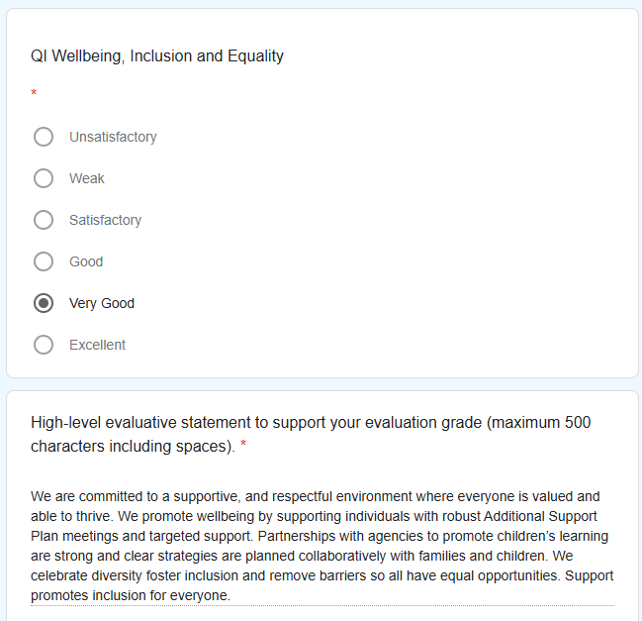
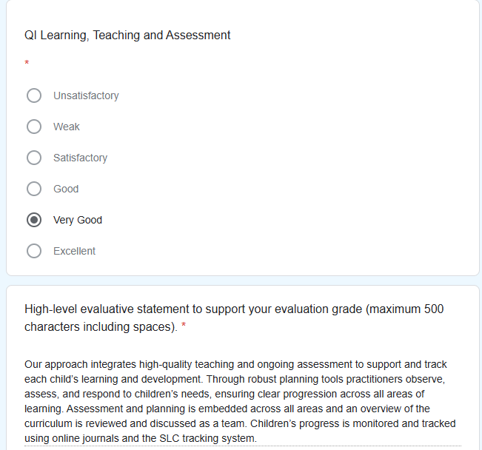
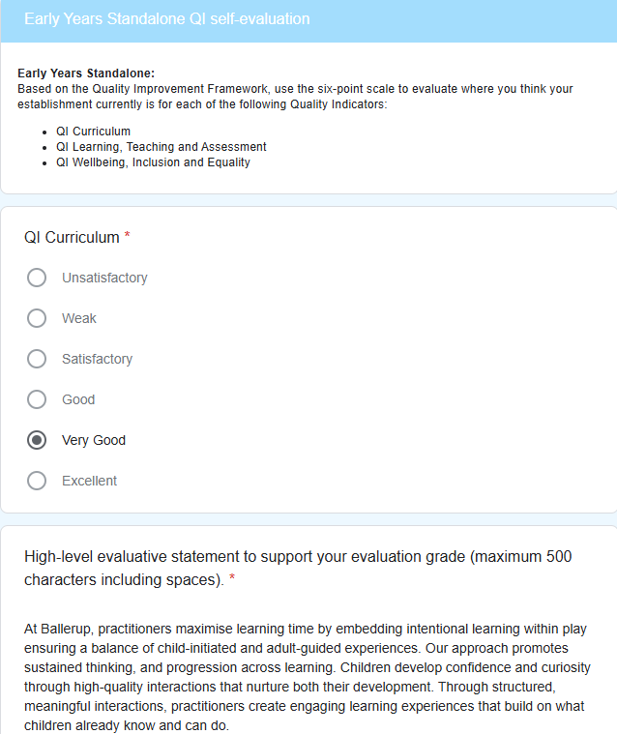
Copy/paste or use snipping tool to insert self-evaluation of QIs from Google Form.

