Make a Party Hat  You will need:  - Paper or card  - Tape or glue  - Colouring materials  - Any decorative materials  - String to attach  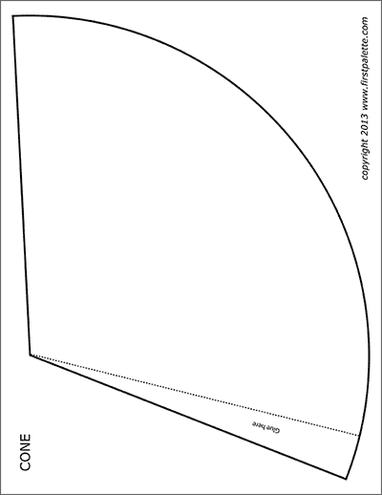  Ask an adult to help you draw the template shape below and cut it out. Decorate the outside with pencils or crayons before rolling into a cone and securing with tape or glue. Add any sparkles or pom poms or whatever you have to jazz up the hat. Attach the string, ask an adult to help you check the size!  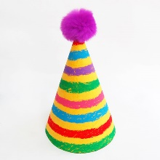 | Write an Invitation  Make a party invitation for a friend. What information will your invite need? Think about…  Where…?  When…?  Time…?  What type of party…?  Theme…?  Make sure you include a name and number for your party guest to reply to to let you know if they are coming!  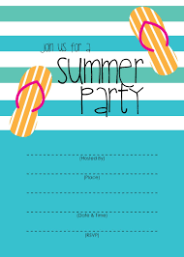  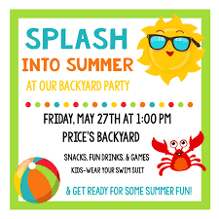 | Make a Poster  Time to decorate! Make a fun Summer themed poster for your party – what kind of things make you think of Summer…?  Sun….sand…sea….palm trees…relaxing…  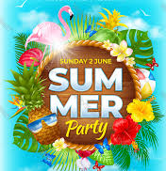  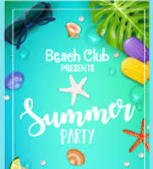
Create a Tuck Shop Price List  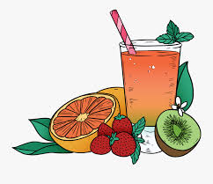  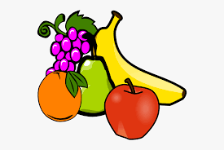  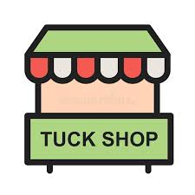  Your guests might get peckish – what kind of snacks might you sell at your tuck shop? Think about the prices of each item and make sure these are clear on your list.  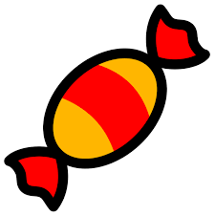 | Dance Party – DJ Set List  Make a list of your favourite songs to play at the party – everyone enjoys good music! Can you make a dance to your favourite song on the list? | Party Games  Choose your favourite party game to play at the party. Write a list of instructions on how to play the game/what the rules are!  