Health and Wellbeing – Here Comes Summer W/B 22nd June 2020

Planning an End of Year Party

Part of looking after your wellbeing is making sure you feel good emotionally so why not plan some sort of party to celebrate finishing the end of the school year? It could be a party, picnic or even just your favourite dinner or lunch with your family.

Monday
Things to think about:
- Who are you going to invite? The new lockdown rules state that you can meet up with people from 2 other households. Do you want to celebrate with 2 of your friends and their families or would you like to celebrate with people from your own family e.g. grandparents, cousins etc.
- Where will the party take place? Will you have your party in your garden or will you go to a public place like a park?
- How will you invite your guests? You could hand make some invitations today and drop them at your guests’ house or you could call or message them to ask if they are free. Don’t forget to include the date, time and where the party will take place.
- Will your party have a theme? If you want, your party could have a theme e.g. summer, rainbow, football etc. Your decorations and what people should wear to the party could be based on this.
- Make some decorations. You could make some banners, bunting, paper chains or streamers from paper. If you have some in the house you might want some balloons too! Maybe you want to print out some photos or draw some pictures to remind you and your guests about the good fun you’ve had with them during the school year.

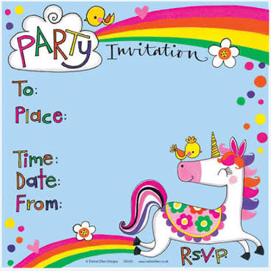
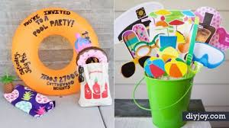

Tuesday
- Think about what will happen at your party. Will you play any games? Will you have a paddling pool out if it’s a nice day? Will you ask people to share their best/funniest memory from school this year? Make a note of some of your ideas and get together any of the things you think you might need.
- Think about any food or drinks you might want to get for your party. Will you put out some snacks like crisps, sweets, fruit, veg sticks and dip? Or will you be allowed to have things like sandwiches and sausage rolls? Talk to your parents and decide what to get at the shops or have a look to see what you already have in the house.

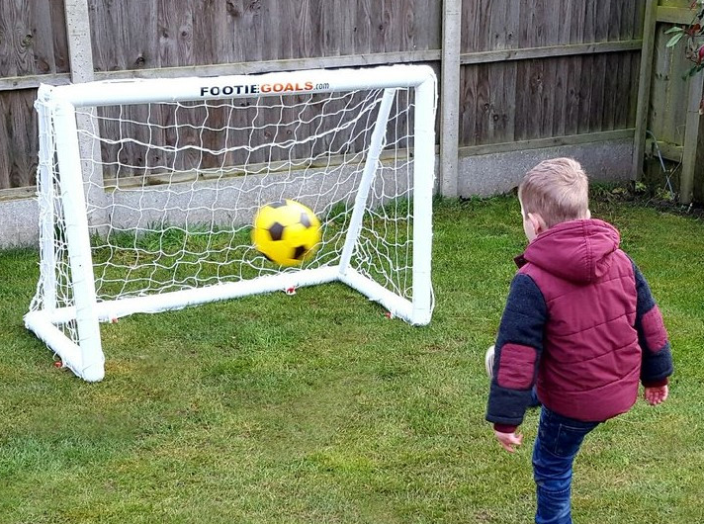
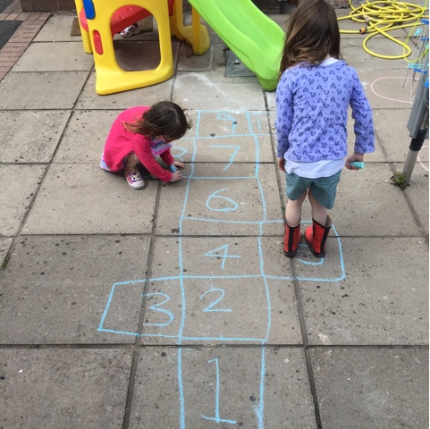
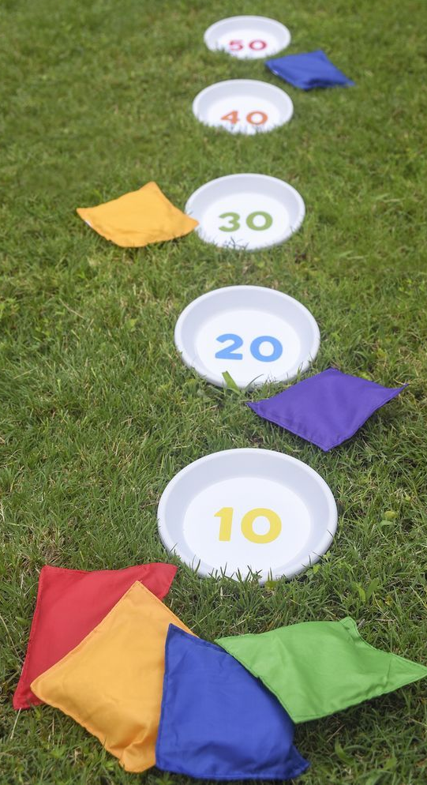

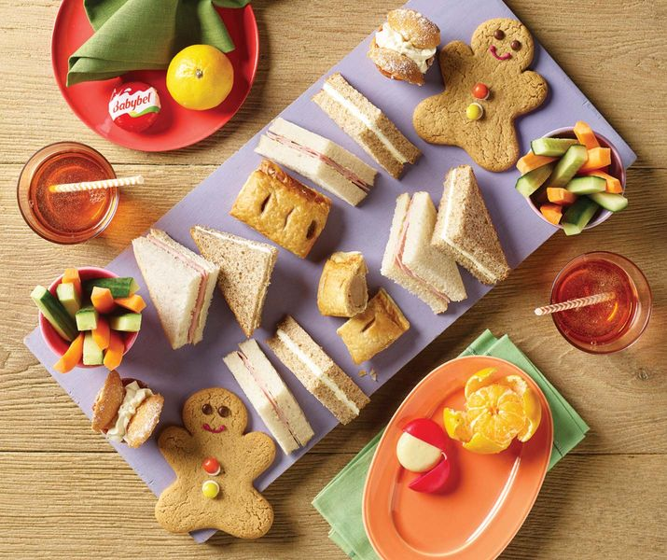

Wednesday
Ittttttt’s party time! The last day of school is finally here and it’s time to celebrate.
- Choose what you are going to wear to the party
- Put up the decorations
- Make any sandwiches etc., and lay out food
- Make a playlist so you can have music playing in the background
- Enjoy a well-deserved rest and celebration with your favourite people after a busy year of working hard. See you next year!

