Fun facts  Find out some facts about ice cream.  - When was the first ice cream cone made?  - How big was the biggest ever ice cream?  - What are the most popular flavors of ice cream? | Add up the cost  Here are some ice creams, find out the cost for each one.  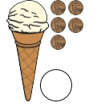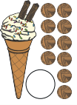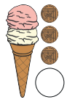  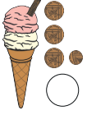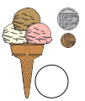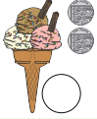 | Number names  Draw a cone with 10 scoops like this one.  Colour the first scoop blue.  Colour the ninth scoop yellow.  Colour the tenth scoop red.  Colour the fifth scoop green.  Colour the second scoop purple.  Colour the last scoop orange.  Colour the third scoop brown.  Colour the ninth scoop black.  Colour the fourth scoop pink.  Choose any colour for the fourth scoop.
Ice Cream cones  Click on the ice cream below to watch the clip. It might help you answer some questions above.  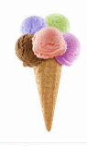 | Tally  I have collected some favourite ice cream flavours. Can you complete the missing numbers or tally marks.  Chocolate Strawberry Vanilla Mint  5 10 12  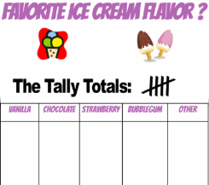 | Science  