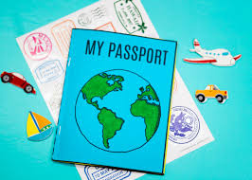  Passport  Imagine you are getting to go abroad for the first time – you will need a passport. Use the example below to create a pretend passport for your holiday. | 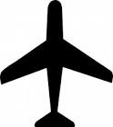  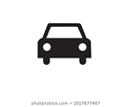  Travelling  Using Google Maps  Can you click on the blue arrow (directions). Put in your starting address and destination (country you have chosen to visit). Note down the varying times it will take you to get to your chosen destination. This may be by car, plane, train or walking. | Paper Aeroplane  Many people fly to go on their summer holiday.  Use one piece of paper to create your own paper aeroplane. See how far and how high it can fly. Can someone else in your house make one and you could have a competition to see whose aeroplane flies the furthest? Here is a Paper Aeroplane Tutorial to help you make yours.
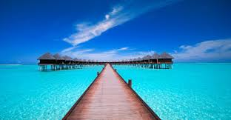  Destination  Choose a country you would like to visit on holiday. Use the internet to research 3 facts about this country. | 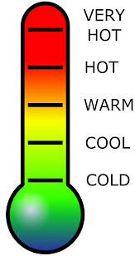  Weather  Use the Holiday Weather website to find out what the average temperature is in June, July and August for your chosen country. | 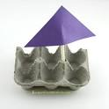  Boat  To go on holiday to some countries you can go on a boat (also known as a ferry) or some people may choose to have a holiday on a boat (called a cruise). Use anything you can find that will float (egg boxes, yogurt pots etc.) to try and make your own boat. Place your boat in water and blow on it to make it move across the water. Time how quickly you can get it from one side to the other. Can you make another boat using something different and see if it is any quicker?
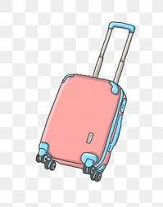  Suitcase  Teddy has never been on holiday abroad before. Read his letter (below) and help to draw a suitcase with the things he needs or write a list. | 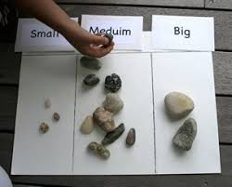  Size Sorter  Pretend you have gone to a pebble beach. On a walk or around your garden collect different sizes of pebbles. Can you sort these into small/medium/large? | 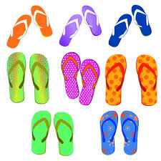  Flip Flops  Using paper or card, draw around a pair of shoes you already have. Design your own pair of flip flops that you could pack for your holiday. Make these as colourful and bright as you can.
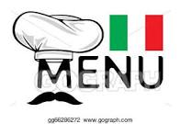  Menu  Create a menu themed around food for your chosen country. You can use the internet to find out what type of food the country is famous for e.g. Italy is famous for pizza and pasta. Remember starters, main courses and desserts. | Ice Cube  When you are on holiday it is usually lovely and hot. A cool drink is made refreshing by adding ice.  Take an ice cube out of the freezer and leave it outside. Time using a stopwatch on a mobile phone how long it takes to melt. You can compare one in the sun and one in the shade, to see which one melts first. | Ice Cream  Whilst on holiday everybody enjoys an ice cream. Why not have a go at making your own easy ice vanilla ice cream using the following recipe:-  Vanilla Ice Cream  Enjoy!
Postcard  Look at pictures of the country you have chosen. Can you create a postcard? Remember the front of a postcard usually has a picture of something from the country e.g. a beach, famous landmark and the name of the place. | I Spy to 20 Summer Challenge  Use the I spy challenge attached below. Can you count how many of the following there are:-  - bikes  - ice creams  - people on rubber ring  - drink  - ice lolly  - sandcastle  - sunglasses  - sun  - flip flops  - beach ball  Can you write the numeral (1, 2,3) and the number word (one, two, three)? | STEM Challenge  Many people stay in the UK or go abroad in their car to go on holiday. Your challenge this week is to create your own CARDBOARD CAR.  The instructions for creating your cardboard car are detailed below.
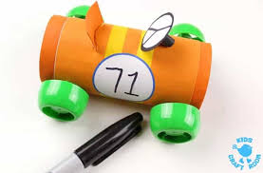
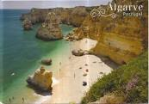

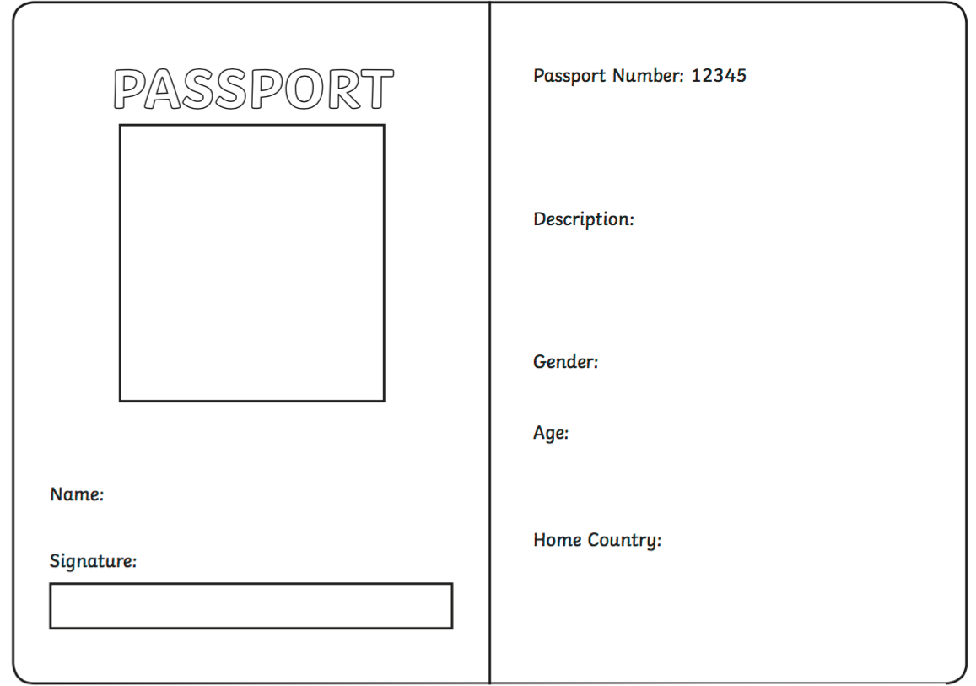

Hello children!
My name is Buttons the Bear. I have a bit of a problem and I am hoping you can help me.
My friend Zach and his family are going on holiday soon and they have given me a little suitcase to pack the things I want to take on holiday with me. However, I have not been on holiday before so I’m not sure what I need to take. Please can you help me pack my suitcase?
I know we are going to a sunny beach but what should I take? What clothes do I need? What toys should I take?
Thank you for your help, children. I might send you a postcard!
From
Buttons the Bear

