Health and Wellbeing – Here Comes Summer W/B 15th June 2020

 | Monday | Tuesday | Wednesday | Thursday | Friday
P1 and P2 | Sun Safety  With the good weather here it is important that you know how to keep your skin safe when out playing out in the sun. Watch this 5-min video about ‘George the Sun Safe Superstar’ and talk about what you learned with an adult.  https://www.sunsafeschools.co.uk/resources/georgeTheSunSafeSuperstar/  Then, draw a picture of you being safe in the sun. Make sure you remember to draw important things in your picture like a hat and sun cream!  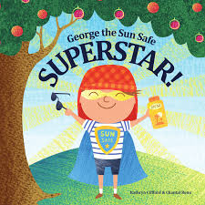 | Summer Mindfulness Colouring Sheets  Click on the link in my blog post to access some lovely summer themed mindfulness colouring sheets. There are 5 different ones to choose from!  If you don’t have a printer than you could get an adult to try and copy the outline on a piece of paper for you to colour in.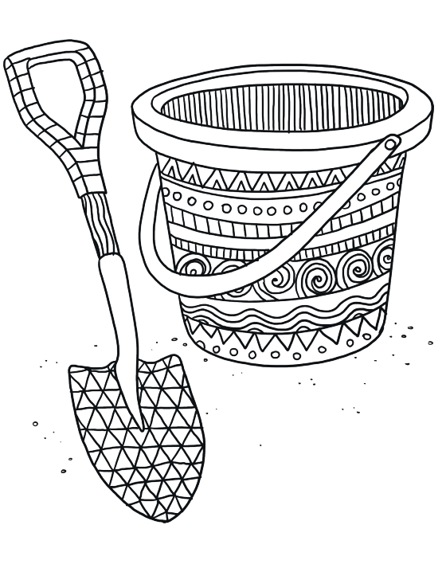 | Teddy Bears Picnic  Why not have a lovely picnic outside for lunch? Set up a blanket and choose some teddies to join you for the picnic. Try to think of some healthy things you could have at your picnic like some salad in your sandwich, some fruit or some carrot sticks to put in dip.  Maybe you would like to listen to a story with your teddies. Here are two stories that have bears in them!  The Bear Who Came to Babysit:  https://www.youtube.com/watch?v=wZ7qSpVWUS8  Goldilocks and the Three Bears https://www.youtube.com/watch?v=qOJ_A5tgBKM  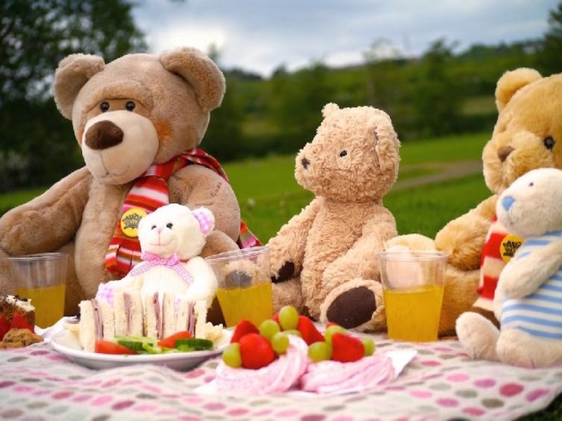 | Meeting Your New Teacher Worksheet  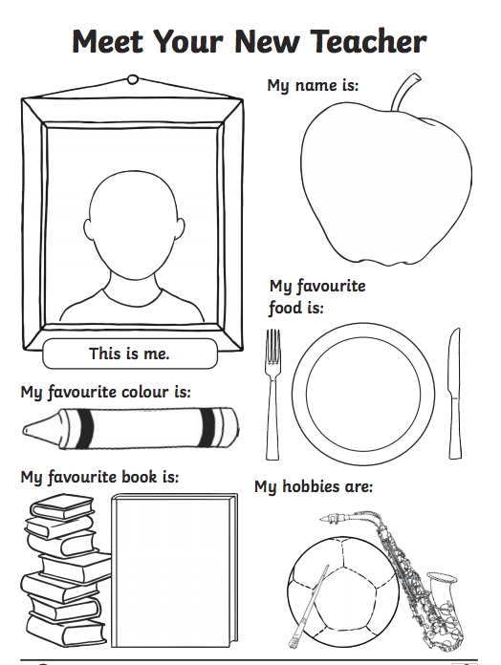  Use this worksheet so that when you find out who your teacher is you can let them know a little bit about you. If you don’t have a printer you can put your information on a piece of paper. | Make a Healthy Ice Lolly  Use the recipe card on my blog post to make some delicious ice lollies to keep you cool!  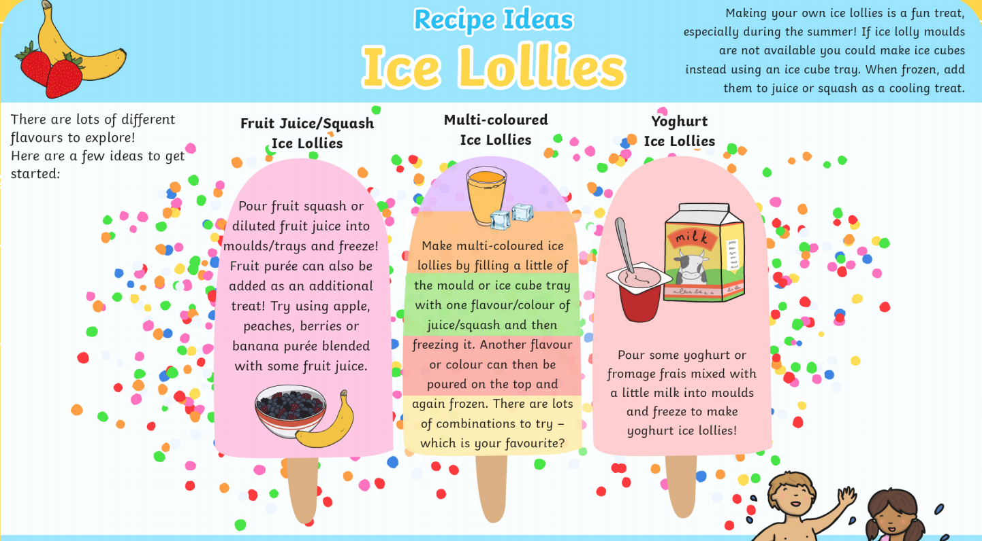  There are 3 different options and it also gives a tip for what you can use instead of ice lolly moulds if you don’t have them. Enjoy!
P3 and P4 | Sun Safety  Now that we are able to spend more time outside with the good weather it is important you know how to keep safe from the sun. Look at the ‘Sun Safety PowerPoint’ which is in my blog post.  Then make a sun safety poster to show what you have learned. Remember posters should be clear and eye catching!  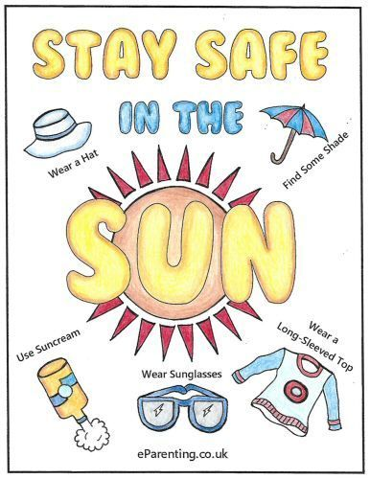 | Summer Mindfulness Colouring Sheets  Click on the link in my blog post to access some lovely summer themed mindfulness colouring sheets. There are 5 different ones to choose from!  If you don’t have a printer than you or an adult could copy the outline on a piece of  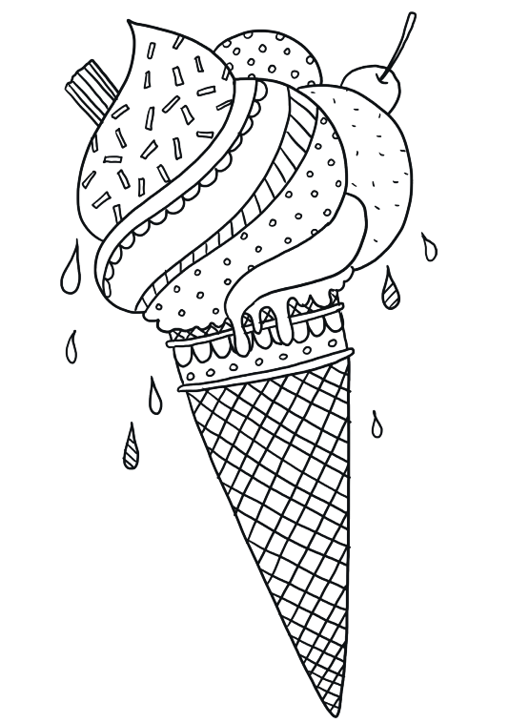  paper. | Planning the Best Picnic Ever  Use the ‘Planning the Best Picnic Ever’ sheets posted in my blog post to help you plan a summer picnic for you and your family!  Seeing as this is a HWB task I would like you to think about when we learned about the eatwell plate. What could you have at the picnic that would be healthy? Can you include some fruit and veg, protein, carbohydrates and some dairy? But don’t worry, there’s a space on the planning sheet for sweet treats!  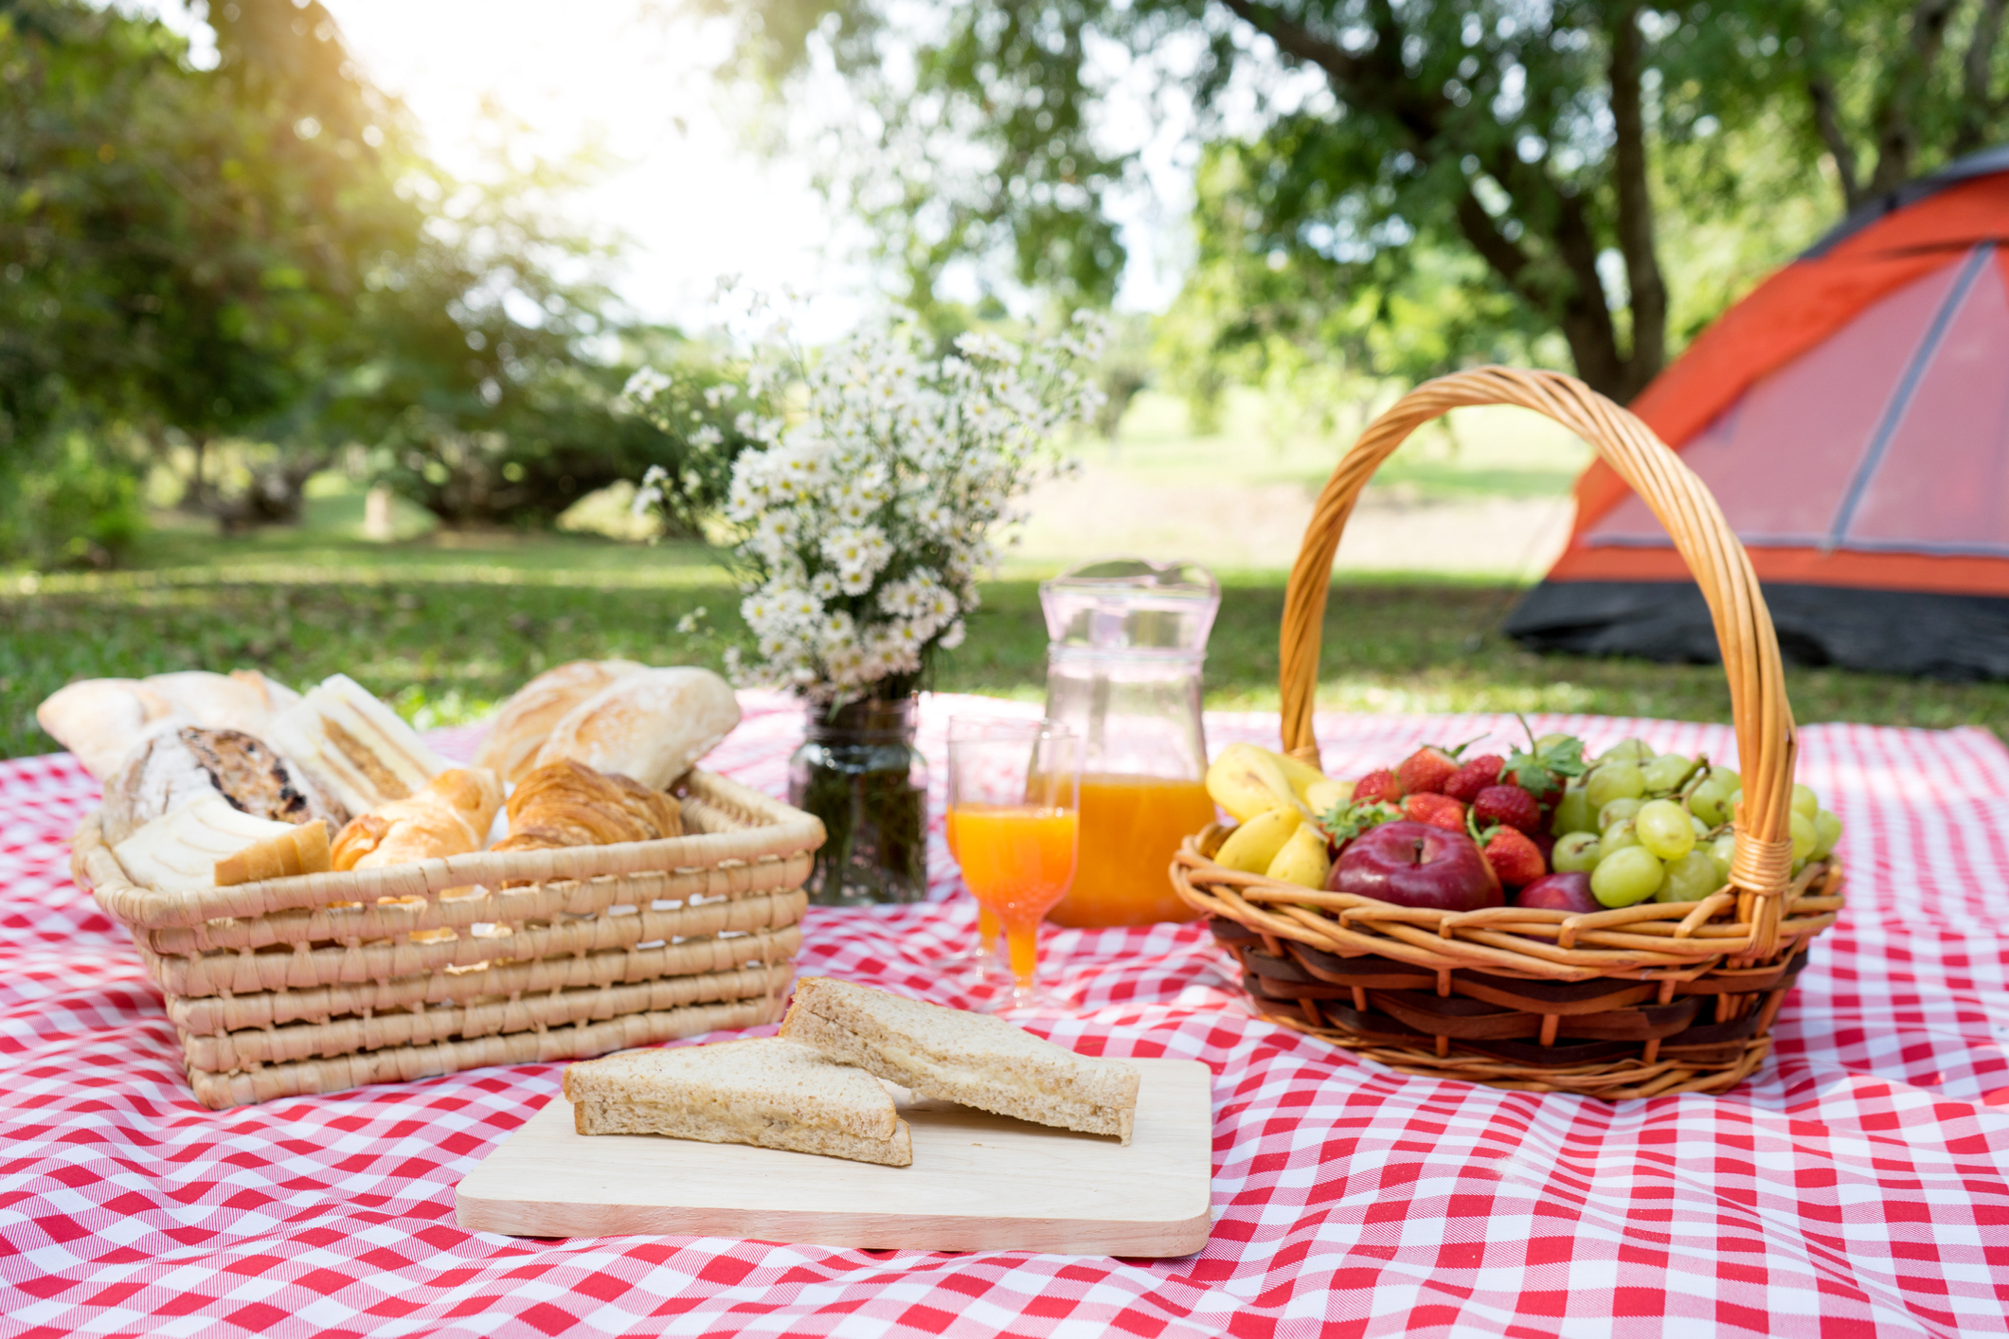 | Summer Bag Challenge  Use the ‘Summer Bag Challenge’ worksheet from my blog post to let your new teacher get to know you a little! You can print the document out or draw it and fill it out on a piece of paper and show it to your new teacher once you know who they are.  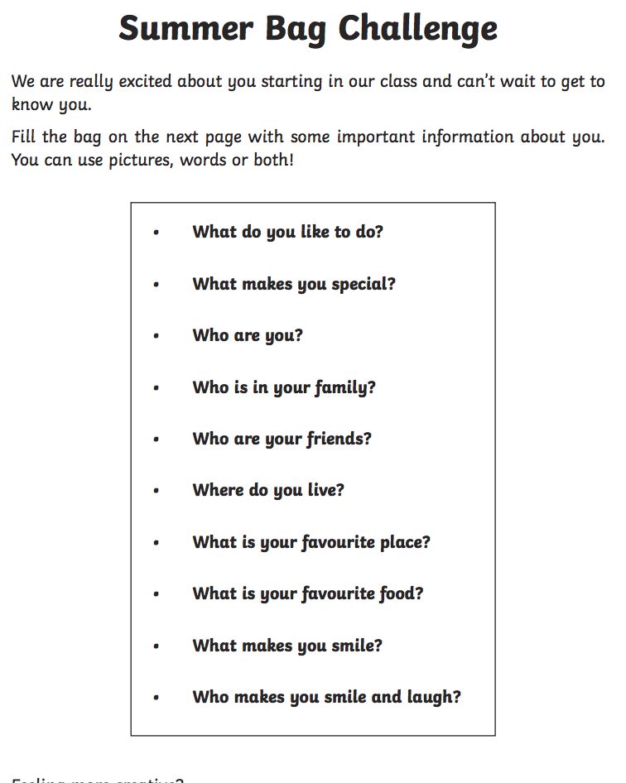 | Rainbow Fruit Kebabs/Veg Kebabs  https://www.bbcgoodfood.com/recipes/rainbow-fruit-skewers  Try making some fruit kebabs to keep you refreshed! You can use the recipe above or choose your own fruit.  If you prefer vegetables to fruit then here is a recipe for you:  https://twohealthykitchens.com/rainbow-veggie-kabobs/  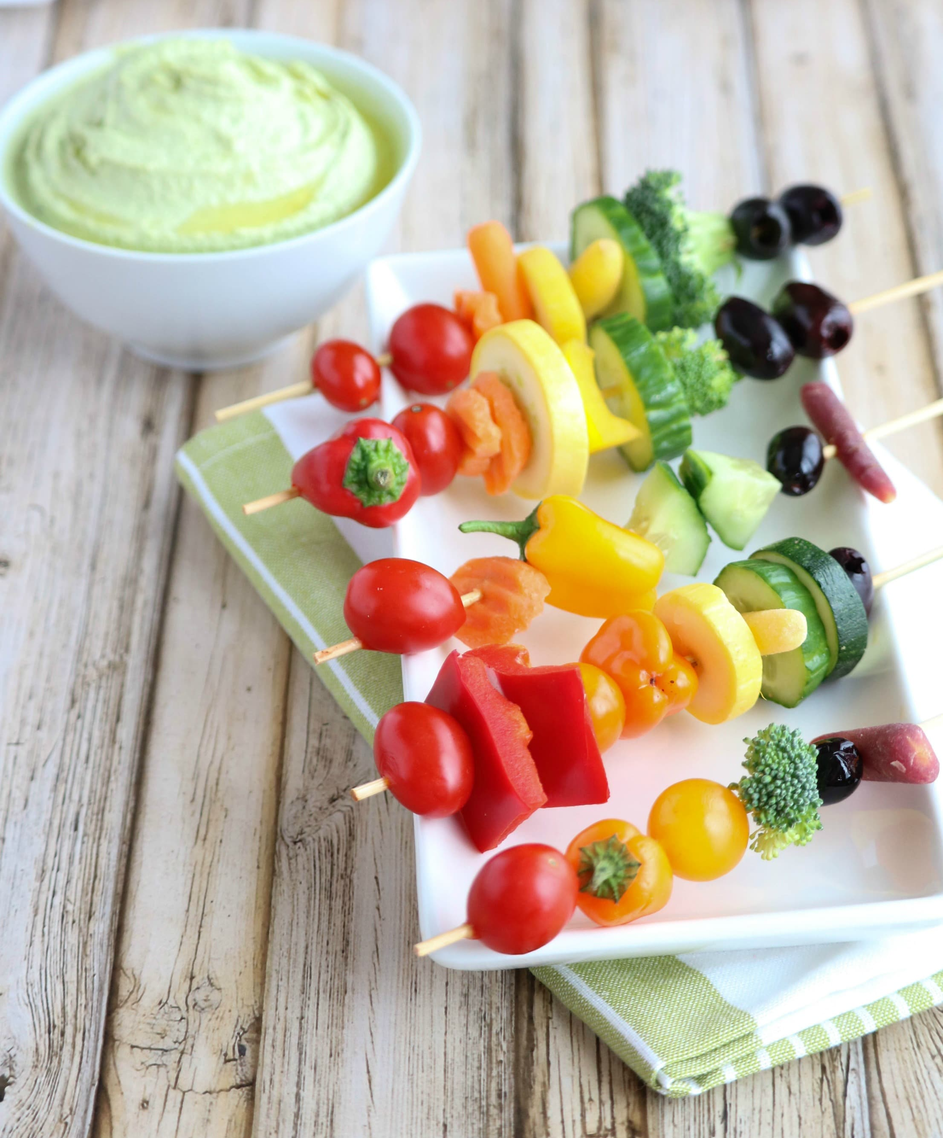  If you wanted, you could also grill them!  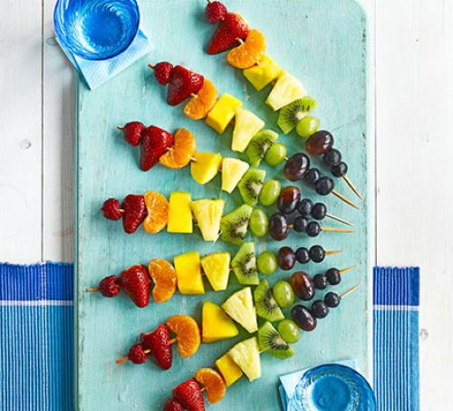
P5, P6 and P7 | Sun Safety  By now you should know to protect yourself when in the sun but you may not realise that if you don’t, you are at risk of developing skin cancer. Many young people think it’s ‘not cool’ to wear sun cream or that if they do, they won’t get a tan. This is not true!  Challenge – design a poster/make a video to persuade people your age to be smart with their skin in the sun. How could you make them realise it’s not ‘uncool’? Do you think people your age really understand the effects of the sun e.g. painful and red skin, sun stroke, getting wrinkly skin earlier, increased chance of cancer etc. Maybe you could google celebrities that always use sun cream and use that to persuade people. | Summer Mindfulness Colouring Sheets  Click on the link in my blog post to access some lovely summer themed mindfulness colouring sheets. There are 5 different ones to choose from!  If you don’t have a printer than you or an adult could copy the outline on a piece of paper.  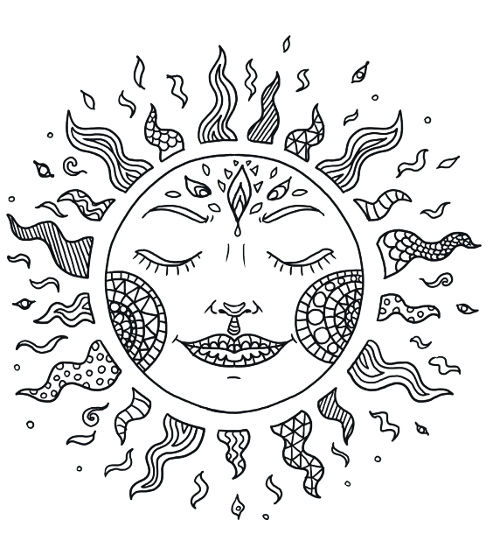 | Planning the Best Picnic Ever  Use the ‘Planning the Best Picnic Ever’ sheets posted in my blog post to help you plan a summer picnic for you and your family!  Seeing as this is a HWB task I would like you to think about when we learned about the eatwell plate. What could you have at the picnic that would be healthy? Can you include some fruit and veg, protein, carbohydrates and some dairy? But don’t worry, there’s a space on the planning sheet for sweet treats! | Transition Worksheets  P5 and P6  Use the ‘Summer Bag Challenge’ worksheet from my blog post to let your new teacher get to know you a little! You can print the document out or draw it and fill it out on a piece of paper and show it to your new teacher once you know who they are.  P7  As you move on to Secondary school it can be good to think about what your hopes and dreams for the future are. This can help to keep you focused so that you can achieve them! Complete the ‘Hopes and Dreams’ worksheet. I know Miss Weir and I would love to see these! | Fruity Mocktails!  Pretend you’re on holiday with these delicious mocktail recipes!  https://www.bbcgoodfood.com/howto/guide/top-5-mocktail-recipes-kids  https://www.healthylittlefoodies.com/mocktail-for-kids/  You could even make your own decorations like these cocktail stick umbrellas  https://www.youtube.com/watch?v=9NXEnGiOeUU  