P7 Home Learning Activities -Week beginning 15th June 2020
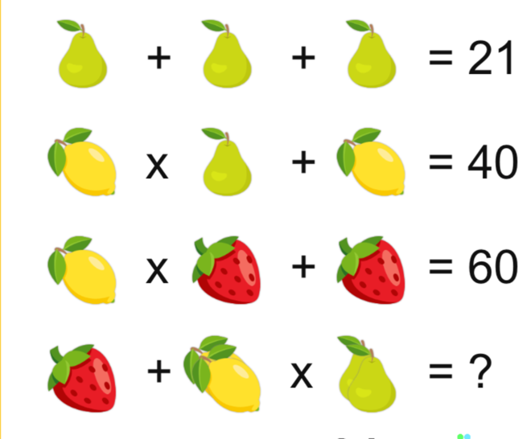  Find further examples at www.solvemoji.com | The Power of Thoughts  If we concentrate on the positives, this can help to change our mindset and mood. Create your own motivational message. | The answer is pineapple, what is the question?  Write down at least 5 possible questions then create some examples of your own.
Boardgame  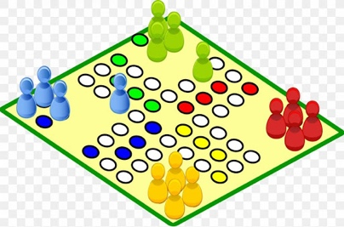  Design and make a boardgame then play it with your family. | Taste Test  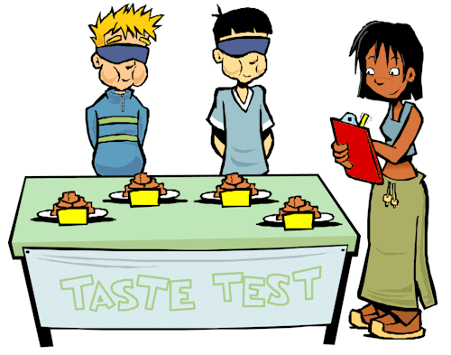  Take part in a family taste test. One person should be blindfolded and will need to guess what food they are tasting. | Get Building!  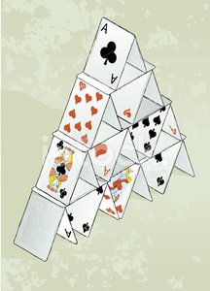  You could build a Lego model, a tower of playing cards or something else!
Science  The clip below looks at how materials change from solid to liquid and back to solid. Enjoy watching how chocolates are made and perhaps attempt this at home with help from an adult. Don’t waste the chocolate, make some chocolate crispy cakes for others to share.  https://www.stem.org.uk/resources/elibrary/resource/34080/understanding-reversible-change |  | Music time  Write a song or rap about your time at primary school.
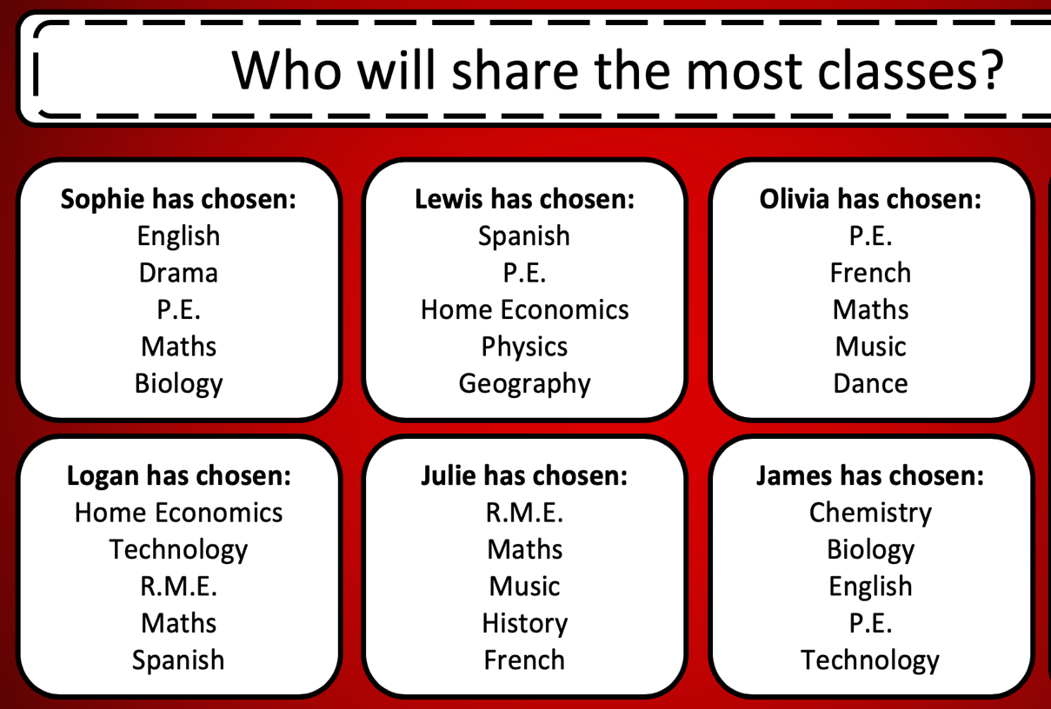
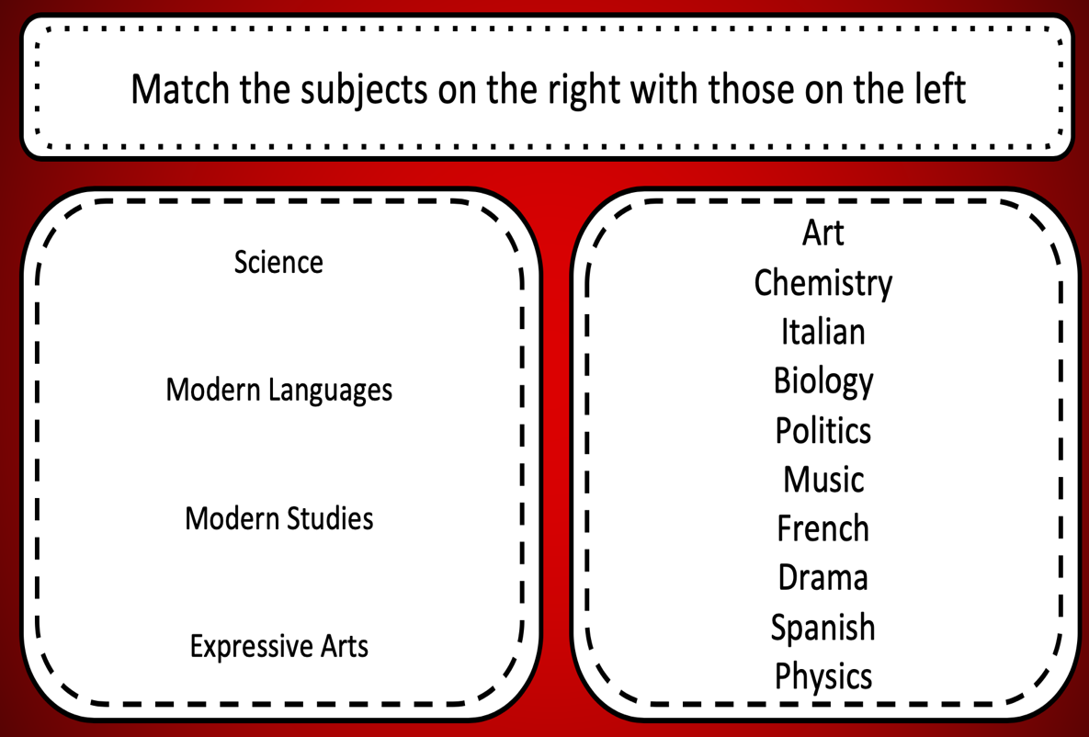
P7 Transition

