Try some rock art  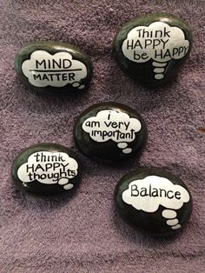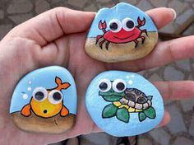  Go for a walk and see if you can find some well-shaped rocks that would be suitable for painting. Have a go at painting some pictures or messages on them. | Poster  Think about your local area. Think of the interesting things you can do and places to go.  Make a poster advertising Blantyre as a place to visit. Remember to use pictures, text and lots of colour.  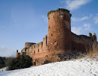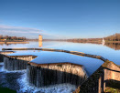  Bothwell Castle Strathclyde Park | Design  You have been shopping online and you can’t find the summer T-shirt that you want.  Have a go at designing your own T-shirt.  Think about shape, colour, design.  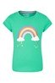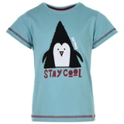
Scottish Wildlife Trust  Log on to the Scottish Wildlife Trust website and see what you can find out about ospreys.  https://scottishwildlifetrust.org.uk/  There are lots of other animals to find out about on this site.  Which animal is your favourite? | Scavenger Hunt  Make a list of the letters a – z.  Go for a walk and see if you can find an item that begins with each letter of the alphabet.  Some are easy like f – feather. Some are more of a challenge. | Science  https://www.stem.org.uk/resources/elibrary/resource/34080/understanding-reversible-change  This clip looks at how materials change from solid to liquid and back to solid.  Enjoy watching how chocolates are made and perhaps attempt this at home with help from an adult.  Don’t waste the chocolate, make some chocolate crispy cakes for others to share.
Quick Practice  652 - 183 = 237 - 170 = 403 - 23 = 101 + 107 = 416 + 40 = 642 + 192 = 585 + 413 = 844 - 25 = 509 - 83 = 112 + 249 = 413 + 480 = 832 - 124 = 896 + 104 = 752 - 249 = 396 + 370 = 541 + 240 = 643 - 286 = 13 + 394 = | Mad multipliers  24 x 5 = 37 x 2 = 19 x 5 =  16 x 7 = 28 x 6 = 67 x 3 =  34 x 4 = 17 x 5 = 82 x 4 =  12 x 9 = 66 x 6 = 15 x 3 =  75 x 4 = 14 x 9 = 29 x 7 = | Design a Sports Day event  Use the attached sheet to design a sporting event that would be great to use on a school sports day.
Design your own Sports Day event

Design a sporting event suitable for all ages and abilities
Equipment needed:
Draw a picture of your event.
______________________________________________
______________________________________________
______________________________________________
______________________________________________
______________________________________________
______________________________________________
______________________________________________

Rules:
________________________________________________________________________________________________________________________________
________________________________________________________________________________________________________________________________
________________________________________________________________________________________________________________________________
________________________________________________________________________________________________________________________________
________________________________________________________________________________________________________________________________
________________________________________________________________________________________________________________________________
________________________________________________________________________________________________________________________________
________________________________________________________________________________________________________________________________

