Nature Picture  Gather twigs, branches, leaves, pebbles, and other natural resources to make a life-sized you.  What else can you create from using these resources? | Flower Hunt:  Go on a hunt for as many different plants or flowers- take a photograph of what you find.  Can you create a picture of what you have seen?  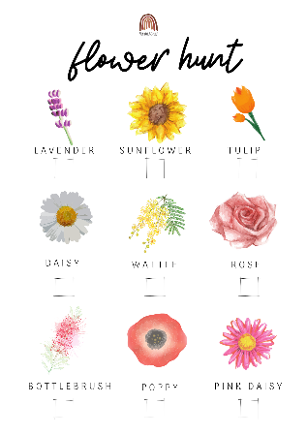  Can you be creative with your pictures? | Use chalk to draw a game of hopscotch outside.  Can you think of any other games you can create and play outside with chalk?  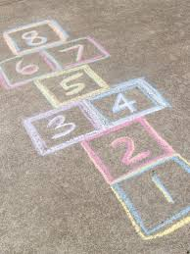
Make a paper windmill and take it outside on a breezy evening to make sure it that it spins properly!  Here is a video to help you:  https://www.youtube.com/watch?v=xUpCuwf3JEg  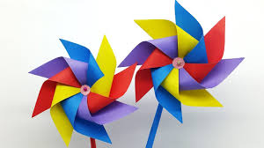 | Design a Summer postcard.  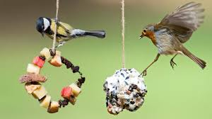  Design a postcard to your family or friends. Remember a postcard needs to have a picture on the front and a message on the back. Let the person you are sending the postcard know how you are feeling, what have you been and what you are looking forward to during Summer. Remember a postcard needs to include the persons name and address.  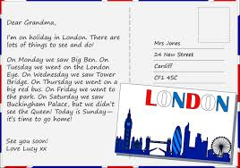 | Create a bird feeder out of natural or recyclable materials.  The link below gives you some tips:  https://www.bbc.co.uk/cbeebies/makes/bird-feeder
Write a Summer Acrostic Poem.  Remember an acrostic poem is when the word is down the side and each sentence as to start with that letter. To help you remember to think about your senses. What are the sights, smells, tastes, sounds, and touches for you?  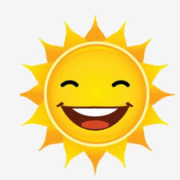  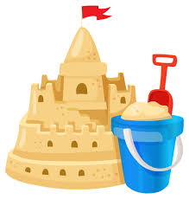  S  U  M  M  E  R  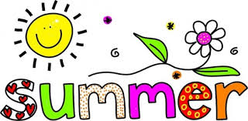 | Lie back and see what shapes you can see in the clouds, then draw what you see.  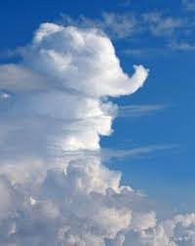 | Use feathers, beads, and any other objects to make an eye-catching wind chime.  Here is a link to help you.  https://www.youtube.com/watch?v=QRgum3KzfLo  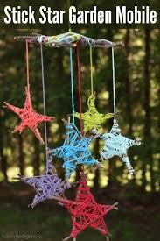
Make some ice lollies using diluted juice, lollipop sticks and a freezer. If you’re feeling adventurous, add some more ingredients! You could add fresh fruit or yoghurt.  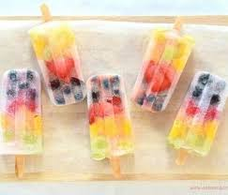 | Paint any spare pebbles or stones you have and turn them into colourful creature.  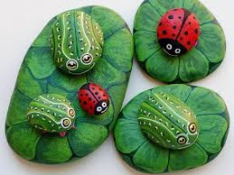 | Make a collage of some of the living things and non-living things you can see when you are outside.  