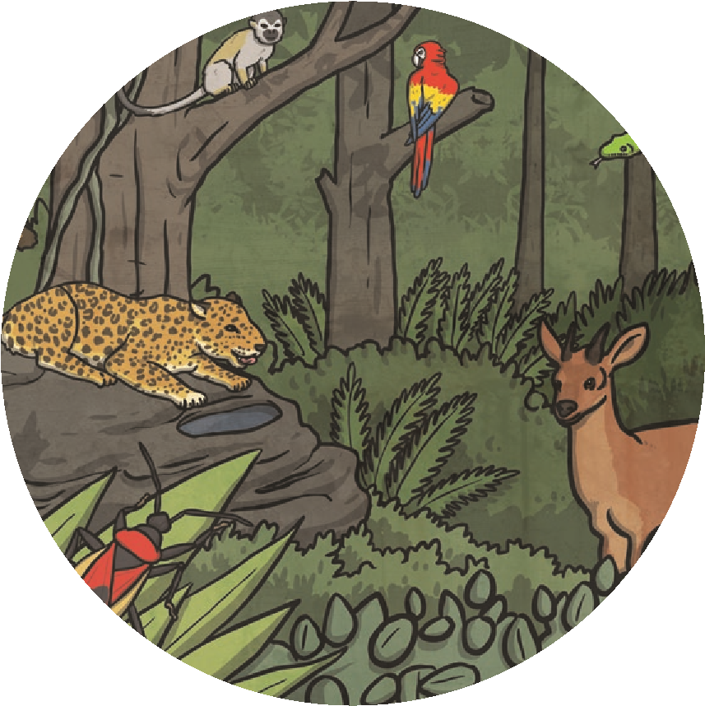
Tribes of the Rainforest
Our rainforests are not just home to animals and plants; they are also home to groups of people. There are many tribes of people who call the rainforest home but the most well-known are the Yanomami tribe, the pygmy tribe and the Huli tribe.

The Yanomami Tribe
The Yanomami tribe live in the South American rainforest. Some of those in this tribe have had little or even no contact with the outside world. It is believed that there are around 35 000 people in this tribe living in the rainforest.
The Yanomami place a great deal of importance on equality. As a result of this, they have no chiefs, unlike many other tribes.
They live in very large circular houses that have no coverings over their central areas. There can be as many as 400 people living in one of these houses. The area in the centre is kept for social gatherings and families have their own space for sleeping and cooking around the covered section.
When it comes to clothing, the Yanomami do not wear a great deal because of the hot climate. They like to decorate themselves with flowers and feathers. They also will often pierce their faces with bones as further decoration.
As a tribe, the Yanomami rely on the rainforest to provide for their needs, both in terms of food and medicine. They also grow their own crops and will fish too.

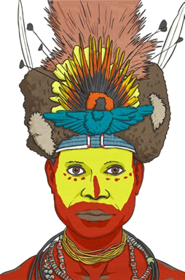
The Huli Tribe
The Huli tribe are another tribe who are indigenous to the rainforest. They live in Papua New Guinea and it is thought there are around 65 000 in the tribe.
Their traditional houses are made from grass and tend to be round. All of the men in the tribe live together, often at the centre of the village. The women and children share houses further out from the centre.

One of the most interesting traditions of Huli culture is their tradition for growing wigs! The male members of the tribe will grow their hair in special ways, adding feathers from various exotic birds. The wigs are cut off every once in a while and sold, sometimes for a lot of money. However, this practice must stop once the Huli man gets married!

The Pygmy Tribe
The pygmy tribe can be found in the rainforest of West
and Central Africa. It is estimated that their population
is around half a million.
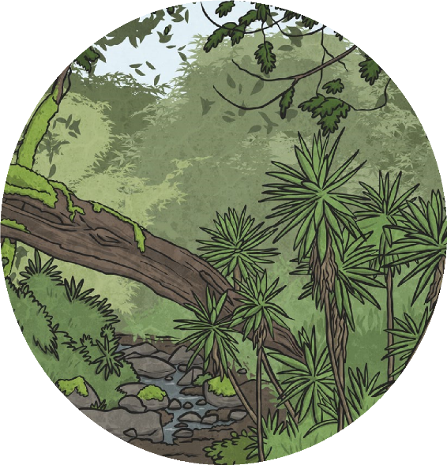

The pygmy tribe are distinctive because of their small stature, although this helps them in their rainforest environment. Many pygmies now wear western clothes but their traditional dress is made from bark and leaves.

Music plays an important part in the lives of the pygmy tribe and they particularly enjoy using their voices in harmony.
The pygmy tribe traditionally live in huts, built with bits of trees and leaves from the rainforest. They also rely on the rainforest for their food and for ingredients for their medicine. Hunting is an important part of pygmy life and they hunt for wild animals to eat. Before they go hunting, the people from the tribe perform a ceremony in which they ask permission from the spirits of the rainforest to hunt its animals.

The pygmy tribe faces many threats to their way of life. Conservation projects, farmers, poachers and disease all threaten to erode this way of life which has taken place in the rainforest for many generations.

Questions
- Name the three tribes mentioned in the fact file.

- Why do the Yanomami not have chiefs?

- Describe the houses the Yanomami live in.

- What are the Huli tribe famous for growing?

- Which is the largest of the tribes?

- What do the pygmy tribe do for food?

- What makes the members of the pygmy tribe easy to identify?

- Which tribe would you most like to be part of and why?

