Primary 2 Minibeast Challenge
Minibeasts are tiny creatures that live all around us, like insects and spiders! Moving into Summer you will see lots more minibeast all around you. Watch this clip to learn a little bit about different minibeasts and special things each can do: https://www.bbc.co.uk/bitesize/clips/z44g9j6
Head out on a walk and see if you can spot any minibeasts, remember they might be hiding!
Task
Create a fact-file all about your favourite minibeast (can design on paper or computer if you have access). This could be one from the video above, or something else you might have found on your walk!
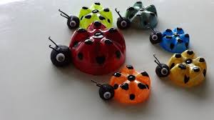
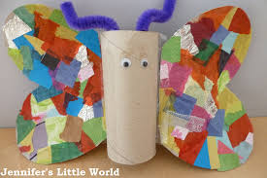
Your fact-file will need:
- Title (name of minibeast)
- Illustration
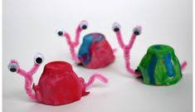
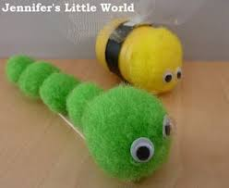
- Description of the minibeast (How many legs? What colour? Can it fly?)
- One interesting fact

Once you have made your fact-file, I would like you to try make a model of your minibeast. You can se anything for this; playdough, junk cardboard, foam, Lego … anything your imagination can think of! Send pictures of your fact-file and model to gw19auchinraithhl@glow.sch.uk

