Summer Sensory Poem  Create your own summer poem all about the senses of summer! What are the sights, smells, tastes, sounds and touches of summer for you?  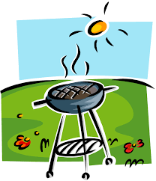  Summer looks like …  Summer feels like …  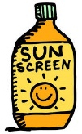  Summer sounds like …  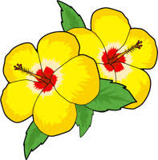  Summer tastes like …  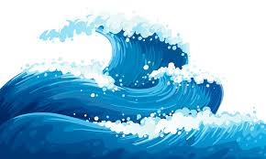  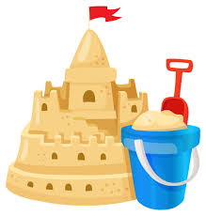  Summer smells like … | Nature Picture  Create a picture using natural resources you can find in your garden or local green space. Gather sticks, weeds, stones, petals and anything else interesting you can find and create a picture with them.  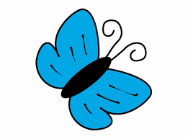 | Holiday Packing  Make a list of all the things you would pack in your holiday suitcase. What will the weather be like? Think what you would wear for that kind of holiday. Once you have finished your list, design a luggage tag and write your name and address on the back.
Summer Timetable  Look at the clocks below. Answer these questions:  - What time did you go to the beach?  - What time did you wake up?  - Draw the correct time on the clock to show when you went swimming.  - When did you get an ice cream? | Picnic Multiples  - 4 children have a picnic. There are 8 apples in the picnic basket. How many apples can each child eat?  - 8 children have a picnic. Each child eats 2 sandwiches. How many are eaten?  - 3 children are on a picnic. They finish a packet of biscuits. They each ate 5. How many biscuits were in the packet? | Photo Challenge  Go on a walk with an adult round your local area. Can you take a photo of something for each colour of the rainbow? You are looking for something…  Red  Orange  Yellow  Green  Blue  Indigo  Violet

Summer Timetable
