 | Mental maths | Daily 10 | Challenge
Monday 8th June | 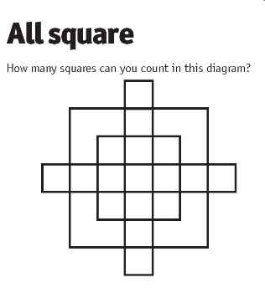 | *Simplify these fractions to their smallest amount*  (remember to find a common factor between the top and bottom number)  - 3/6  - 2/12  - 21/30  - 60/100  - 49/70  - 14/32  - 100/1000  - 25/50  - 56/64  - 81/90 | Tom was on the way to KLCC Park. He met a guy with 7 wives and each of them came with 7 sacks. All these sacks contain 7 cats and each of these 7 cats had 7 kits. So in total, how many were going to KLCC Park?
Tuesday 9th June | Write down as many different calculations as you for the answer:  48 | *use formal calculations*  - 3456 + 8723  - 10,000 – 4539  - 12,873 + 243  - 23,410 – 10,343  - 65,345 – 64,984  - 30,000 + 45,674  - 83,642 + 21,840  - 87,365 – 77,777  - 100,000 – 45,984  - 100,000 + 34,764 | A grandfather, two fathers and two sons drove to park together. Each of them bought one entry ticket each. How many tickets have they bought in total?
Wednesday 10th June | 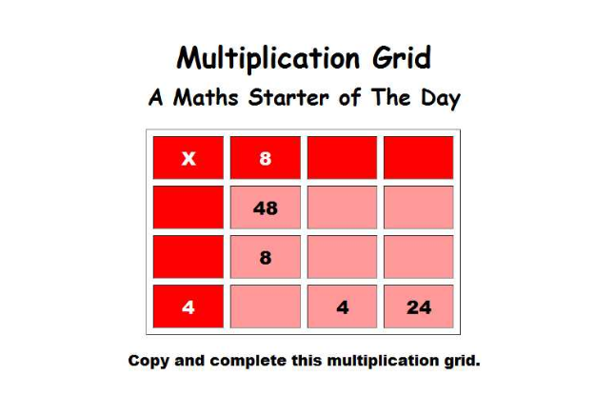 | *use either formal or mental math strategies to complete*  - 300 x 2  - 123 x 6  - 393 x 9  - 1000 x 10  - 4532 x 3  - 567 x 9  - 672 x 4  - 9234 x 7  - 2342 x 9  - 8453 x 4 | Two airplanes started the voyage. One flight is flying from London to KL at a speed of 400 MPH. The other flight is flying from KL to London at a speed of 600 MPH. Both these flights met at a point. Which of these flights will be closer to KL
Thursday 11th June | Write as many facts you can about the number:  2654  For example, it is a four digit number | Write the following numbers in words.  - 5874  - 30,654  - 23,875  - 67,983  - 100,874  - 300,873  - 567,932  - 1,564,874  - 2,785,700  - 10,345,879 | Mary has 7 daughters and each of them has a brother. Can you figure out the total number of kids Mary have?
Friday 12th June | Try and get as close to the target number using three of the six numbers below:  100 75 20 4 9 5  Target Number: 645 | *Use the chunking method to calculate the following, some will have remainders- be careful*  - 245 ÷ 4  - 129 ÷ 3  - 353 ÷ 5  - 985 ÷ 4  - 389 ÷ 5  - 900 ÷ 6  - 468 ÷ 2  - 100 ÷ 3  - 265 ÷ 4  - 875 ÷ 7 | 27 hens were marching towards the farm. 5 of them lost their way, 13 hens returned, and 9 hens finally reached the farm. What happened to the remaining hens?

- Remember to give all the activities a go and always try your best. Make sure you do your activities in your jotter or online and then you can take a picture or upload your work to the email.
- If you have any questions remember you can post any questions you have on the blog.
- Take care and stay safe

Squares | Mental Maths | Daily 10 Questions | Challenge
Monday 8th June | Write you numbers from 100 all the way down to 0. | Missing Number:  - 2 + __ = 12  - 6 + __ = 14  - 8 + ___= 20  - 22 - ___= 17  - 39 - ___ = 29  - 48 - ___= 28  - 52 + __ = 69  - 36 + __= 76  - 100 - __ = 81  - 99 - __ = 49 | Choose a one digit or two digit number. How many ways can you make that total? Example: 12 = 2+10, 6+6, 4+8 …  Try this for 5 different numbers.
Tuesday 9th June | Find the missing numbers:  - 13, 14, ?, 16, 17  - 34, ?, ?, 37, 38,?  - 99, 98, ? 96, ?, ? | Complete the following calculations. Set out and find: | Imagine you have £10. Choose three sweets to buy. Work out the total cost and how much change you would have.
Wednesday 10th June | Write the number  fifty-six in digits.  One hundred and thirty two.  Three hundred and seventy-five. |  | Try this game to test your problem-solving skills!  https://pbskids.org/peg/games/happy-camel
Thursday 11th June | Write yours number out to 20.  With a red pen or pencil circle the Odd Numbers  With a green pen or pencil circle the Even Numbers | Put these numbers into the correct order. Start with the lowest number first. | Watch the first video on this website about measuring words.  https://www.bbc.co.uk/bitesize/articles/zf4vbdm  Can you find something long and short in your house? Can you describe them by using comparing words?  Try this game all about measuring words.  https://www.topmarks.co.uk/early-years/lets-compare
Friday 12th June | Practice your number families to 20.  For example:  17 + 3 = 20  3 + 17 = 20  20 – 3 = 7  20 – 7 = 3 |  | Read the chilli challenges below. Choose the mild option for an easier challenge, and spicy to test yourself! Can you work out the answers?  Mild  Eric bakes these two trays of muffins.  He eats 2 muffins.  His dad eats 3 muffins.  His sister eats 4 muffins.  How many muffins does he have left?  Spicy  Lola buys this key ring.  Her mum gives her half of the money.  She pays for the rest herself.  How much does she pay herself?

- Remember to give all the activities a go and always try your best. Make sure you do your activities in your jotter or online and then you can take a picture or upload your work to the email.
- If you have any questions remember you can post any questions you have on the blog.
- Take care and stay safe

