Picnic Story  Percy the Park Keeper – The Rescue Party  Click on the link to listen to the story  Percy the Park Keeper - BBC | Picnic patterns  Can you repeat the patterns of fruit below?  Click the link to complete some patterns in this game.  Patterns – Top Marks | Sandwich  Can you use your own recipe to make your own sandwich? Be careful and follow each of your steps.
Invitation  Create an invitation for your teddy, toy of choice or just somebody you would like to invite on a picnic. | Tasty treats  These cakes have gone up 2p in price. What do they cost now?  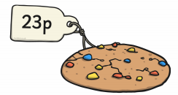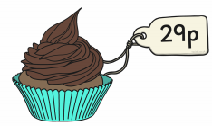  For an extra challenge how add up the total cost. | Fruity Milkshakes  Click on the link to get a recipe to make your own milkshake that you could take on your picnic. Milkshake Recipe – Keep a note of the fruits you liked in your milkshake.
Picnic Menu  Write a menu for your picnic – think about all the yummy food you would like to include. | Picnic fruit  Have a look at the chart below. Which fruit is the most popular? Which is the least popular?  Can you make a tally count for each fruit?  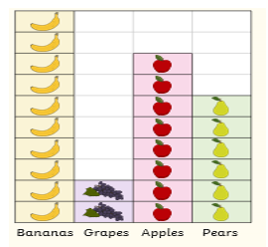  e.g.  pears = = 6 | Bubbles  Time for some outside fun! Mix some washing up liquid and water. Ideas for alternatives to bubble wands have been attached below.
Sandwich Sequencing  See below for a jam sandwich sequencing activity. Can you create your own sequence for a sandwich of your choice or write a recipe for the sandwich. | Bug Hunt  Whilst outside look around to see what types of insects or bugs you can spot! You can include flies or wasps. Record your answers in tally marks.  Remember for every 5 use  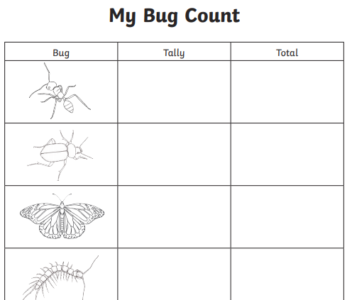 | Bird Watching  Lie or sit in a comfortable spot and look up at the sky or in the trees. Can you spot birds? What are they doing? How many did you see?
Talking and Listening  Use the Teddy’s Bear’s Picnic Spot the Difference attached below to try and find the 10 differences. Discuss these with somebody in your house. | Odd and Even  Sort these sweets into odd and even jars.  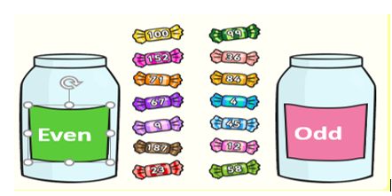 | STEM Challenge  Use materials from around your home – kitchen roll tube, egg carton, milk carton etc. can you try and create your own bug that may join you on your picnic without you even knowing?

Fruit Patterns

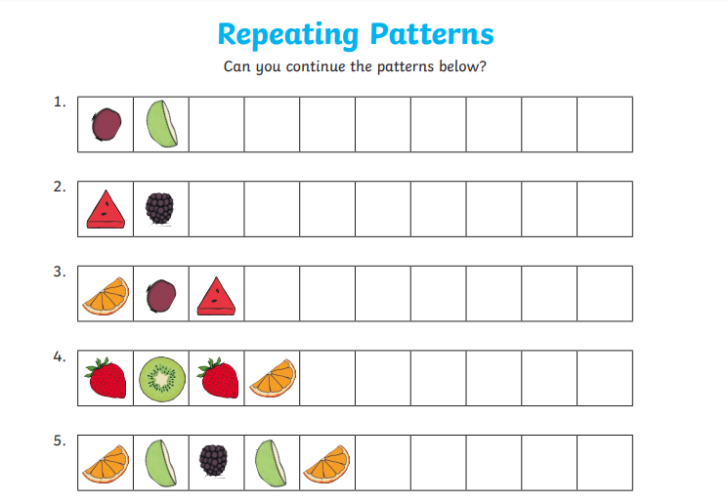

Jam Sandwich Sequencing

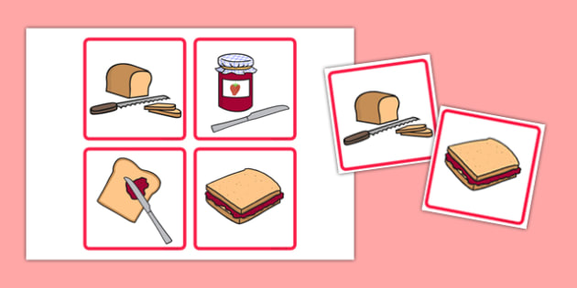

Teddy Bear’s Picnic – Spot the Difference

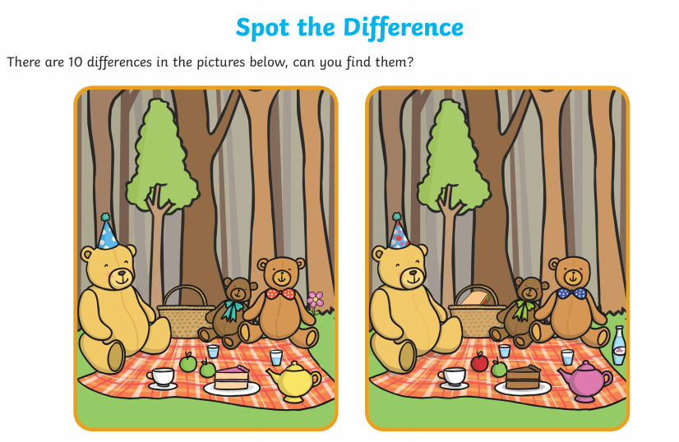

Alternative Bubble Wands

Plastic cup:
Punch a hole in the bottom to blow through.
Dip the large open end into the solution and blow.

Plastic soft drink bottles:
Cut the bottom off the bottle and dip.
Use the lid end of the bottle to blow you bubbles.

Drinking straws:
These should be small, but fast flowing bubbles. Why not bunch some together and see how many you can blow. Dip and try!

