Health and Wellbeing – Week Beginning 8th June 2020
 | Monday | Tuesday | Wednesday | Thursday | Friday
P1 and P2 | First Aid – Week 2  Task 1 - watch this video. It introduces you to 2 characters that are going to help you learn about first aid. https://www.youtube.com/watch?v=2k1-1qluAts&feature=youtu.be  Task 2 – Danger circle  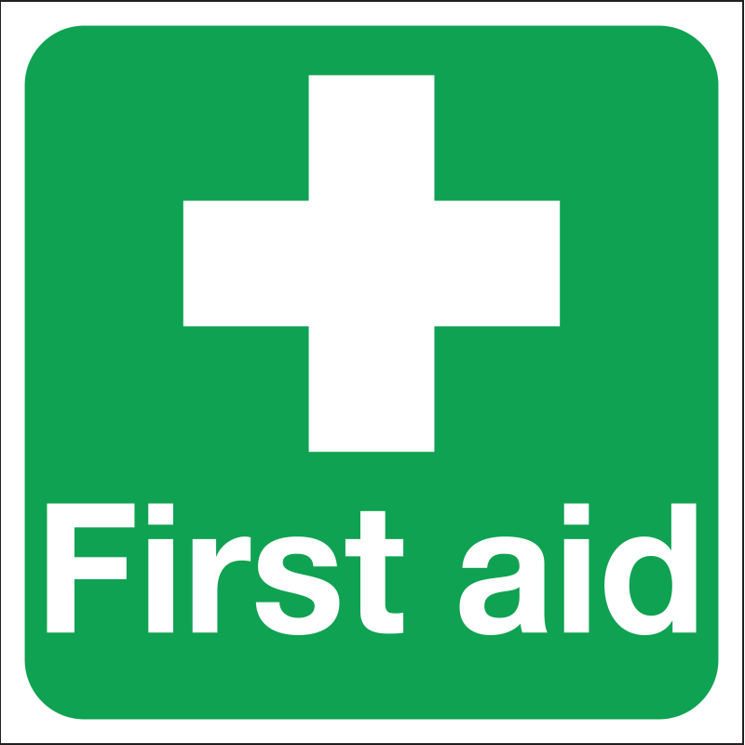  It is really important that before you help someone else who is ill/hurt that you make sure the area is safe. Use the ‘Danger Circle’ document in my blog post to learn about being safe. You can either print it out, write your answers on paper or just discuss it with an adult. | Positive Thoughts  Mrs Donald, who used to work at Auchinraith, has been making a weekly positive thoughts video for the children in her school and has kindly let us use it too!  Watch Week 1 and Week 2’s videos and discuss them with an adult.  E.g. In week 1, Mrs Donald talks about being proud of yourself. Can you think of things that you have been proud of recently?  In Week 2, she talks about turning your thoughts into positive ones. Write down some of your thoughts and see if you can change them so they sound more positive.  Week 1 https://www.youtube.com/watch?v=NsTpcmNHDcc  Week 2  https://www.youtube.com/watch?v=14a824EyS1M | First Aid  This continues on from Monday’s work.  Task 3 – Use the High 5 Hand (in blog post) learn about how to help someone now that you’ve made sure the area is safe. If you have a printer, you can cut out and colour the high 5 hand as a reminder but, if not, just go through it on screen and practise.  Task 4 – This is revision from last week. Make sure your child knows how to find and use your phone to call 999 and the importance of only using it if a grown up asks or if a grown-up cannot be woken up.  Task 5 – Use the instructions on the Postcode Song document. Look at the Little Rescuers 999 call and Postcode Song videos and practise. All resources can be found in the blog post. | Practical Skills at Home  I am giving you 2 challenges today that are all about knowing how to do certain things around the house.  - Making your bed – get an adult to show you how to do this. Make sure the sheet is nice and tight around the mattress and that your duvet and pillow are neat!  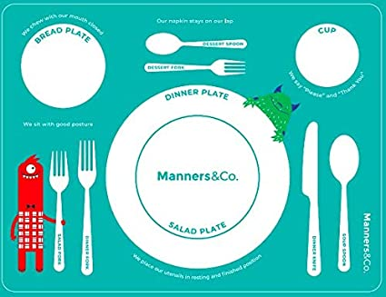  - Setting the table for dinner – get an adult to teach you how to set a table. Think about what side the knife and fork go on and the correct place for a cup/glass. If you are having a dessert after, where should the spoon go? | Looking on the Bright Side Picture  On Tuesday, you watched a video of Mrs Donald talking about positive thinking.  People who have a positive attitude are said to ‘look on the bright side’. Can you draw a picture of happy you in the sunshine, using bright colours?  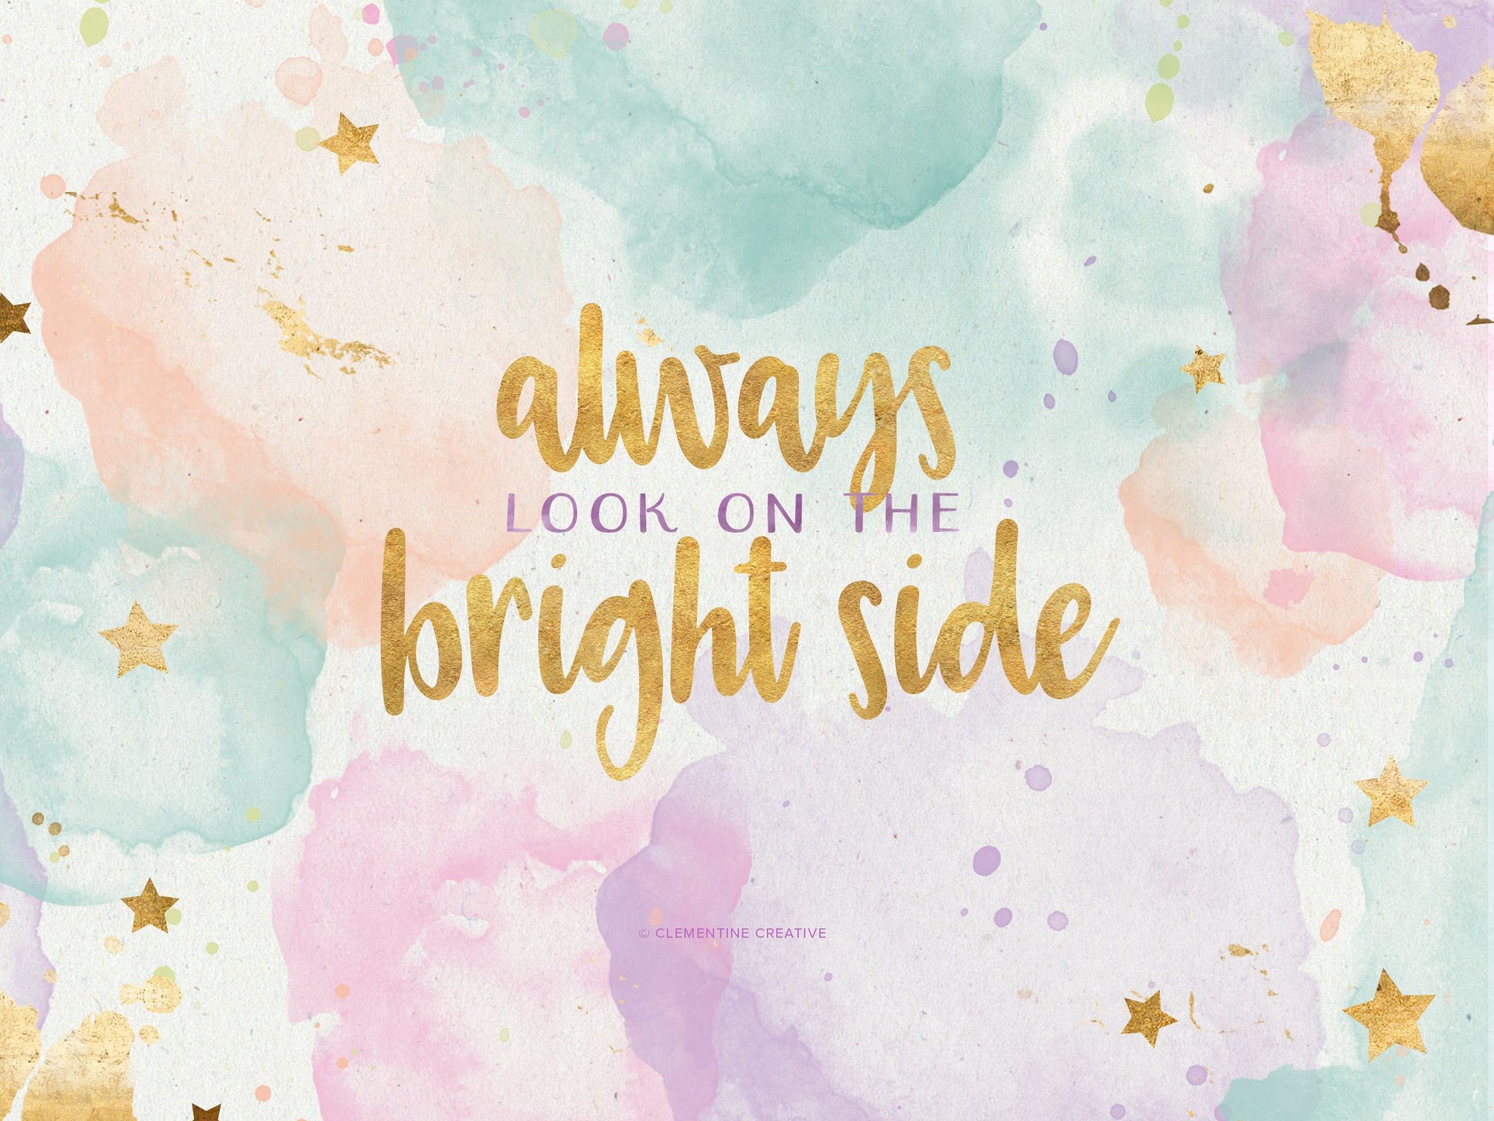
P3 and P4 | First Aid Week 2  Staying Safe Activity Sheets  Now that you have learnt some first aid skills, you need to make sure that you know how to make the area around the person you are helping safe so that you don’t get hurt as well. Look at the 3 activity sheets (all in one document with the link in blog post) and discuss with an adult what hazards you can see and what you could do to avoid them and stay safe. The answers are on the last page. | Positive Thoughts  Mrs Donald, who used to work at Auchinraith, has been making a weekly positive thoughts video for the children in her school and has kindly let us use it too!  Watch Week 1 and Week 2’s videos and discuss them with an adult.  E.g. In week 1, Mrs Donald talks about being proud of yourself. Can you think of things that you have been proud of recently?  In Week 2, she talks about turning your thoughts into positive ones. Write down some of your thoughts and see if you can change them so they sound more positive.  Week 1 https://www.youtube.com/watch?v=NsTpcmNHDcc  Week 2  https://www.youtube.com/watch?v=14a824EyS1M | Heart Map  A heart map is a visual reminder of all the things you love and care about. See some pictures below for examples.  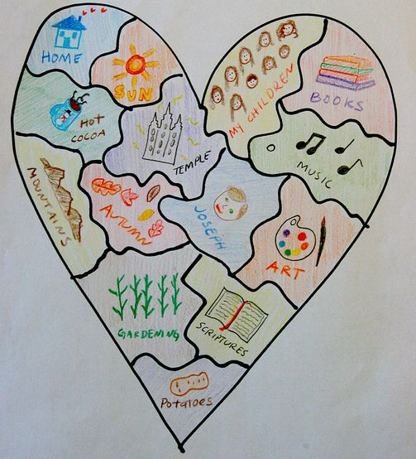  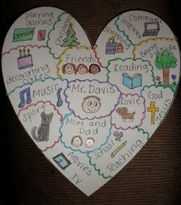 | Practical Skills at Home  I am giving you 2 challenges today that are all about knowing how to do certain things around the house.  - Sorting the washing into whites, lights and darks (or however it is sorted in your house). Ask an adult to teach you how to do this and practise through the week. Discuss that washing needs to be separated in case dye from the clothes runs and because different materials need to be washed at different temperatures.  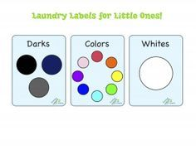  - Folding clean clothes – get an adult to show you how to fold different types of clothes properly so that they can be put away neatly. Practise this throughout the week.  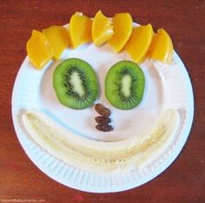 | Design a Positive Thinking Cap  On Tuesday, you watched a video of Mrs Donald talking about positive thinking.  Today I’d like you to design a ‘positive thinking cap’. It should have colourful messages about positive thinking on it. You can use different kinds of writing, symbols and pictures.  The ‘Positive Thinking Cap’ document in my blog post shows you a template and gives you ideas for words and phrases you could put on your cap.  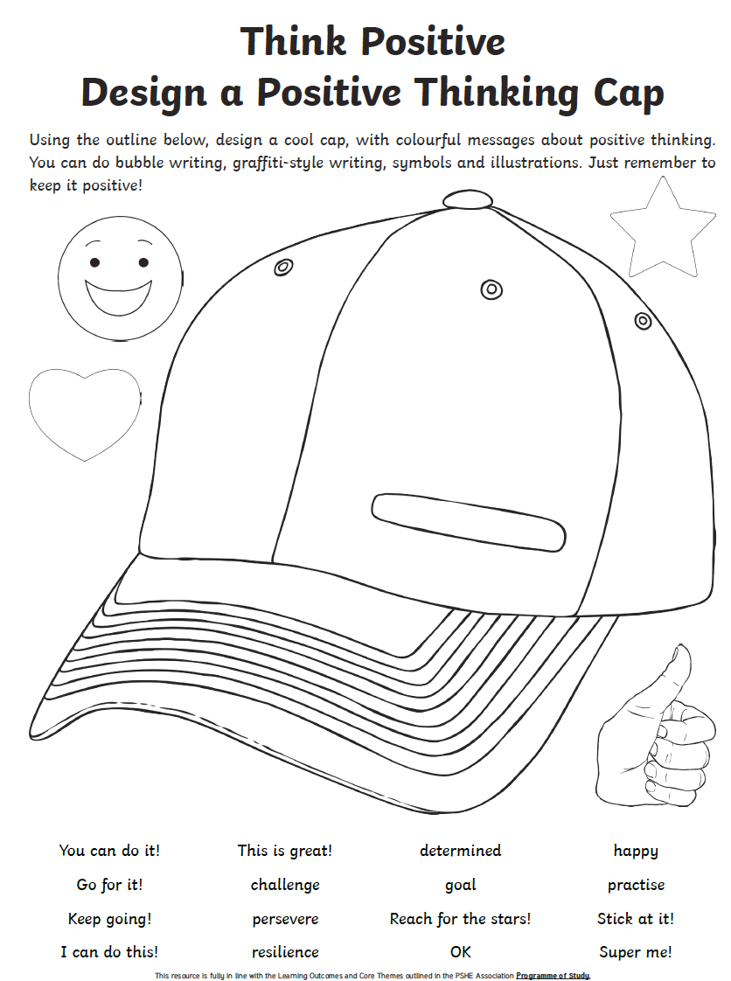
P5, P6 and P7 | First Aid Week 2  Feeling confident in knowing what to do in different situations and giving first aid takes practice. Look at the First Aid PowerPoint (link is in my blog post). Think about what you would do in each of the scenarios. On the next slide are links to explain the correct response. Then use the ‘Recovery Position’ document (link in blog post) to learn how to move someone into this very important position. Practice on someone at home until you feel confident that you can do it without the instructions.  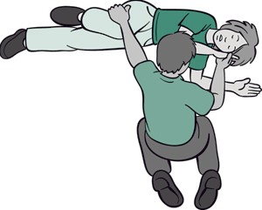 | Positive Thinking  Sometimes, without even realising, your mind goes towards negative thoughts more often than positive ones. This can really affect your mood and the way you see things. So today, we’re going to practise turning our negative thoughts into positive ones!  This link explains how negative thoughts can become habit:  https://www.youtube.com/watch?v=x-dMPXBl7yA  This link show examples of how to turn negative thoughts into positive ones:  https://www.youtube.com/watch?v=B-qJ8fu0rrI  Now put this into practice by completing the ‘Making Negative Thoughts into Positive Thoughts’ worksheet that I posted in my blog comment. If you can’t print it out then write your answers on paper. The first page has examples for you to change and the second is for you to write down your own negative thoughts and turn them into positives. | Music  Songs can make you feel different emotions. Some songs make you feel happy or excited, while others can make you feel sad. Some songs can be linked to memories in your head. For example, Hall and Oates – You Make My Dreams reminds me of when I went on a trip to Loch Lomond on a sunny day because we listened to it in the car.  Spend some time making a playlist that makes you feel happy/excited/relive good memories.  You could also make a playlist of sadder songs for when you feel you want to let some emotions out. | Practical Skills at Home  I am giving you 2 challenges today that are all about knowing how to do certain things around the house.  - Firstly, make sure you know how to sort the washing into lights, darks and whites. Then get an adult to teach you how to put a washing on. You should check pockets to make sure there is nothing in them and look at clothes labels to check the temperature they can be washed at. Do any of the clothes have the hand wash symbol?  - Get an adult to teach you how to iron some simple things like t-shirts. Remember to look at the labels to check what temperature the iron should be at.  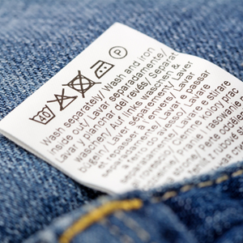 | Free Choice Health and Wellbeing Craft  I am giving you the challenge of coming up with your own wellbeing craft!  It could be related to:  - Mindfulness colouring  - Memory box/jars  - Positive thinking  - Being thankful  - The brain  - Food  - Friendship  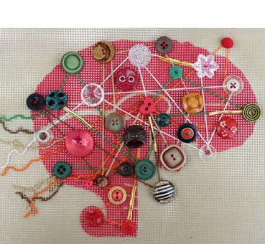  These are only some ideas to get you thinking!  