P.E. – Week Beginning 8th June 2020

Monday
Co-ordination and balance – Hopscotch is a really good way to practise your co-ordination and balance. Follow the instructions below to play. If you don’t have chalk, you can use tape.
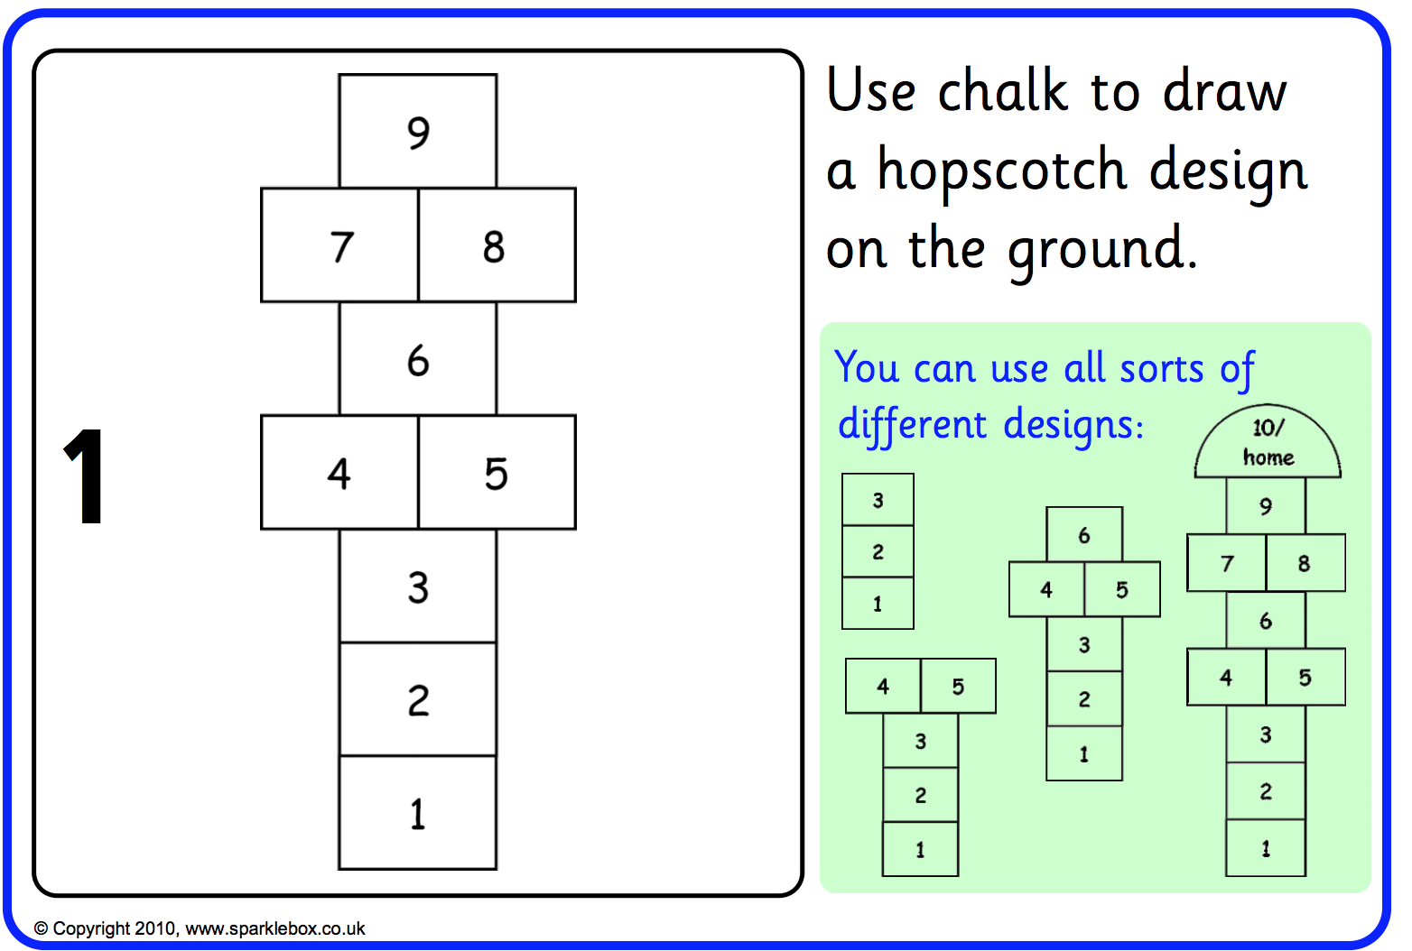

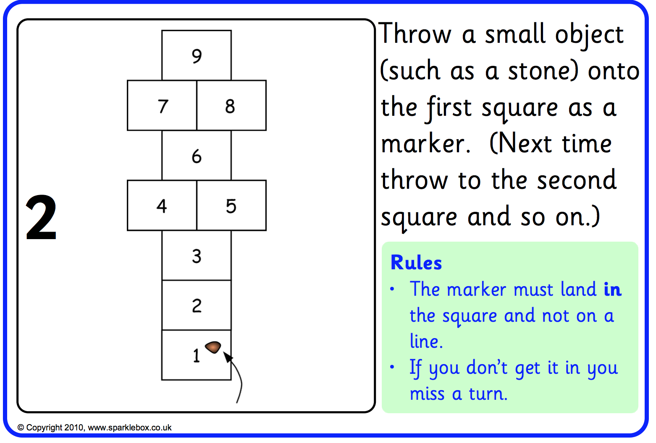

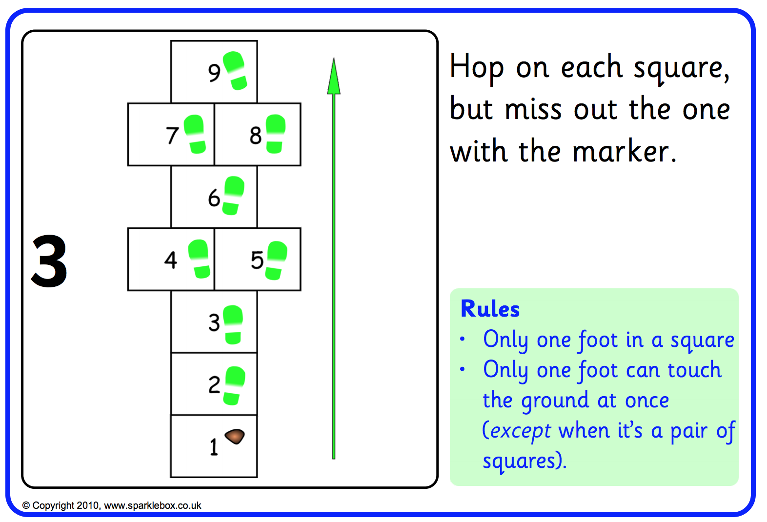

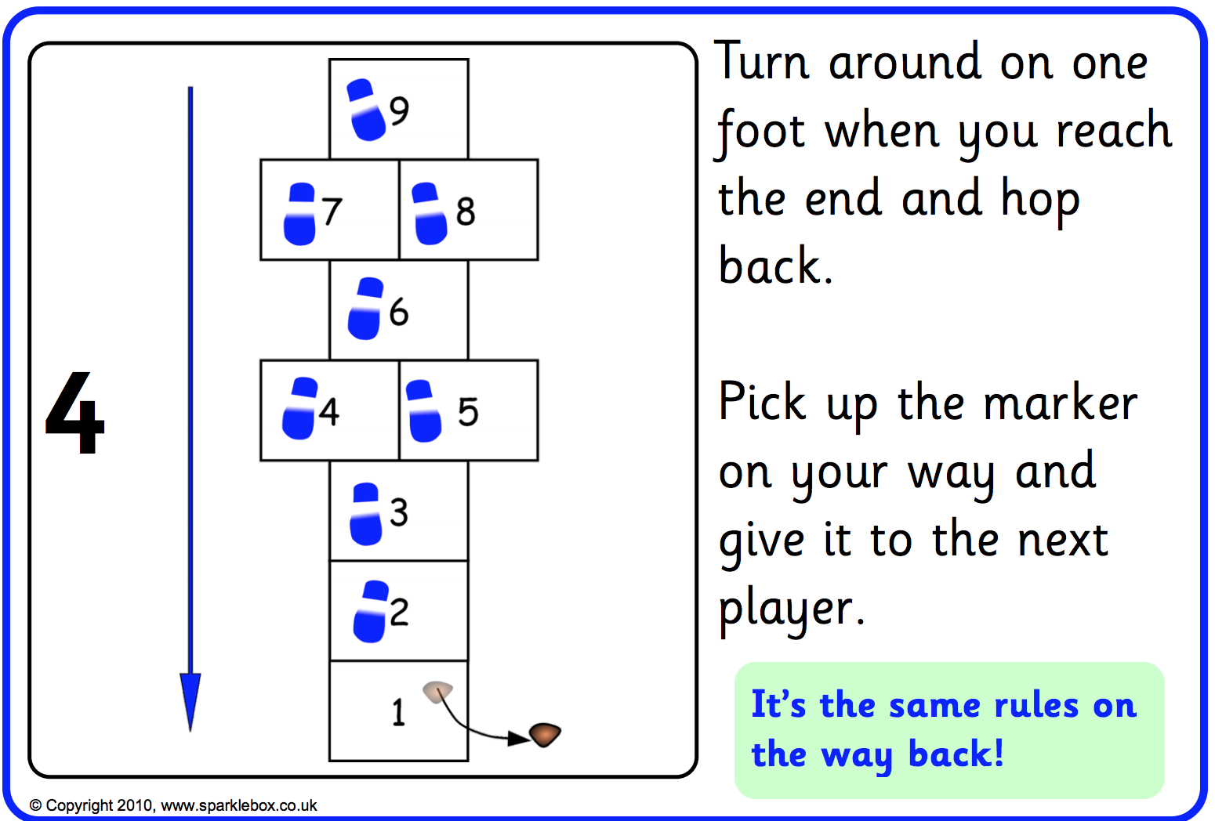

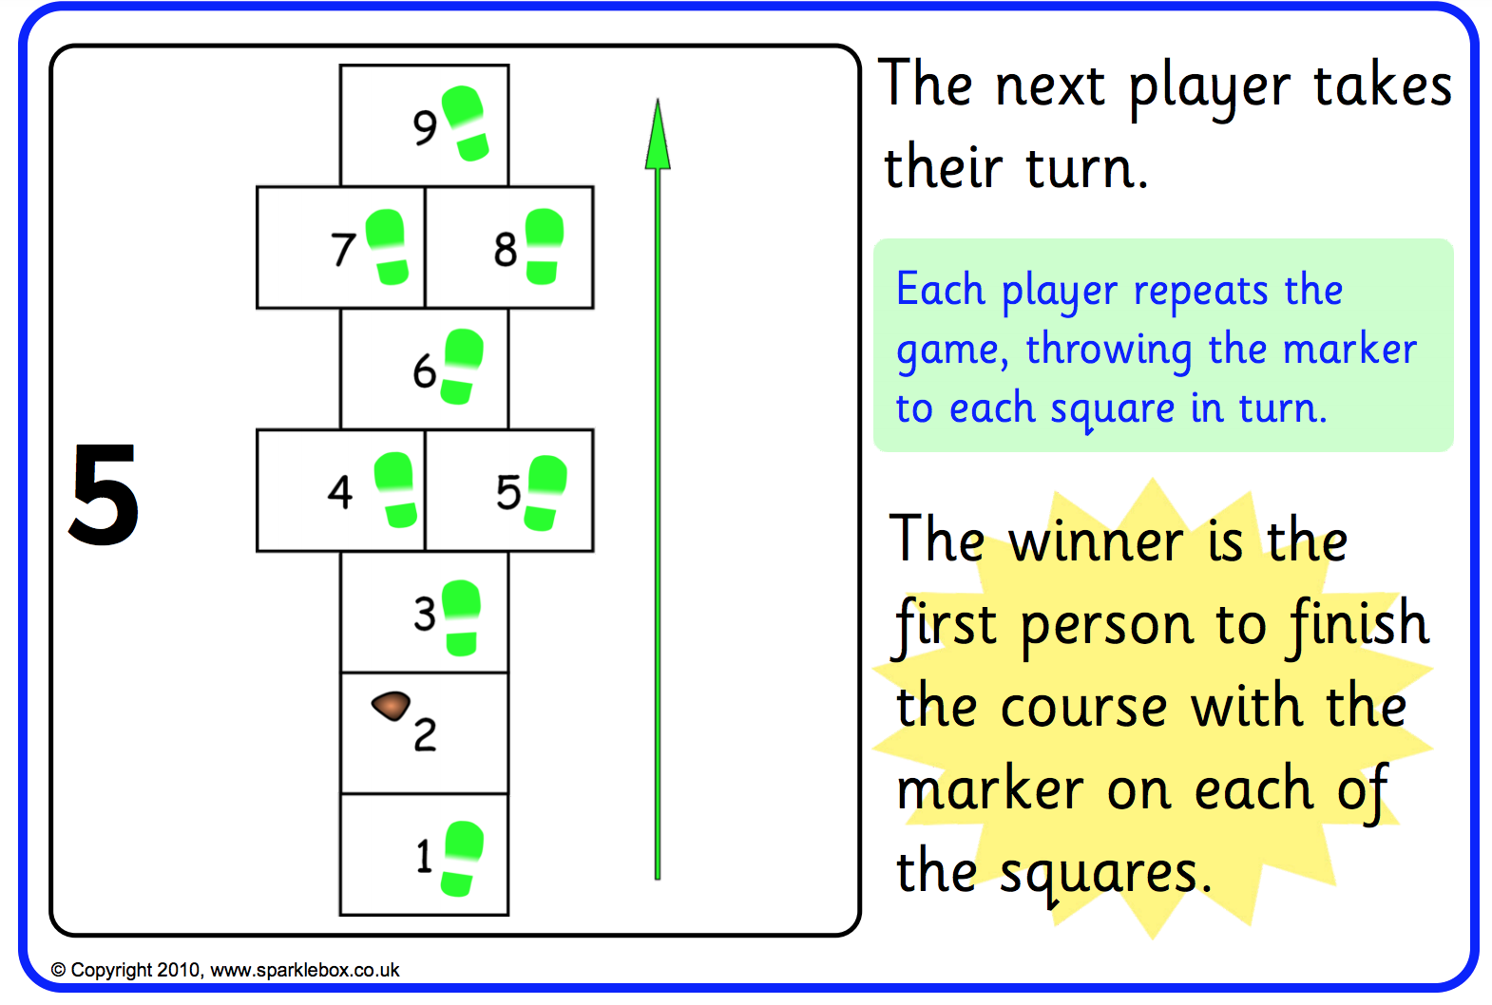

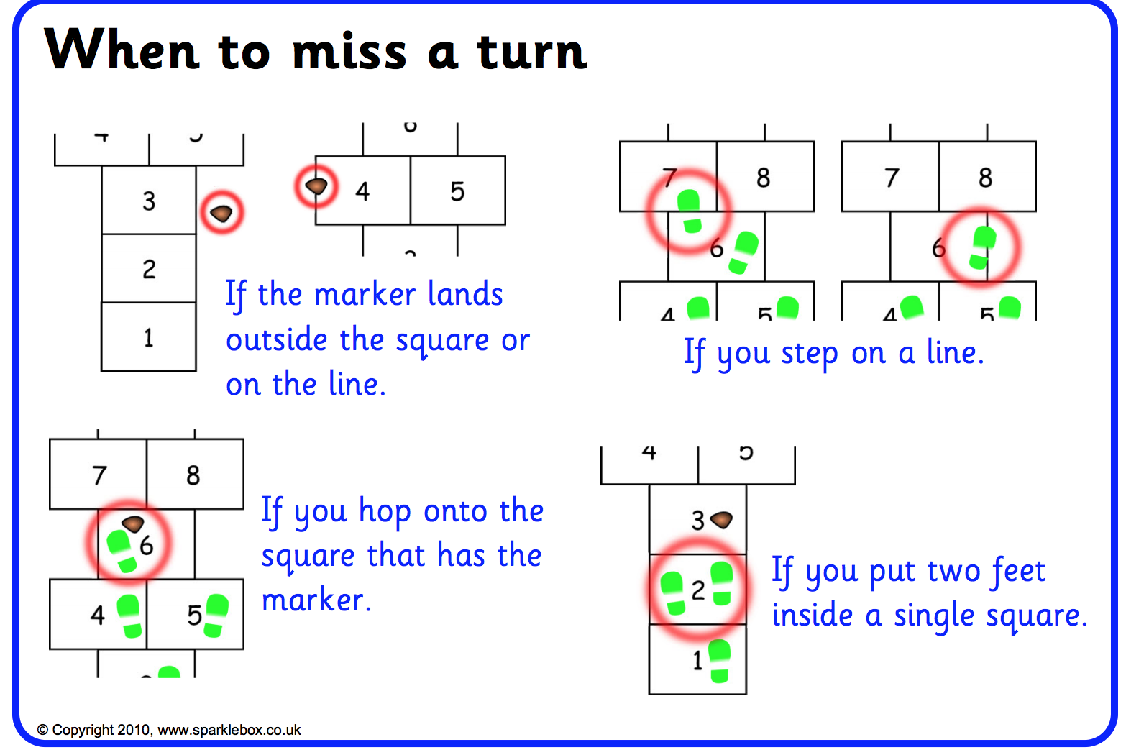

Tuesday
Circuits Challenge – Work your way through the different exercise stations 3 times trying to beat your score each time. You can choose what level you would like to try – Younger children might want to do the bronze/silver level. If you can do the platinum level 3 times then you must be very fit!

I have uploaded the instructions for this separately (see post for this week).

Wednesday
Today I’d like you to do a Joe Wicks workout. These are live on his YouTube channel at 9am but if you aren’t ready to do your workout then, don’t worry because he posts the video on his page straight away.
Here’s the link: https://www.youtube.com/user/thebodycoach1/featured

Thursday

Wacky Races
Try these 3 different races with the people in your house. These will really work your muscles!
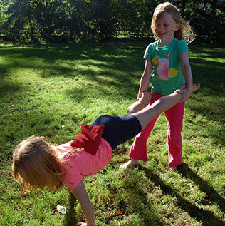
- Wheelbarrow race – if you are the person being the wheelbarrow then keep your tummy muscles strong to help hold you up!

- Crab race

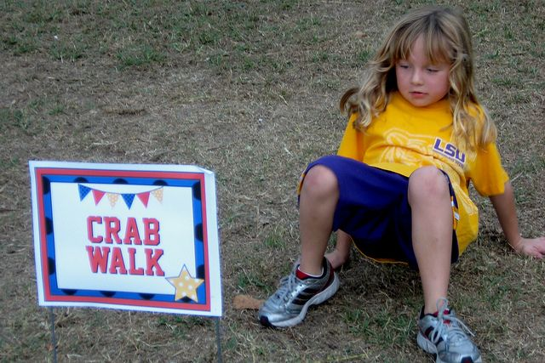

- Bear crawl race

Friday
Here are 2 activities to get you moving! For ‘Keep on the Move’, after you have played it a few times why not change the challenges for the different station?

